The Lord Hampton
House of Lords
London
SW1A 0PW

19 August 2026

Dear Lord Hampton,

I would like to thank you for your contribution to Lord Hunt’s oral question on Thursday 16" July on what assessment the government have made of the impact of the failure of Pearson to deliver Key Stage 2 exam results on time.

I am writing in response to your question to Baroness Blake, regarding the publication of the Department’s statutory safeguarding guidance Keeping children safe in education.

I would like to assure you that we do recognise the incredibly important role that Designated Safeguarding Leads and school leaders play in implementing safeguarding guidance and ensuring that policies and procedures remain up to date. We also appreciate the significant work involved in reviewing and updating school policies in response to changes in statutory guidance.

Our priority has always been to publish KCSIE before the summer recess, and this continues to be the case. We appreciate this is more difficult for those schools that close earlier than others. However, I am pleased to confirm that we published the ‘for info’ version of KCSIE 2026 on 7 July, ahead of it coming into force on 1 September.
We continually look for ways to improve the guidance handling, and your feedback is very helpful in this regard for when we consider future iterations of KCSIE.

Thank you for your engagement on this important matter. I will deposit a copy of this letter in the House Libraries.

Yours sincerely,
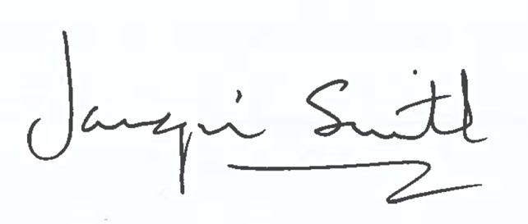
The Rt Hon Baroness Jacqui Smith
Minister for Skills

