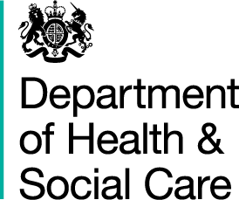

The Deposited Papers Clerk
The Library
House of Lords
SW1A 0PW

10th March 2026

Dear Deposited Papers Clerk,

Please see attached the letter from myself to the health and social care committee regarding recent announcements on Dentistry.

I would be grateful if you could deposit a copy in the Libraries of both Houses.

Yours sincerely,
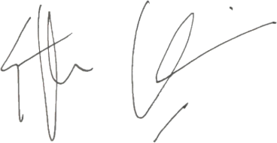

STEPHEN KINNOCK

MINISTER OF STATE FOR CARE

