House of Commons Library

Palace of Westminster

London

SW1A 0AA

22August 2025

**ANNUAL ABSTRACT OF BIRTHS**

I am writing to request that you place in the libraries of both Houses of Parliament a copy of the Annual Abstract of Births, to be made available to members of both Houses, following its publication by the Office for National Statistics (ONS).

The ‘annual abstract’ is the statistical table produced annually by the ONS. The annual abstract of births was published by the ONS on 1 July. There is a statutory requirement for the tables to be deposited in the libraries of both Houses.

**Yours sincerely,**

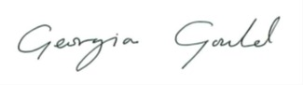

**Georgia Gould MP**

**PARLIAMENTARY SECRETARY**