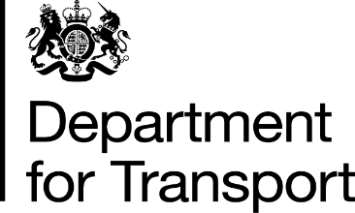 | Lord Hendy of Richmond Hill  Minister of State for Rail  Great Minster House  33 Horseferry Road  London  SW1P 4DR  Tel: 0300 330 3000  E-Mail: lord.hendy@dft.gov.uk  Web site: www.gov.uk/dft
Lord Moylan,
House of Lords,
London
SW1A 0PW

28 July 2025

Dear Daniel,

Thank you for your Written Parliamentary Question of 7 July (ref: HL9179), about the new integrated leadership team for Southeastern and the Network Rail Kent route. Further to my answer provided on 18 July, I have asked officials to provide you with more detail on the benefits of this way of working.

South Eastern Railway (SER) was launched in June 2025, with an integrated Senior Leadership Team comprising Southeastern and Network Rail Kent route colleagues, under the leadership of Managing Director Steve White. Southeastern and the Network Rail Kent route have been working in close partnership since October 2023 and the formalisation of this partnership builds upon the collaborative, efficient ways of working that have already been established and provides a single point of accountability for the network and customers.

The creation of SER provides for a system-wide view of the railway in the South East, uniting track and train under a single leadership team to cut red tape, drive investment and efficiency, and deliver for passengers in an important step towards Great British Railways (GBR).

By bringing together the teams that run the trains and manage the infrastructure together, SER is finding new ways of working to ultimately make better, faster decisions for customers and taxpayers. Decisions impacting customers are being made by those closest to them and their journeys. For example, the team has brought in more efficient track maintenance regimes and is targeting investment to grow revenue and reduce the subsidy required to operate the railway by £50 million over the next financial year.

Operational Performance has also benefited from this arrangement, with cancellations being amongst the lowest in the country. SER is using AI-enabled CCTV and thermal imaging cameras on trains to monitor infrastructure condition, so it can respond to more issues before they affect customers. SER is also deploying drones to reduce incidents and delays from trespass – a significant cause of disruption on today’s railway.

There will be more integrated management of track and train across the country as more and more services are brought into public ownership. Ultimately under GBR, there will no longer be 14 separate train companies, as well as Network Rail, each with their own staff, incentives and competing commercial motivations. Passengers think of the railway as a singular entity and that is how it should be run.

Public ownership and integrated management will ensure that all parts of the system are pulling together to deliver a better and more efficient service for customers with greater autonomy.

I will place a copy of this letter in the libraries of both Houses. I hope this further explanation is helpful.

Yours sincerely,

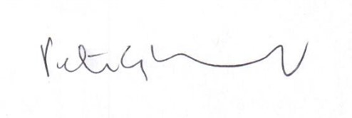

Peter, Lord Hendy of Richmond Hill

MINISTER OF STATE FOR RAIL

