The Rt Hon Liam Byrne MP  Chair, Business and Trade Committee  House of Commons  London  SW1A 0AA | T: +44 (0) 020 4551 0011  E: madders.correspondence@businessandtrade.gov.uk  W: www.gov.uk/dbt  7 July 2025

Dear Liam,

Central Arbitration Committee Annual Report 2024/25

I am writing to let you know that the Central Arbitration Committee’s annual report for 2024/25 is being published today, on the 3 July. The Central Arbitration Committee is a public body with responsibilities to determine certain issues under trade union law, including union applications to be recognised for collective bargaining purposes.

I enclose a copy for information, and I will be depositing a copy of the report and this letter in the Libraries of both Houses.

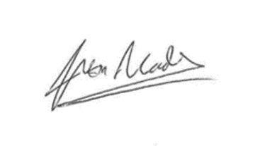

Yours ever,

JUSTIN MADDERS MP
Minister for Employment Rights, Competition and Markets
Department for Business and Trade

