1.9.2 2 June 2025

Dear Ms Young,

**Strategic Defence Review – Making Britain Safer: Secure at Home, Strong Abroad**

I would be grateful if the enclosed document with the above title could be placed in the Library of the House.

Yours sincerely,

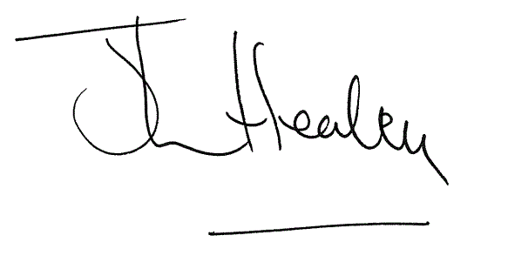

**THE RT HON JOHN HEALEY MP**

Secretary of State for Defence