19 March 2025

My Lords,

**Armed Forces Commissioner Bill: Draft Regulations – Definition of family members**

I thank you for your contributions and support for the Armed Forces Commissioner Bill during Second Reading. As I assured you all in my closing remarks, I now enclose the draft regulations covering the definition of ‘family members’ for the purposes of this bill.

I would welcome your views about whether this captures all the necessary and appropriate groups who constitute what family is for the bill.

I very much look forward to your valued examination of the bill at Committee Stage on 19, 24, 26 March 2025 and I will place a copy of this letter and enclosure in the Library of the House.

Yours sincerely,

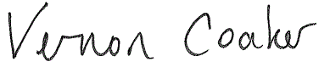

**LORD COAKER**