**Lord Hendy of Richmond Hill**

Minister for Rail

Great Minster House

33 Horseferry Road

London

SW1P 4DR

Tel: 0300 330 3000

E-Mail: lord.hendy@dft.gov.uk

Web site: www.gov.uk/dft

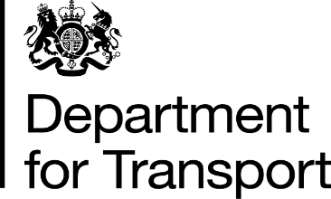

The Lord Rogan

House of Lords

London

SW1A 0PW

27 February 2025

Dear Lord Rogan,

I am writing further to your question to Lord Hanson as part of the debate on e-scooters on Thursday 13 February, regarding progress this Government has made on consulting with all enforcement bodies in Northern Ireland before changes are made to the legal status of e-scooters there.

If and when the UK Government brings forward changes to the legal status of e-scooters, my department will consult on the proposed regulations, to ensure all those with an interest have the opportunity to shape the new regime.

However, my officials have advised me that the UK Government’s remit in this case does not extend to Northern Ireland. As Northern Ireland is responsible for its own road traffic laws, any changes to the legal status of e-scooters would lie with the Northern Ireland Executive (NIE), and it will be its own decision if and how to engage with enforcement agencies on any changes they are proposing to the legal status of e-scooters. I would therefore recommend raising your request with the NIE as they will have the powers to progress this further.

I have copied this letter to all the Noble Lords who spoke in this discussion and will place a copy of this letter in the Library of the House.

Yours sincerely,

**Peter, Lord Hendy of Richmond Hill**

**MINISTER OF STATE FOR RAIL**