Consultation:

CONTINGENT RELAXATION OF LICENSING HOURS DURING THE SEMI-FINALS AND FINAL OF THE 2025 UEFA WOMEN’S EUROPEAN CHAMPIONSHIP

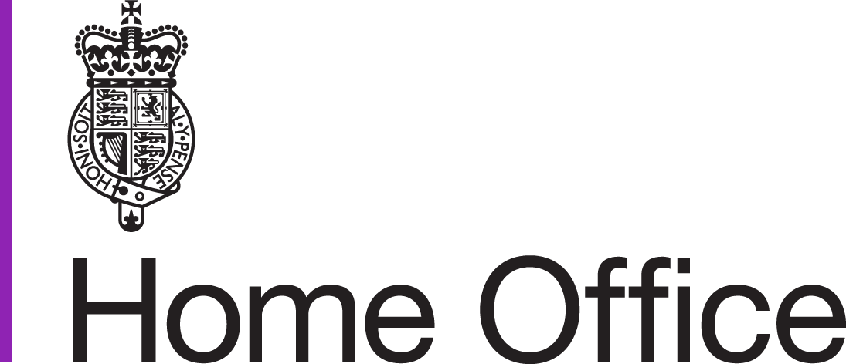

This consultation begins on 23 February 2025

This consultation ends on 23 March 2025

About this consultation

|  |  |
| --- | --- |
| **To:** | We are keen to hear from everyone who may be affected by a national relaxation of licensing hours, including: members of the public, those who live near to licensed premises, those who own or work in on-trade premises, the police, licensing authorities and trade associations. The consultation covers England and Wales where these proposals apply. |
| **Duration:** | From 23 February to 23 March 2025. |
| **Enquiries (including requests for the paper in an alternative format) to:** | Email: [alcohollicensingconsultations@homeoffice.gov.uk](mailto:alcohollicensingconsultations@homeoffice.gov.uk) |
| **How to respond:** | Please send your response by 23 March 2025.  Responses can be submitted online through the GOV.UK website or by post by sending responses to:  Licensing Hours Consultation  Alcohol team  5th Floor, Fry Building  Home Office  2 Marsham Street, SW1P 4DF  Email: [alcohollicensingconsultations@homeoffice.gov.uk](mailto:alcohollicensingconsultations@homeoffice.gov.uk) |
| **After the consultation:** | Responses will be analysed and a ‘Response to Consultation’ document will be published. This will explain the Government’s final policy intentions. All responses will be treated as public, unless stated otherwise. |

Contents

Introduction 2

The proposals 3

Background 5

Questionnaire 6

About you 7

Contact details and how to respond 8

Consultation principles 10

# Introduction

This paper sets out consultation proposals to relax licensing hours for licensed premises in England and Wales for the semi-finals and the final of the 2025 UEFA Women’s European Championship, contingent on the England women’s national football team and/or the Wales women’s national football team playing in those matches.

The consultation is aimed at members of the public, local licensing authorities, licensed premises, and other interested parties in England and Wales where these proposals apply.

Copies of the consultation are being sent to:

Local Government Association

Welsh Local Government Association

National Association of Licensing Enforcement Officers

Institute of Licensing

National Organisation of Residents Associations

National Police Chiefs Council

Association of Police and Crime Commissioners

British Beer and Pub Association

Association of Licensed Multiple Retailers

Wine and Spirits Trade Association

Alcohol Health Alliance

Alcohol Research and Concern

Institute of Alcohol Studies

However, this list is not meant to be exhaustive or exclusive and responses are welcomed from anyone with an interest in or views on the subject covered by this paper.

# The proposals

1. The Government is consulting on whether to relax licensing hours across licensed premises in England and Wales to mark the **2025 UEFA Women’s European Championships (Euro 2025) semi-finals and final**, or whether to rely on the existing system of Temporary Event Notices (TENs) which gives the local police and environmental health officers a say in decisions on whether individual local premises should extend their licensing hours for a particular event, based on local circumstances.
2. The proposal is to extend licensing hours if the England women’s national football team and/or the Wales women’s national football team is successful in reaching the semi-finals and final of Euro 2025.
3. The Government proposes to make a licensing hours Order under section 172 of the Licensing Act 2003 which would contingently extend opening hours on the days of the semi-finals (22 and/or 23 July 2025) and the final (27 July 2025) so that they would end at 01:00 (i.e. early in the morning after the matches have taken place) rather than 23:00 on the day of the matches for the sale of alcohol for consumption on the premises.
4. The Government has decided that, if it were to relax licensing hours nationally following this consultation, this would be contingent on England and/or Wales reaching the semi-finals, with a further extension applying in the event that either of these teams then reach the final. No extension would come into place on any date during the tournament should the aforementioned team/s not participate in those matches. If the aforementioned team/s reach the semi-final, but are unsuccessful in that match, the extension would only apply to the relevant semi-final match, and licensing hours would not then be extended for the final.
5. The Government proposes that any national relaxation of licensing hours during the semi-finals and final would **only apply to the sale of alcohol for consumption on the premises**, and would **not** apply to the sale of alcohol for consumption off the premises (i.e. in supermarkets and off-licences) as anyone wishing to mark the occasion at home will be able to buy alcohol during normal shopping hours. Late-night refreshment venues, by definition, are already licensed to open late at night and would not benefit from a relaxation in licensing hours. We do not intend to extend licensing hours for the provision of regulated entertainment. It should also be noted that unlicensed premises would not benefit from a relaxation in licensing hours and would still need to give a Temporary Event Notice (TEN) to undertake licensable activities.
6. The purpose of the national relaxation of licensing hours during the Euro 2025 semi-finals and the final would be to enable all pubs and other on-trade premises to sell alcohol to people watching the relevant match(es) live.
7. The consultation asks for views on whether licensing hours should be relaxed during the semi-finals and the final of Women’s Euro 2025 if the conditions set out are met. The options presented in the consultation seek to enable pubs and other on-trade premises to sell alcohol throughout the duration of live matches with some additional time whilst balancing concerns about public order. Licensing hours would not be relaxed beyond 01:00. After these licensed hours, premises would not be able to sell alcohol under the licensing hours Order. However, premises may be able to allow customers to remain on the premises beyond the extended hours and could give a TEN if they wished to open later.
8. This licensing hours extension would apply to premises in England and Wales only. Licensing is a devolved matter in Scotland and Northern Ireland.

# Background

1. Under section 172 of the Licensing Act 2003 (the Act), the Secretary of State may make an Order relaxing licensing hours for licensed premises in relation to a ‘celebration period’ to mark an occasion of ‘exceptional international, national or local significance’. A ‘licensing hours Order’ can be used to relax licensing hours in licensed premises during a period not exceeding four days. An Order may be applied to all licensed premises in England and Wales or only to premises in one or more specific area. Other variables in the Order are the dates, times and licensable activities to which it applies.
2. Since the introduction of the Act, this national power has been used to mark the Royal Weddings in 2011 and 2018, the Late Queen’s Diamond Jubilee, 90th Birthday celebrations, and Platinum Jubilee, His Majesty’s Coronation in 2024, the Men’s World Cup Group Stage Qualifier in 2014, the UEFA Men’s Euro Championship final in 2020 and the semi-final and final of the UEFA Men’s Euro Championship 2024.
3. Should England and/or Wales reach the semi-finals and subsequently reach the final of Euro 2025, this will be a sporting event of national celebration and it is likely that many pubs and other licensed premises in England and Wales will wish to open later to ensure full coverage of the match(es) and any possible post-match celebrations. Football is recognised as a particularly high-profile sport and is seen by many to be the national game in the United Kingdom.
4. Licence holders currently have the option of using a Temporary Event Notice (TEN) to extend their opening hours for a limited period. A TEN costs £21 and must be submitted at least 10 working days before the event begins. However, they are subject to certain annual limits and may be refused if the police object on the grounds of crime and disorder. The TENs regime also allows people or organisations without existing licenses to give notice that they intend to sell alcohol at times when this would not otherwise be authorised on a ‘one-off’ limited basis. This system is designed to balance giving people and organisations flexibility in selling alcohol and carrying on other licensed activities, whilst protecting local people from the problems this can cause, including crime and disorder and public nuisance.
5. There are potential risks to relaxing licensing hours nationally – this includes the impact on enforcement agencies, and an increased risk of alcohol-related crime and disorder. However, there is no significant evidence that an increase in alcohol-related crime and disorder has materialised during past national licensing hours extensions.
6. Whilst considering whether or not to relax the licensing hours nationally, the Government will balance those wishing to watch and celebrate the England and Wales teams in Euro 2025 with protecting the public from potential crime and disorder and public nuisance late at night.

# Questionnaire

We would welcome responses to the following questions set out in this consultation paper.

**Q1: Do you support the proposal for extending licencing hours in England and Wales in the event that the England and/or Wales teams reach the semi-finals of Euro 2025?**

Yes

No

**Q2: Do you support the proposal for extending licencing hours in England and Wales in the event that the England and/or Wales teams reach the final of Euro 2025?**

Yes

No

**Q3: Do you agree that the contingent order should only apply to the sale of alcohol for consumption on the premises (i.e. it should not apply to the sale of alcohol for consumption off the premises)?**

Yes

No

**Q4: Do you agree that the contingent order should extend licensing hours for the semi-finals - 22 and/or 23 July - until 01:00 the following morning?**

Yes

No

**Q5: Do you agree that the contingent order should extend licensing hours for the final - 27 July - until 01:00 the following morning?**

Yes

No

**Q6. If you disagree with this proposal, please give reasons.**

# About you

Please use this section to tell us about yourself.

|  |  |
| --- | --- |
| **Full name** |  |
| **Job title** or capacity in which you are responding to this consultation exercise (for example, member of the public) |  |
| **Date** |  |
| **Company name/organisation** (if applicable) |  |
| **Address** |  |
|  |  |
| **Postcode** |  |
| If you would like us to acknowledge receipt of your response, please tick this box | (please tick box) |
| Email address to which the acknowledgement should be sent |  |
|  |
|  |

**If you are a representative of a group**, please tell us the name of the group and give a summary of the people or organisations that you represent.

|  |
| --- |
|  |
|  |
|  |
|  |

# Contact details and how to respond

Please complete the Consultation online at Gov.UK or send your response by 23 March 2025 to:

Licensing Hours Consultation

Alcohol Team, 5th Floor Fry Building

Home Office

2 Marsham Street

London, SW1P 4DF

**Email**: [alcohollicensingconsultations@homeoffice.gov.uk](mailto:alcohollicensingconsultations@homeoffice.gov.uk)

### Complaints or comments

If you have any complaints or comments about the consultation process you should contact the Home Office at the above address.

### Extra copies

Further paper copies of this consultation can be obtained from this address and it is also available online at Gov.UK.

### Publication of response

A paper summarising the responses to this consultation will be published. The response paper will be available online at Gov.UK.

### Representative groups

Representative groups are asked to give a summary of the people and organisations they represent when they respond.

### Confidentiality

Information provided in response to this consultation, including personal information, may be published or disclosed in accordance with the access to information regimes (these are primarily the Freedom of Information Act 2000 (FOIA), the Data Protection Act 2018 (DPA) and the Environmental Information Regulations 2004).

If you want the information that you provide to be treated as confidential, please be aware that, under the FOIA, there is a statutory Code of Practice with which public authorities must comply and which deals, amongst other things, with obligations of confidence. In view of this it would be helpful if you could explain to us why you regard the information you have provided as confidential. If we receive a request for disclosure of the information we will take full account of your explanation, but we cannot give an assurance that confidentiality can be maintained in all circumstances. An automatic confidentiality disclaimer generated by your IT system will not, of itself, be regarded as binding on the Home Office.

The Home Office will process your personal data in accordance with the DPA and in the majority of circumstances this will mean that your personal data will not be disclosed to third parties.

# Consultation principles

The principles that government departments and other public bodies should adopt for engaging stakeholders when developing policy and legislation are set out in the consultation principles.

<https://www.gov.uk/government/publications/consultation-principles-guidance>



© Crown copyright 2025

This publication is licensed under the terms of the Open Government Licence v3.0 except where otherwise stated. To view this licence, visit [nationalarchives.gov.uk/doc/open-government-licence/version/3](http://nationalarchives.gov.uk/doc/open-government-licence/version/3/) or write to the Information Policy Team, The National Archives, Kew, London TW9 4DU, or email: [psi@nationalarchives.gov.uk](mailto:psi@nationalarchives.gov.uk).

Where we have identified any third party copyright information you will need to obtain permission from the copyright holders concerned.

This publication is available at Gov.UK.

Any enquiries regarding this publication should be sent to us at [public.enquiries@homeoffice.gov.uk](mailto:public.enquiries@homeoffice.gov.uk)