5 February 2025
Dear Members’ Library Service,

Water (Special Measures) Bill: Factsheets

During Commons Committee stage for the Water (Special Measures) Bill I made a commitment to deposit a factsheet relating to emergency overflows in the House of Commons Library. I have attached this factsheet and would be grateful if you could please ensure it is made available in the Library.

In addition to this, I would also like to deposit a factsheet relating to water industry special administration regimes. While I did not make an explicit commitment to deposit this factsheet in the Library, I did share the factsheet with the Bill Committee and would be very grateful if you could make this available in the Library too.

Please do let me know if you have any questions at all.

Yours sincerely,

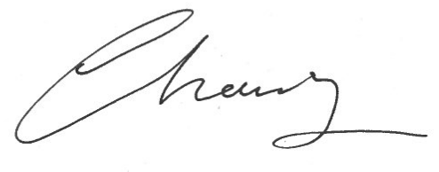

EMMA HARDY MP
Parliamentary Under Secretary of State for Environment, Food & Rural Affairs

