Lord Vallance
Minister of State for Science,
Research & Innovation
Department for Science, Innovation & Technology
100 Parliament Street
London SW1A 2BQ

www.gov.uk/dsit
22 January 2025
Dear Lord Clement-Jones,

I would like to make a correction to an answer I gave during the Oral Questions on Online Safety in the House of Lords on Thursday 16 January, recorded in Hansard Volume 842, Column 1260.
During the debate, I misspoke when I said: “Category 1, in the way that the Bill was approved, was for large sites with many users”.
Instead, I should have said “Category 1, in the way that the Bill was approved, is about easy, quick and wide dissemination of content, which is why the threshold has been set to focus on large sites with many users”.

I will also place a copy of this letter in the Libraries of the House.

Yours sincerely,
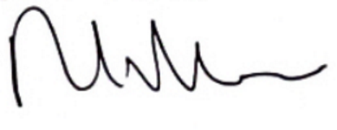

Lord Vallance
Minister of State
Department for Science, Innovation & Technology

