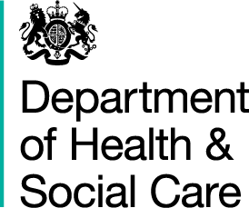

*From Andrew Gwynne MP*

*Parliamentary Under-Secretary of State for Public Health and Prevention.*

*39 Victoria Street London SW1H 0EU*

Penny Young  
Librarian  
House of Commons  
London

13 December 2024

Dear Penny,

Please see attached the letter to Ian Lavery on infected blood.

I would be grateful if you could deposit a copy in the Libraries of both Houses.

Yours sincerely,



**ANDREW GWYNNE**

***Parliamentary Under-Secretary of State for Public Health and Prevention.***