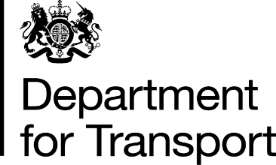 | Lord Hendy of Richmond Hill  Minister of State for Rail  Great Minster House  33 Horseferry Road  London  SW1P 4DR  Tel: 0300 330 3000  E-Mail: lord.hendy@dft.gov.uk  Web site: www.gov.uk/dft
The Lord Bishop of Manchester
House of Lords
London
SW1A 0PW

17 September 2024

Dear Lord Bishop of Manchester,

Thank you for your contribution to the Oral Statement debate held on Thursday 12 September. As promised, I am writing to address your question regarding whether Local Transport Authorities (LTAs) have the option to collaborate in jointly franchising their bus services.

Bus franchising powers for LTAs in England, outside of London, were created in the Bus Services Act 2017, which amended the Transport Act 2000.

The bus franchising guidance details the process authorities must follow to implement bus franchising in their area. It explains how the franchising legislation works in practice and highlights the statutory duties that franchising authorities and auditors must consider when carrying out their relevant functions.

I can confirm that the process permits two franchising authorities to work together to create a franchising scheme covering all or part of their respective areas or combined area.
The bus franchising guidance refers to an ‘authority’, although it is accepted that there may be more than one LTA involved in developing a franchising assessment and scheme.
I hope this answers your question, but please feel free to contact me again if you require more information.

I have copied all Noble Lords who spoke in this discussion and will place a copy of this letter in the Library of the House.

Yours sincerely,
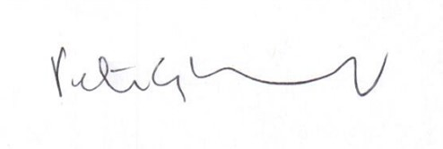
Peter, Lord Hendy of Richmond Hill

MINISTER OF STATE FOR RAIL

