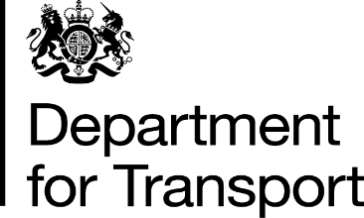 | From the Minister of State for Transport  Lord Hendy of Richmond Hill CBE  Great Minster House  33 Horseferry Road  London  SW1P 4DR  Tel: 0300 330 3000  E-Mail: Lord.Hendy_MOS@dft.gov.uk  Web site: www.gov.uk/dft
The Lord Austin
House of Lords
London
SW1A 0PW

9 September 2024

Dear Lord Austin,

Thank you for your contribution during the Oral Question debate held on Wednesday 4 September. As promised, I am writing to you regarding the diversion or replacement by buses of CrossCountry rail services between Birmingham and Leicester on 31 August, a day which was particularly busy due to football fans travelling between the two cities.

A closure of the route was needed on this weekend (Saturday 31 August – Sunday 1 September) as a follow up to the recent ten-day closure (17-26 August) between Birmingham New Street and Coleshill Parkway. Work has taken place here to upgrade 450 metres of track and to move a section of railway in preparation for HS2.

While I understand the disruption this will have caused many fans who were travelling to the game, works such as these are planned much further in advance than football fixtures. There are serious cost implications of changing the date of such works, and this closure has been planned since 2021. In exceptional circumstances, football clubs can request fixture adjustments, due to travel constraints, from the Premier League.

As there is never a good time to close the railway, Network Rail has worked closely with CrossCountry and HS2 around the summer holidays when there are typically fewer passengers travelling on the network. To ensure passengers could still travel during the closure, CrossCountry’s long-distance services were diverted on alternative lines, with regular rail replacement buses operating between Birmingham New Street and Coleshill Parkway stations.

The work, which has now been completed, will help to deliver more reliable journeys for passengers and freight services.

I hope the above is helpful, but please feel free to contact me again if you require more information.

I have copied all Noble Lords who spoke in this discussion and will place a copy of this letter in the Library of the House.

Yours sincerely,
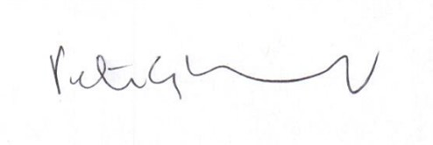
Lord Hendy of Richmond Hill

MINISTER OF STATE FOR TRANSPORT

