27 September 2024

Dear Jonathan,

Thank you for your contributions in the House on Thursday 12 September in response to the repeat statement I made regarding the Government’s decision to establish an independent inquiry into the death of Patrick Finucane. I want to thank you also for your kind words of support and encouragement as I take on this new role - they are greatly appreciated.

As promised, I wanted to provide a further response to some of the questions you raised.

You asked why the Government has decided to establish an independent inquiry, rather than referring the case to the Independent Commission for Reconciliation and Information Recovery (ICRIR), and what it is expected an inquiry will achieve. You also asked what the unique circumstances of the Finucane case are when compared to other Troubles-related cases, and whether the Government had considered the impact of this decision on other victims and survivors.

The Government has enormous sympathy for all of those killed, injured and bereaved as a result of the Troubles. It is very difficult for any of us to fully grasp the levels of pain and trauma that victims and their loved ones have experienced. There is, of course, nothing that any of us can do to bring people back or to erase the deep pain that was caused, but the Government has committed to finding a way to address the legacy of the Troubles that can both gain the support of victims and families, and meet our human rights obligations. As part of this, the Government has committed to consulting on measures to further strengthen the ICRIR, but we have full confidence in its ability to deliver for victims and families.

When it comes to this particular case, there was a long-standing commitment made two decades ago by the then-Government – first in an agreement with the Irish Government, and then to Parliament - to establish an inquiry into the death of Mr Finucane. It is for this exceptional reason that the Secretary of State made this decision.

You also asked about the Supreme Court’s decision in February 2019. We have never suggested that there is a legal obligation on the Government to hold a public inquiry. However, given the solemn commitment that was made by the Government in 2001 and again in 2004, the only appropriate way forward is to establish a public inquiry.

You then asked about the expected costs and timeframe for the Inquiry, and when the Terms of Reference will be agreed.

The Government will follow proper due process under the Inquiries Act 2005. This includes the appointment of a Chair, securing agreement with them on the Terms of Reference and other details, including funding arrangements. More information on these points will be set out in due course. As set out to Parliament, the Secretary of State agrees with the Judge in the most recent High Court proceedings, who said that an Inquiry could ‘build on the significant investigative foundations which are already in place’. The Secretary of State expects the scope of the Inquiry to reflect this and avoid unnecessary duplication - a view that he will share with the Chair, once appointed and during their discussion of the Terms of Reference.

Finally, you asked how many demands for public inquiries the Government is currently considering, about which I cannot comment.

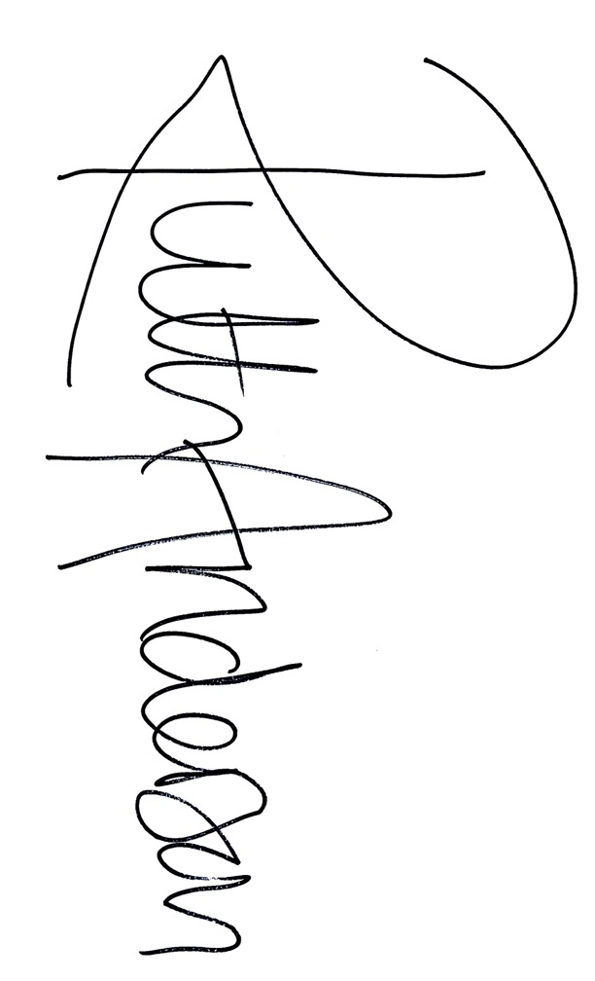

Thank you, again, for your engagement on this issue and I look forward to working with you over the months ahead.

I hope you find this letter helpful. I will also send a copy to those Peers who spoke during the repeat statement and place a copy in the House library.

**BARONESS ANDERSON OF STOKE-ON-TRENT**

Lord Caine

House of Lords