|  |  |
| --- | --- |
| Baroness Humphreys  House of Lords  London  SW1A 0PW | **Lord Khan of Burnley**  *Parliamentary Under-Secretary of State*  4th Floor, Fry Building  2 Marsham Street  London SW1P 4DF  [**www.gov.uk/mhclg**](http://www.gov.uk/mhclg) |
| 29 July 2024 |

Dear Baroness Humphreys,

Thank you for your contribution to the debate on Tuesday 23 July on The Constitution and Devolution. In the debate, you raised issues regarding several of the government’s manifesto commitments.

I would like to assure you that we are committed to resetting our relationships with the Devolved Governments, with the principles of trust, cooperation and respect.

The Government remains committed to the ambitions set out in the manifesto, including on free speech protections and new powers to Wales, and we will continue to explore options on them.

I agree that the Sewel Convention must be respected, and the government is committed to doing so. We are determined to work constructively with the devolved governments, and we will look at how we can best strengthen the Sewel Convention.

I will place a copy of this letter in the House Library.

Yours sincerely,

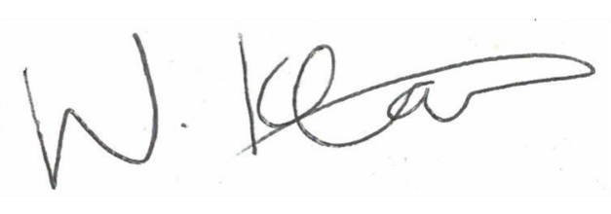

**Lord Khan of Burnley**

**Parliamentary Under-Secretary of State**