|  |  |
| --- | --- |
| Earl of Kinnoull  House of Lords  London  SW1A 0PW | **Lord Khan of Burnley**  *Parliamentary Under-Secretary of State*  4th Floor, Fry Building  2 Marsham Street  London SW1P 4DF  [**www.gov.uk/mhclg**](http://www.gov.uk/mhclg) |
|  |

29 July 2024

Dear Earl of Kinnoull

Thank you for your contribution to the debate on Tuesday 23 July on The Constitution and Devolution. In the debate, you raised issues regarding structures of Intergovernmental Relations and the location of responsibility for constitution and devolution in government.

I would like to assure you that we are committed to resetting our relationships with the Devolved Governments, with the principles of trust, cooperation and respect.

The Government will work with the devolved governments to make sure we use the structures of intergovernmental working to improve collaboration on policy. We are open to looking at and learning from international comparisons.

Machinery of Government changes are, of course, a matter for the Prime Minister.

I will place a copy of this letter in the House Library.

Yours sincerely,

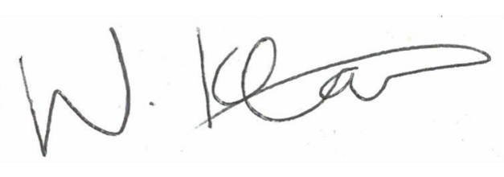

**Lord Khan of Burnley**

**Parliamentary Under-Secretary of State**