|  |  |
| --- | --- |
| Lord Offord of Garvel  House of Lords  London  SW1A 0PW | **Lord Khan of Burnley**  *Parliamentary Under-Secretary of State*  4th Floor, Fry Building  2 Marsham Street  London SW1P 4DF  [**www.gov.uk/mhclg**](http://www.gov.uk/mhclg) |
|  |

29 July 2024

Dear Lord Offord,

Thank you for your contribution to the debate on Tuesday 23 July on The Constitution and Devolution. In the debate, you raised issues regarding the 25th Anniversary of devolution in Scotland, Wales and Northern Ireland, and structural funding.

I recognise your important contribution to the previous government’s work to strengthen the constitutional settlement in Scotland in your role as Parliamentary Under-Secretary of State in the Office of the Secretary of State for Scotland over the past few years, and I look forward to you contributing further.

I would like to assure you that we are committed to resetting our relationships with the Devolved Governments, with the principles of trust, cooperation and respect.

In this 25th anniversary year of devolution to Scotland, Wales and Northern Ireland, we commit to working with the devolved governments to deliver on the priorities of people across the whole United Kingdom, in the next 25 years and beyond.

I will place a copy of this letter in the House Library.

Yours sincerely,

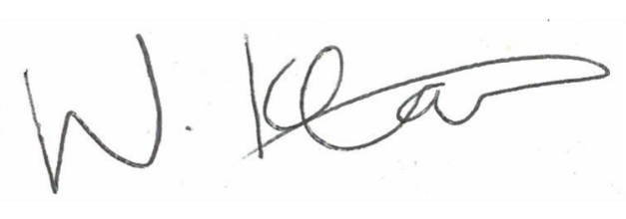

**Lord Khan of Burnley**

**Parliamentary Under-Secretary of State**