3 June 2024

Dear Baroness Berridge

During questions on Thursday 2 May, you asked about the use of powers to accommodate asylum seekers under 18.

The Illegal Migration Act 2023 (IMA) confers a power on the Secretary of State to provide accommodation, and other appropriate support, for unaccompanied children who meet the four conditions in section 2 of the IMA. This power has not been commenced. Following the High Court judgment of [2023] EWHC 1953 (Admin), commencement of the full powers in sections 16 to 20 of the IMA (accommodation and transfer of unaccompanied children) will be kept under review by the Secretary of State.

As these powers have not been commenced, the Home Office does not believe any asylum seekers under 18 have gone missing.

I hope you find this letter helpful. I will also send a copy to those Peers who spoke to the question and place a copy in the House Library.

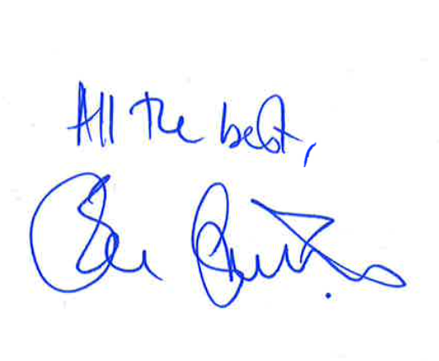

LORD GASCOIGNE

Baroness Berridge
House of Lords

