**Rt Hon Sir Lindsay Hoyle MP**

**House of Commons**

21 February 2024

Dear Mr Speaker,

In January 2020, you wrote to my predecessor establishing a procedure by which he could record his views regarding any of your decisions which he felt comprised a substantial breach of the Standing Orders or a departure from long-established conventions. You asked him to place in the Library a note of any such view and you undertook to make the House aware if he did so.

I am today exercising the opportunity to place on record my view that the decision to allow an Official Opposition spokesperson to speak and to move an amendment before a Government minister in response to an SNP spokesperson moving their Opposition day motion represents a departure from the long-established convention for dealing with such amendments on Opposition days, governed by Standing Order No. 31. Where an orderly Government amendment to leave out some words of the motion and insert others is tabled and selected, the expectation is that such an amendment is then moved by the minister in the second speech of the debate and, once the amendment has been moved, the Standing Order provides that the first question considered by the House at the end of the debate must be on the text of the original motion. If that is negatived, the question is put on the Government’s amendment. When introducing the proposal in 1979 the Leader of the House said  the arrangements were “so that a vote could take place on the Opposition’s own motion” (Hansard 31 October 1979 vol 972 [c1278](https://hansard.parliament.uk/commons/1979-10-31/debates/4cf0ba72-2e2e-4d27-8a14-8416edba1307/CommonsChamber#contribution-450b3290-5eee-4370-a6ff-d0b7f6a99c50)). The procedural impact of the decision taken today is that the first division is likely to be on the Official Opposition’s amendment rather than on the SNP’s motion; and, depending on the outcome of any such division, it is possible that the House will not be able to vote on the SNP motion (nor on the Government’s alternative proposition).

In taking this step, I recognise that:

1. Your decision is not specifically precluded by any Standing Order;
2. The Speaker and his Deputies have complete discretion regarding the order in which to call Members to speak;
3. The Speaker has discretion over which amendments to select;
4. There have been two occasions in the last 25 years or so when an amendment has been moved by an opposition party Member from a party other than the one to which the day had been allotted (as well as one when a government backbencher moved an amendment) and on one of those occasions, the Official Opposition Member was called to move his amendment before a minister was called – however, in those few circumstances, no Government amendment had been tabled; and
5. You have been motivated by giving the House what you considered to be the widest choice of decisions on alternative propositions, on a subject of immense importance, on which people in and outside the House have the strongest of views.

Nevertheless, I know that you understand why I feel compelled to point out that long-established conventions are not being followed in this case. I am grateful to you for making every effort to discuss this with me extensively and for taking full account of my views when reaching your decision, which I know was not an easy one, and which of course is one for you to make.

Yours sincerely,

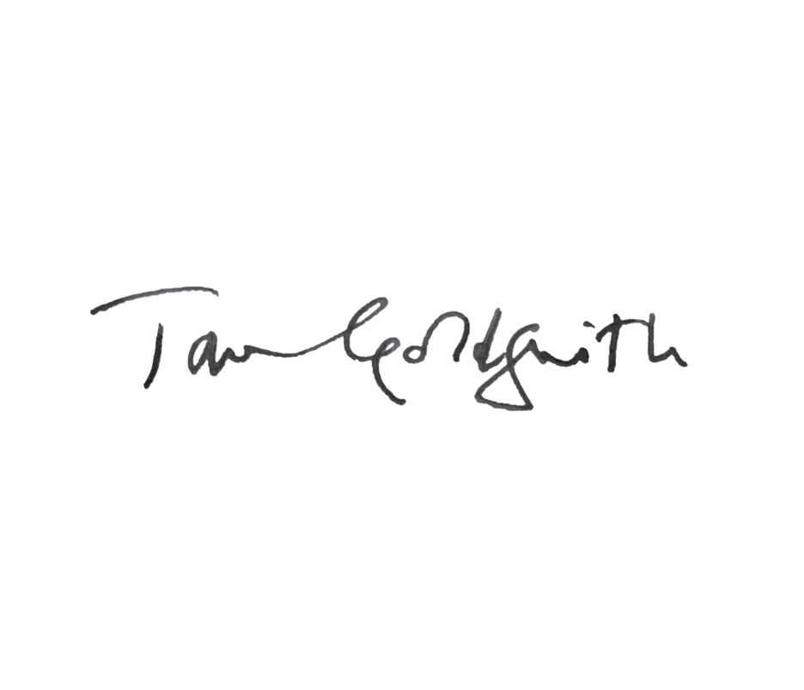

**Tom Goldsmith**

**Clerk of the House**