Impact and Process Evaluation of the Electoral Integrity Programme
Evaluation Plan Year 1

Contents
Introduction 2
Research Questions 3
Evaluation Design 7
Evidence and Data Sources 8

Introduction
In December 2022, the Government committed to appoint an external research agency to synthesise the findings from various strands of research and analyses being conducted to evaluate measures in the Elections Act 2022, to report their findings and to publish a first report in November 2023. In May 2023, IFF Research was appointed to conduct a process and impact evaluation of the Electoral Integrity Programme (EIP) measures and to report on their findings.
The Elections Act 2022 requires the implementation of the voter identification policy to be evaluated at the first stand-alone set of local council elections at which it is introduced and the following two UK parliamentary elections. The evaluation, however, will go beyond what is required in legislation and evaluate the impact and implementation of the Elections Act.
This document sets out the plan for the first year of the evaluation. It covers the introduction at the English local elections held in May 2023 of the requirement for voters to show photo identification in polling stations, and the introduction of accessibility measures – new requirements relating to accessibility for people with a disability, when voting in polling stations in England and Northern Ireland.
The Electoral Integrity Programme (EIP) is delivering a number of manifesto and other Ministerial commitments, as part of the Government’s electoral reform agenda. The programme goals are to strengthen the integrity of the electoral system and ensure that elections remain secure, fair, modern and transparent.
The legal framework for these commitments has been set through the Elections Act, which received Royal Assent in April 2022. The provisions in the Elections Act 2022 will be implemented through a wide-ranging programme of secondary legislation, which is already well underway, with the intention that all of the following electoral measures will be in force before the end of this parliament:
- The introduction of voter identification requirements to show an accepted form of photographic identification at polling stations at UK Parliamentary Elections, Police and Crime Commissioner elections in England and Wales, and at local elections and referendums in England, supported by a free of charge service providing all electors with another form of accepted identification upon request - a Voter Authority Certificate (VAC) - to use when attending a polling station.
- Changes to postal and proxy votes will apply at UK Parliamentary Elections in Great Britain, Police and Crime Commissioner elections in England and Wales, and at local elections and referendums in England. These include changes to the duration of postal voting arrangements (setting a maximum length of three years), the handling and secrecy of postal votes, limiting the number of electors for whom someone can be appointed to act for as a proxy up to a maximum of four electors, the introduction of an identity checking process for absent voting applications, and a new online service for absent vote applications. The proxy voting measure and the handling and secrecy of postal votes measure will also apply to UK Parliamentary elections in Northern Ireland, local elections in Northern Ireland, and elections for the Northern Ireland Assembly (though noting that postal votes cannot be handed in at polling stations and can only be returned to the Returning Officer in Northern Ireland).
- Changes to allow all British Citizens living abroad who have been previously registered or resident in the UK the right to vote in UK Parliamentary elections, beyond the previous fifteen-year limit. In addition, following the UK’s departure from the European Union, the introduction of new eligibility rules for EU citizens voting and standing in local elections in England, Police and Crime Commissioner elections in England and Wales, local elections in Northern Ireland and elections to the Northern Ireland Assembly.
- New requirements relating to the accessibility of voting at polling stations during local elections in England and Northern Ireland, elections for the Northern Ireland Assembly, Police and Crime Commissioner elections in England and Wales, and UK Parliamentary elections. This broadens the requirement for Returning Officers to provide support for people with a wide range of disabilities to vote in the polling station and removes restrictions on who can act as a companion to assist disabled voters, giving a disabled voter the choice of anyone over 18 years of age to assist them.
- Changes to electoral campaigning rules (referred to as Campaigning Measures), namely:
  - To improve the accountability of the Electoral Commission to the UK Parliament, four related measures were introduced – the power for the Secretary of State for Levelling Up, Housing and Communities to designate a Strategy and Policy Statement for the Electoral Commission, changes to the powers and membership of the Speaker’s Committee on the Electoral Commission and changes to the Commission’s powers to remove the potential for the Electoral Commission to bring criminal prosecutions in England, Wales and Northern Ireland.
  - To improve transparency of digital campaigning, a new digital imprint regime was introduced. It requires anyone paying for digital political material to be advertised to explicitly show who they are, and on whose behalf, they are promoting the material. Certain campaigners are also required to include an imprint on their other electronic material.
  - Election Act measures relating to political finance improve transparency and controls against foreign spending by:
    - Introducing a lower registration threshold for third-party campaigners spending more than £10,000 during the regulated period before an election;
    - Restricting all third-party campaigning spending at elections over £700 to UK-based (or otherwise eligible) campaigners;
    - Prohibiting groups from registering on both the political party register and third-party register (dual registration) and so potentially bypassing existing spending limits;
    - Improving transparency in political party finance through a new requirement to produce an assets and liabilities declaration for new political parties registration.
  - The offence of undue influence is designed to ensure that voting choices are made freely. The offence has been updated with modern terminology to provide greater clarity to the police and prosecutors so that intimidatory behaviour can be dealt with properly.
  - The intimidation sanction is designed to protect individuals who participate in public life from intimidation. It bans individuals from standing in an election for 5 years where the individual is convicted of an intimidatory offence.

The Elections Act 2022 requires the implementation of the voter identification policy to be evaluated at the first stand-alone set of local council elections at which it is introduced and the following two UK parliamentary elections. The evaluation, however, will be go beyond what is required in legislation and evaluate the impact and implementation of the Elections Act.

Research Questions
The evaluation includes both a process and impact evaluation. The process component will gather evidence on implementation to describe the activities and processes that were undertaken to deliver the voter identification and accessibility measures, and the ways in which they were delivered by electoral services teams in local authorities (LAs) and polling station staff. The aim is to identify lessons and draw out any barriers or facilitators from the implementation of the measures in the May 2023 local elections that can inform their delivery at the next UK parliamentary election. The objective of the impact evaluation is to assess the effectiveness of voter identification and accessibility in relation to the programme’s goals, and to understand their impact on both electors and the electoral sector, including Electoral Register Officers, Returning Officers and staff in electoral services teams and working in polling stations.
IFF Research have worked with DLUHC to develop the following research questions for the voter identification and accessibility measures that cover both the implementation (process) and impact of these measures.
Voter Identification Process Research Questions
Overarching process
- Were all aspects of the voter identification measure delivered as set out in the Elections Act 2022 legislation?
- How did LAs approach the implementation of the voter identification and VAC measures?
- What barriers or challenges did LAs face in implementing voter identification and VAC measures?
- What enablers helped LAs to implement voter identification and VAC measures?
- How, and to who, have LAs communicated voter identification and VAC to the electorate?
- What has been learnt so far from implementing the voter identification and VAC measures for May 2023 local elections?
- What are the next steps for LAs in implementing voter identification and VAC at the next UK Parliamentary General Election?
- To what extent do electoral services staff in LAs feel confident in delivering the voter identification and VAC measures?

Voter Identification process in polling stations
- What challenges did polling station staff face in implementing the voter identification measure?
- What enablers helped polling station staff to implement the voter identification measure?
- To what extent do polling station staff feel confident in delivering the new process?
- What training was provided to polling station staff on voter identification?

VAC specific process questions
- What training was provided to electoral services teams on VAC?
- How well did the new online service and digital process for processing VACs work?

Voter Identification Impact Research Questions
Impacts on the Electoral Sector
- How have the voter identification and VAC measures affected the work of electoral services teams?
- How have the voter identification and VAC measures affected the work of polling station staff?
- To what extent has the introduction of the voter identification measure affected trust and confidence in the security of elections among staff running registration and elections?
- What impact has the implementation of the voter identification and VAC measures had on the cost of registration and elections?

Impacts on Electors
- Are electors aware of the changes?
- To what extent does the VAC remove any potential barriers to voting for electors who do not have accepted photo identification?
- To what extent do the newly available provisions in polling stations remove any potential barriers to voting for electors who do not wish to have their identification checked in public?
- To what extent has the voter identification measure affected the voting experience in polling stations for electors?
- To what extent has the voter identification measure affected electors’ preferred method of voting and propensity to vote?
- To what extent has the voter identification measure affected electors' trust and confidence in the security of elections?
- To what extent has the voter identification measure affected electors’ satisfaction with voting in polling stations?

Impacts on Electoral Fraud
- To what extent has the voter identification measure made it easier to detect cases of personation in polling stations?
- To what extent has the voter identification measure deterred attempts at electoral fraud in polling stations?
- To what extent has the voter identification measure impacted opportunities for electoral fraud arising in any part of the system?
- Did the implementation of the voter identification measure at the May 2023 local elections have any unintended outcomes?

Accessibility Process Research Questions
- How did LAs approach the implementation of the accessibility measures?
- What barriers or challenges did LAs face in implementing the accessibility measures?
- What enablers helped LAs to implement the accessibility measures?
- What training was provided to polling station staff on the accessibility measures?
- To what extent have LAs been able to provide the accessibility equipment and support in line with the Electoral Commission’s guidance?
- How and to who have LAs communicated the accessibility changes?
- What has been learnt so far from implementing the accessibility measures at local elections?
- What are the next steps for LAs in implementing the accessibility measures at the next UK Parliamentary General Election?

Accessibility Impact Research Questions
Impacts on Electors with a Disability
- Are people with accessibility needs, their carers and disability Civil Society Organisations aware of the changes and how they affect disabled voters?
- To what extent do the changes remove barriers to voting in person at a polling station for electors with disabilities?
- To what extent have the changes affected the voting experience of voters with disabilities?
- To what extent have the changes affected the voting behaviour of electors with disabilities, both in terms of method of voting and propensity to vote?
- To what extent do the changes impact perceptions on the accessibility of elections among disabled electors?
- To what extent do the changes impact disabled electors’ confidence in the process and accuracy of voting in person?
- To what extent do the changes impact disabled electors’ satisfaction in the process of voting in person?

Impacts on Electoral Sector
- How have the changes affected the work of elections staff in LAs?
- What impact has the implementation of the accessibility measures has on elections costs?
- How have the accessibility measures affected the work of polling station staff?
- Did the implementation of the accessibility measures at the May 2023 local elections have any unintended outcomes?

Evaluation Design
The evaluation will adopt a theory-based approach drawing on theory of change (ToC) models and contribution analysis. ToC models set out how each of the voter identification and accessibility measures is expected to effect change in the short, medium and long term by mapping the expected inputs, activities, outputs, outcomes and impacts for each. The models for the voter identification and accessibility measures were initially drafted by DLUHC and further developed by IFF Research.
Contribution analysis will be used to explain and test the validity of the ToC models. A series of contribution claims will be developed to articulate how each measure leads to change, while recognising the importance of other influencing factors. The contribution claims are simply subsets of the ToC model that isolate the relevant inputs, activities, and outputs related to specific outcomes and impacts.
The contribution analysis will draw on a range of evidence from different strands of research and analyses that are being conducted as part of the evaluation. These are summarised in the section on Evidence and Data Sources. Figure 1 below provides a visual illustration of the evaluation design. It shows how the different strands of research and analyses feed into the overarching theory-based evaluation led by IFF Research. IFF Research’s synthesis and reporting of the evidence is structured around the ToC models, contribution claims and research questions, as described above.
Figure 1: Evaluation Overview

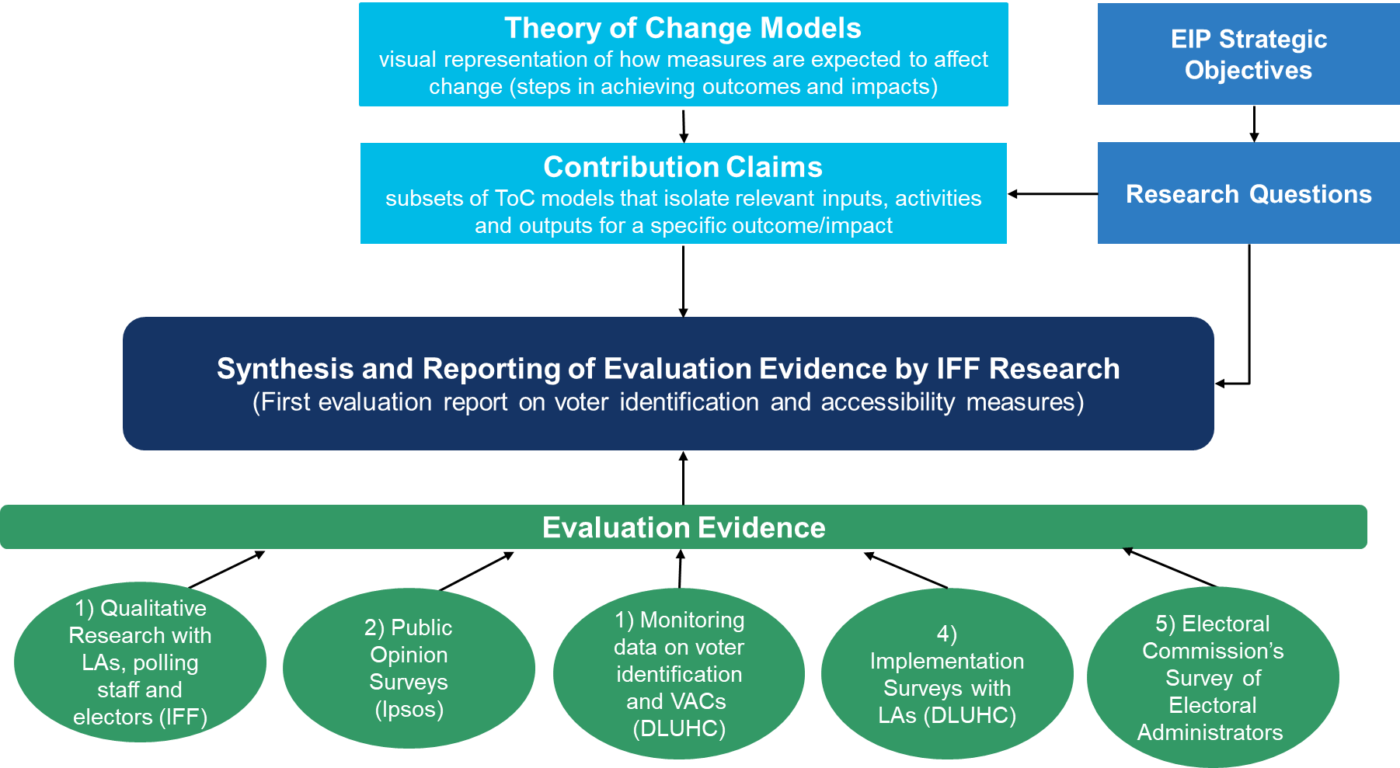

The following sets out the steps that will be followed for the contribution analysis.
Scoping and ToC development (Stages 1 and 2)
In the initial stages, the ToC models are reviewed and a set of contribution claims for each measure is developed.
Collect available evidence (Stage 3)
In stage three, the evaluation evidence (see Evidence and data sources) is synthesised and analysed against the contribution claims. Verifying the assumptions in the contribution claims against the available evidence forms the basis of the contribution analysis.
Contribution workshop (Stage 4)
The contribution claims and evidence are assembled and validated at a contribution workshop. Each claim is critically assessed to identify whether links between inputs and activities to outputs, outcomes and impacts are strong or weak, and for its overall credibility.
Seek additional evidence (Stage 5)
Following the contribution workshop, areas of strengths and weaknesses in the ToC models, and any contradictory evidence, are identified. Areas where the evidence base is weak are further tested in qualitative research with electors and the electoral sector, where possible.
Synthesis (Stage 6)
Finally, all the evaluation evidence is fully mapped against the contribution claims into a coherent set of findings. This is an iterative process; the claims may be adjusted, along with the ToC models, to take account of all available evidence.

Evidence and Data Sources
The evaluation will bring together data from a range of qualitative and quantitative research and analyses, carried out by DLUHC, the Electoral Commission, Ipsos MORI, and IFF Research.
The sources of evidence for the evaluation are as follows:
- Qualitative research (IFF Research). IFF is undertaking qualitative research on the impact and implementation of the voter identification and accessibility measures with electoral teams in LAs, polling station staff and key groups of electors. Sixteen LAs have been selected as case studies across the eight regions outside London that held local elections in May 2023. Within each case study LA, depth interviews will be conducted with staff responsible for delivering elections including Electoral Registration Officers and Returning Officers and Electoral Services Managers. Additionally, depth interviews and focus groups will be carried out with polling station staff and electors in eight of the sixteen LAs.
- Public opinion surveys (Ipsos MORI). Ipsos MORI are conducting three waves of a public opinion survey, before and after the local elections in May 2023, and after the next UK Parliamentary Election. The survey is nationally representative and includes samples in England, Scotland, Wales and Northern Ireland. It collects data on public perceptions of voter identification and accessibility measures, attitudes to voting, trust and satisfaction with the electoral system, and ease of voting.
- Monitoring data on voters turned away at polling stations and Voter Authority Certificates (DLUHC) will be analysed by DLUHC. This includes data collected by poll clerks in polling stations on the number of voters turned away from polling stations at local elections in May 2023 because they did not have accepted photo identification, and of those, the number who later returned to vote. It also includes analyses of applications for VACs and the number of VACs issued.
- Implementation Surveys with LAs (DLUHC): Data on local authorities’ implementation of voter identification and accessibility measures ahead of the May 2023 local elections was collected via regular online surveys administered by DLUHC and completed by Electoral Registration Officers and Electoral Administrators.
- Electoral Commission’s Survey of Electoral Administrators (Electoral Commission): Data on local authorities’ delivery of the voter identification and the accessibility measures was collected by the Electoral Commission via a post-election online survey of Electoral Administrators in LAs that held local elections in May 2023
© Crown copyright, 2023
Copyright in the typographical arrangement rests with the Crown.
You may re-use this information (not including logos) free of charge in any format or medium, under the terms of the Open Government Licence. To view this licence visit http://www.nationalarchives.gov.uk/doc/open-government-licence/version/3/
This document/publication is also available on our website at www.gov.uk/dluhc
If you have any enquiries regarding this document/publication, complete the form at http://forms.communities.gov.uk/ or write to us at:
Department for Levelling Up, Housing and Communities
Fry Building
2 Marsham Street
London
SW1P 4DF
Telephone: 030 3444 0000
For all our latest news and updates follow us on Twitter: https://twitter.com/luhc
September 2023

