Hansard Editors  House Of Lords  Houses Of Parliament  London  SW1A 0AA | Our reference: MC2023/08538

14 July 2023

Dear Hansard Editors,

I would like to make a correction to an answer I gave during the Women and Equalities Oral Parliamentary Questions on Wednesday 12th July, recorded in Hansard Volume 736.

During the debate, I misspoke when I said “I reassure the hon. Lady that work is going on in that space. My ministerial colleagues from the Department for Work and Pensions are looking at this, and will be updating the House shortly.”. This was an accidental error.

Instead, I should have said “I reassure the hon. Lady that work is going on in that space. My ministerial colleagues from the Department for Food, Environment and Rural Affairs are looking into this”.

I am copying this letter to Margaret Ferrier M.P., I have requested that a copy of this letter be deposited in the Libraries of the Houses of Parliament.

Kind regards,

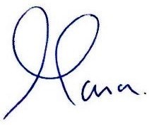

MARIA CAULFIELD MP

