|  |  |
| --- | --- |
| Image result for northern ireland office | **Parliamentary Under-Secretary of State**  **for Northern Ireland**  1 Horse Guards Road  London  SW1A 2HQ  Erskine House  20-32 Chichester St Belfast  BT1 4GF  E: correspondence@nio.gov.uk  www.gov.uk/nio  Follow us on Twitter @NIOgov |

Deposited Papers Clerks

House of Commons Library

Deposited Papers Clerks

House of Lords Library

18 April 2023

Dear Clerks,

During the Lords Committee Stage of the Northern Ireland Troubles (Legacy and Reconciliation) Bill, I indicated that as a means of providing greater transparency I would set out more information on how we expect the appointments process for the various Commissioner appointments for the Independent Commission for Reconciliation and Information Recovery (“the ICRIR”) to take place.

The attached documents set out further detail on the establishment of the ICRIR including the criteria and the process for selecting the ICRIR Commissioners. I would be grateful if you could place the attached documents in the Libraries of both Houses.

Yours sincerely,

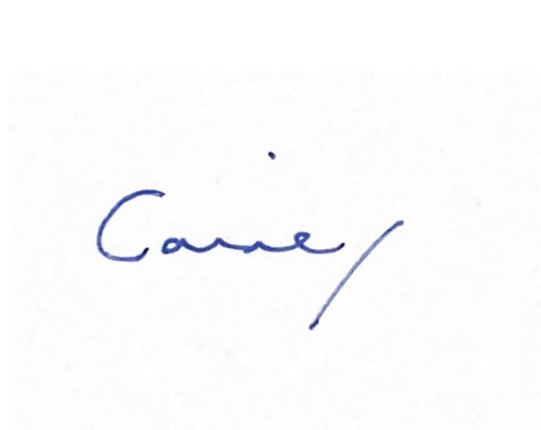

**LORD CAINE**

**PARLIAMENTARY UNDER-SECRETARY OF STATE**

**FOR NORTHERN IRELAND**