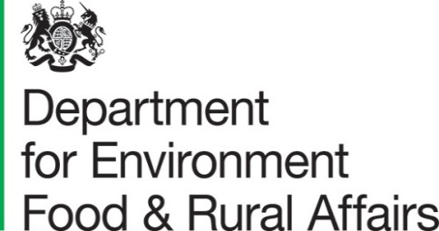

The Rt Hon the Lord Goldsmith of Richmond Park
Minister of State
To: All Peers | 25 June 2021

My Lords,

Day 2 of Committee Stage for the Environment Bill

I am very grateful to noble Peers for all their contributions during the second day of Committee Stage for the Environment Bill on 23 June. This letter responds to points that I could not address during the debate due to time restraints.

Targets and devolution

I would like to address, in particular, queries raised by the noble Lord Wigley, the noble Baroness Jones of Whitchurch and the noble and learned Lord Hope of Craighead regarding the Devolved Administrations and the target-setting powers set out in the Bill. The environment is a devolved matter, except for a small number of reserved areas.

The value of devolution is that it allows for policies to be developed and implemented in ways that are tailored to each nation’s needs or circumstances. Where measures in the Bill are England only, this reflects the outcome of our discussions with the Devolved Administrations and their view that there is value in them taking their own approach. This is the case with the provisions on target setting.

I would like to clarify the difference of approach taken regarding the Devolved Administrations in respect of the extent of the target-setting powers under the Bill. Extent refers to the legal jurisdiction where the provision forms part of the law. Scotland and Northern Ireland each form a separate jurisdiction, whereas England and Wales form one, indivisible, jurisdiction. It is therefore not possible to provide that a provision extends only to “England” or “Wales”. For this reason, clause 138 provides that the targets provisions extend to “England and Wales”.
As such, the position with regards to Wales is dealt with through application provisions, rather than extent provisions. As a result, the Bill’s targets framework applies to England only.
In the case of targets, clause 1(9) prevents the Secretary of State from making any provision in any targets regulations which would be within the legislative competence of Senedd Cymru. When setting any target in regulations, the Secretary of State will need to consider, and explain in the Explanatory Memorandum, the extent and application of the regulations.
We value our discussions with the Devolved Administrations on environmental matters and will continue to share our ambitions and goals with them, including in the context of setting environmental targets under the Bill’s framework. We are committed to working closely with Devolved Administrations regarding any transboundary impacts of our provisions, as evidenced by the meetings of UK Administrations that are held to support liaison over water quality.

Chalk streams

I am also grateful for the noble Lord, Lord Chidgey’s invaluable comments on chalk streams and I wish to assure him that the Environment Agency (EA) is developing long term plans to reduce our reliance on them. The EA has already made changes to 124 licences to protect chalk streams from unsustainable abstraction, returning over 37 billion litres of water per year to chalk streams, and preventing a further 100 billion litres per year being abstracted.

The EA has established the Chalk Stream Restoration Group, with a range of stakeholders including Defra, to develop a restoration strategy for chalk streams. A first draft of this strategy and its recommendations will be presented to Government this year. Minister Pow co-hosted a conference at the end of last year, bringing together key partners whose actions are needed to restore our precious chalk streams.

In support of the Chalk Stream Restoration Strategy, Minister Pow has written to water companies to ask for nominations in their supply area for flagship chalk stream catchment restoration projects. The flagship chalk stream catchment restoration projects will act as exemplars of best practice approaches to chalk stream restoration and the achievement of good ecological status. This will be achieved through a holistic, multi-stakeholder approach to delivering sustainable abstraction, habitat restoration and the reduction of point source and diffuse pollution.

I hope noble Peers find these responses to be useful. I am copying this letter to all Peers who took part in Wednesday’s debate and I am arranging for copies to be placed in the Libraries of both Houses.

Yours sincerely,

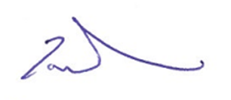

THE RT HON THE LORD GOLDSMITH OF RICHMOND PARK

