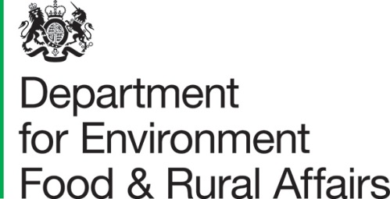 | Lord Gardiner of Kimble  Parliamentary Under Secretary of State for Rural Affairs and Biosecurity
 | Seacole Building  2 Marsham Street London SW1P 4DF | T 03459 335577  defra.helpline@defra.gov.uk  www.gov.uk/defra

Dear Anne,

Baroness McIntosh of Pickering  House of Lords  London  SW1A 0PW | 6 October 2020
I am writing to answer a question you raised on the first day of the Report stage debate on the Agriculture Bill. You asked whether the registration of common land would be complete before the pilots are finished and the new Environmental Land Management (ELM) scheme comes into effect.

The deadline for the registration of Common Land in seven English local authority areas was set by the 2014 Commons Regulations as the 31st December 2020. At present the government has no plans to change this deadline and we expect the registration process to be complete in advance of ELM coming into effect.

The Government recognises that common land frequently provides some of the richest opportunities for the provision of environmental public goods. To support the development of the ELM scheme, we are working with a diverse group of stakeholders to undertake a number of tests and trials across a range of geographies and sectors. We will ensure that we work with those who farm or manage common land throughout this process. As part of the planned 3-year pilot of ELM we will ensure that Commoners are able to participate in ELM and fulfil the Government’s ambition to ‘provide public money for public goods.’

Ongoing consultation with stakeholders is taking place in a variety of ways. In the next year, Defra officials are planning to meet with the National Common Land Stakeholder Group and in the summer will hold a deep dive event with commons stakeholders. Through this engagement, we will ensure that Commoners are able to realise the benefits of ELM.

Turning to the points you made on the second day of the Report debate, Lady Bloomfield said she would write to you about the Farming Recovery Fund.

We recognise that many communities, including farmers, were affected by the wet weather conditions during the autumn and winter of 2019/20, with high rainfall falling on already saturated land. The Farming Recovery Fund established under section 98 of the Natural Environment and Rural Communities Act, provided support to farmers for uninsurable losses when there was exceptional flooding of their agricultural land.

We have opened the Farming Recovery Fund 3 times across 2019 and 2020, starting with the flash flooding in Yorkshire Dales in July 2019. We received 310 applications by the closing date for the final round of 1st September 2020 and have approved 193 applications with a value of £1.23m with a further 59 being appraised, at a value of £884,000. Across the whole scheme the average payment is currently around £6,411 per application.

For each iteration of the Farming Recovery Fund we review the evidence and ensure the available funding is focused where it is most needed, setting eligibility conditions accordingly. The Fund only targets areas where there is unexpected or exceptional flooding and as a result a ‘natural disaster’ has been declared.

Future flood policy

We believe that farmers have an important role to play in being aware of the risks they face, improving both their own flood resilience and supporting others by providing and supporting flood risk mitigation measures.

For this reason, we are considering how the future Environmental Land Management scheme, which is the cornerstone of our new agricultural policy and founded on the principle of ‘public money for public goods’, might help support and incentivise the delivery of actions that provide protection from, and mitigation of, environmental hazards, including flooding. A copy of this letter will be placed in the House Library.

