7 July 2020

Dear Lord Sheikh,

During the Oral Question on Diversity in the Armed Forces on 17 June 2020, you asked for an update on the proposal that Chaplains of all religions should be made full-time officers.

I would like to reassure the Noble Lord that the establishment of Chaplains from the world faiths (Buddhist, Hindu, Jewish, Muslim and Sikh) was carefully crafted to meet the needs of the military personnel, and that this matter has been considered and reflected on in a profound manner.

There are a number of distinct benefits of Chaplains holding Reserve officer roles, not least that they can attend to the needs of Service personnel without having to deploy for protracted periods of time as may be required of a Regular. This would avoid depriving large numbers of personnel from suitable spiritual support if not deployed alongside a Chaplain.

I would also note that the majority can best be served through the provision of a Reserves Chaplain who is readily available to the wider religious community outwith the Armed Forces, and that by enabling Chaplains to remain in their local unit they can better meet the needs of their community. Furthermore, the relatively small numbers of Sikhs and Muslims serving in the Armed Forces mean that there are insufficient career progression opportunities to warrant having a Regular service option for Sikh and Muslim chaplains.

Detailed discussions involving the Muslim Council of Great Britain and with Lord Singh of Wimbledon from the Sikh Council were held, respectively, in January and February 2020, at which it was agreed that Reservist Muslim and Sikh Chaplains were best able to look after the spiritual needs of the Muslims and Sikhs, both in the Regular and Reserve Armed Forces.

I do hope that this response reassures you that careful attention has been and continues to be paid to this issue.

I am placing a copy of this letter in the Library of the House.

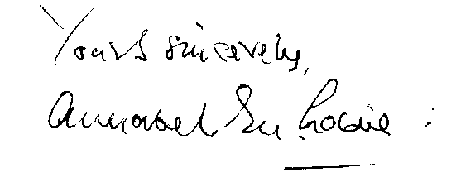

BARONESS GOLDIE DL

