|  |  |
| --- | --- |
|  | **Rt Hon Christopher Pincher MP**  Minister of State for Housing  ***Ministry of Housing, Communities & Local Government***  Fry Building  2 Marsham Street  London  SW1P 4DF |
| Deposited Papers Clerk  The Library  Houses of Parliament  London  SW1A 0AA | Tel: 0303 444 0000    www.gov.uk/mhclg    07 July 2020 |

Dear Clerk,

I am writing to the House to inform you that I wish to deposit the enclosed guidance document ‘Extension of certain planning permissions: Draft guidance’ in the library of both Houses. This relates to the Business and Planning Bill and the measure on extending certain planning permissions.

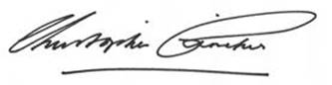

**RT HON CHRISTOPHER PINCHER MP**