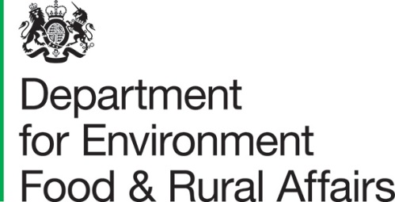 | Lord Gardiner of Kimble  Parliamentary Under Secretary of State for Rural Affairs and Biosecurity
 | Seacole Building  2 Marsham Street London SW1P 4DF | T 03459 335577  defra.helpline@defra.gov.uk  www.gov.uk/defra

My Lords,
House of Lords  London  SW1A 0AA | 30 June 2020
Agriculture Bill
The Agriculture Bill 2019-2020 was introduced to Parliament on 16 January 2020 and was passed by the House of Commons on 13 May. It was subsequently introduced to the House of Lords on 18 May and had its Second Reading on 10 July.
The Bill has been well-received by stakeholders and parliamentarians, with strong support for the core policy proposition of departing from the Common Agricultural Policy and moving towards a system of public money for public goods.
New government amendments requested by the Devolved Administrations for them to recommend legislative consent
The Government has included legislation for the approval of Clause 32 (Identification and traceability of animals) and Clause 37 (Organic Products), by Ministers from the devolved administrations, when the Secretary of State makes UK-wide secondary legislation. This is at the request of the devolved administrations.
Part 6 of the Agriculture Bill contains powers reserved to the UK Government which allow the Secretary of State to make regulations for securing compliance by the UK with its obligations under the WTO Agreement on Agriculture. It contains two clauses – 42(4) and 42(5) – requiring devolved authorities to provide information that would affect their executive competence. The Government has had several discussions with the devolved administrations about the operation of these clauses.
The Scottish and Welsh Governments believe themselves to be under an obligation via existing legislation and that these clauses are unnecessary. Defra reached agreement with the Welsh Government in March 2019 on a bilateral agreement on WTO provisions within the Agriculture Bill. Ministers in the Northern Ireland Executive recommended that consent be granted by the Northern Ireland Assembly for the Agriculture Bill, including the requirement to provide information. Defra has secured further assurances from Scottish Government ministers on their commitment to provide this information under the Scottish Ministerial Code and the Scotland Act. The UK Government is therefore content with the assurances made that these clauses are not required in law and has reached agreement with the devolved administrations to remove them from the Bill. It is our intention to enshrine this commitment in a concordat to be developed between the UK Government and all the devolved administrations, which will sit alongside the regulations made under Part 6.
Technical changes to commencement provisions
The Government is also making technical amendments to the commencement provisions of the Bill (Clause 53) due to the inevitable delays to its progress this year. This is to ensure that we have time to make the statutory instruments under the affirmative procedure needed for the start of 2021.
I hope noble Lords find this information helpful. I am copying this letter to all noble Lords and I shall be placing copies of this letter in the Libraries of both Houses.

