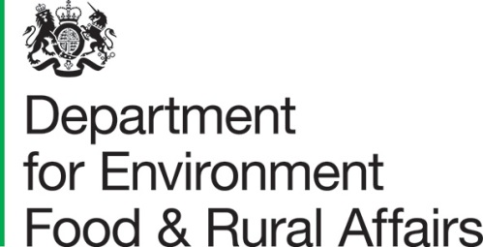 | Lord Gardiner of Kimble  Parliamentary Under Secretary of State for Rural Affairs and Biosecurity
 | Seacole Building  2 Marsham Street London SW1P 4DF | T 03459 335577  defra.helpline@defra.gov.uk  www.gov.uk/defra

Dear Lord Bishop,

The Lord Bishop of St Albans  House of Lords  London  SW1A 0PW | 5 May 2020
I am following up on the points that you raised in your question on dairy prices on Tuesday 28th April

Dairy farmers are crucial in ensuring that food supplies remain resilient in this difficult period. While prices for most dairy farmers are largely unaffected, some have been impacted by the closure of the food service sector as a result of Covid-19. Defra is working closely with the NFU, the AHDB and Dairy UK to support farmers during this period of disruption.

The vast majority of Britain’s dairy farmers continue to supply their contracts at the usual price. Between 5 and 10 per cent of total milk production goes to the food service trade which has been severely impacted by the lockdown restrictions. Farmers supplying milk to processors that sell into the food service sector have seen a significant reduction in demand and we have taken several steps to support those affected.

The government initially relaxed, temporarily, competition rules to allow retailers, suppliers and logistic services to work together. This has allowed the dairy industry to redirect some of their surplus supply from the hospitality sector to retail. Subsequently, on 17 April, we announced a further temporary relaxation to enable further collaboration in the supply chain, making it easier for processors to come together to maximise production and processing and storage efficiency until shops, restaurants and pubs are able to open again. The Statutory Instrument permitting this additional easement was laid on 1 May and will apply retrospectively from 1st April 2020. The Agriculture and Horticulture Development Board and Dairy UK are leading work together with farmers, processors and other key stakeholders to help industry take advantage of these easements.

The Government also took a number of early emergency steps to support dairy farmers and other sectors. These included designating employees in the food sector as key workers and temporarily relaxing the normal rules on drivers’ hours, enabling the sector to keep supply chains running, including deliveries from farm gate to processors.

The dairy industry can also access various Government backed loan schemes. The Covid-19 Business Interruption Loans scheme is available to farmers, milk buyers and milk processors. We have been in priority discussions with the banking sector to clarify the position for farmers and dairy processors, with clear guidance issued to the banks. In addition the new Bounce Back Loan scheme, which will apply to businesses including those operating in agriculture, will ensure that the smallest businesses can access up to £50,000 loans. The government will provide lenders of this latter scheme with a 100% guarantee on each loan, to provide them with the confidence they need to support the smallest businesses in the country. We will also cover the first 12 months of interest payments and fees charged to the business by the lender.

Beyond these immediate measures to manage the current crisis, the Government plans to launch a range of initiatives to improve the position of milk producers. Government is keen to see greater levels of collaboration between producers and will continue to support farmers who want to harness the benefits of working together. Our Agriculture Bill includes powers to introduce a new domestic system for recognising producer organisations, which will be better tailored to the requirements of UK producers.

The Bill also includes powers to introduce and enforce statutory codes of practice to address unfair trading practices which can occur between milk producers and purchasers. We will carry out a full consultation on dairy contracts to take account of the range of stakeholder views and hope to launch the consultation later this year.

A copy of this letter has been placed in the libraries of the House.

