From the Minister of State
Andrew Stephenson

Great Minster House
33 Horseferry Road
London
SW1P 4DR

Web site: www.gov.uk/dft

The Deposited Papers Clerk
House of Parliament
London SW1A 0AA

15 April 2020

Dear Deposited Papers Clerk

I would like to place copy of the High Speed Two Phase 2b: Crewe to Manchester Safeguarding Directions With guidance notes for local planning
Authorities April and Full Business Case for High Speed 2 Phase One in the libraries of both the House of Commons and the House of Lords.

Yours sincerely,

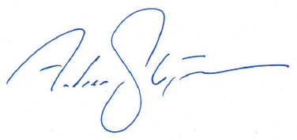

Andrew Stephenson MP

MINISTER OF STATE FOR TRANSPORT

