MSU/1/9/5 23 March 2020

Dear Ms Young,

ARMED FORCES PEOPLE PROGRAMME ACCOUNTING OFFICER ASSESSMENT

I would be grateful if the enclosed document could be placed in the Library of the House.

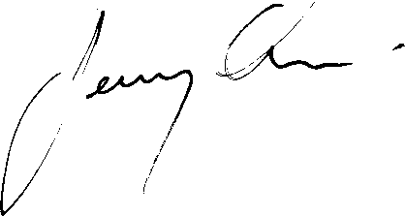

JEREMY QUIN MP

