Research Report

|  |
| --- |
| JE Review Market Research - Final Report |
| Prepared for: Ministry of Defence (MoD) |



JE Review Market Research - Final Report

**Prepared for: Ministry of Defence (MoD)**

**Prepared by: Dawn Hands - Managing Director, Lys Coleman – Research Director, Dr Michael Turner – Research Director**

**Date: April 2018**



**Produced by BMG Research**

**© BMG Research Ltd, 2020**

**www.bmgresearch.co.uk**

Project: 1451

Registered in England No. 2841970

Registered office:

BMG Research

Beech House

Greenfield Crescent

Edgbaston

Birmingham

B15 3BE  
UK

Tel: +44 (0) 121 333 6006

UK VAT Registration No. 580 6606 32

Birmingham Chamber of Commerce Member No. B4626

Market Research Society Company Partner

The provision of Market Research Services in accordance with ISO 20252:2012

The provision of Market Research Services in accordance with ISO 9001:2008

The International Standard for Information Security Management ISO 27001:2013

Investors in People Standard - Certificate No. WMQC 0614

Interviewer Quality Control Scheme (IQCS) Member Company

Registered under the Data Protection Act - Registration No. Z5081943

A Fair Data organisation

Cyber Essentials certification

The BMG Research logo is a trade mark of BMG Research Ltd.

Table of Contents

1 Introduction 4

1.1 Context 4

1.2 Programme of research 4

1.2.1 Overview 4

1.2.2 Phase 2: Quantitative research method 5

1.3 Overview of MTA sample composition 7

1.4 Overview of Gatekeeper sample composition 10

1.5 Overview of Junior Soldier sample composition 11

2 Executive summary 14

2.1 Introduction 14

2.2 Junior Soldiers views on AFCH 14

2.2.1 Source of awareness of AFCH 14

2.2.2 Motivations for coming to AFCH 14

2.2.3 Time taken to get into AFCH 15

2.2.4 Extent to which expectations of AFCH have been met 15

2.2.5 Likelihood to continue career in the Army 15

2.2.6 Possible changes to the JE offer 16

2.3 Segmentation 17

2.3.1 Modelling likelihood of being interested in an Army career 17

2.3.2 Segmentation overview 17

2.3.3 Mapping Key Segments to Local Authorities 20

2.3.4 The effect of STEM and FE offers on Army consideration by age 20

2.3.5 Forecasting group size for 2021 21

2.3.6 MTA and gatekeepers 21

2.3.7 Effects of Gender & Ethnicity on Junior Entry Offer Choice 23

2.3.8 Junior Soldiers 24

2.4 Sentiment analysis 25

2.5 Overview of quantitative survey results 27

2.5.1 Sources of careers advice 27

2.5.2 Activity levels 27

2.5.3 Religion 27

2.5.4 Importance of aspects to sense off self 27

2.5.5 MTA consideration of applying to the Army/likelihood of gatekeeper to allow 28

2.5.6 Advocacy 28

3 Overview of results 29

3.1 Junior Soldiers views on AFCH 29

3.1.1 Source of awareness of AFCH 29

3.1.2 Motivations for coming to AFCH 29

3.1.3 Time taken to get into AFCH 31

3.1.4 Extent to which expectations of AFCH have been met 32

3.1.5 Likelihood to continue career in the Army 34

3.1.6 One thing would change about AFCH 36

3.1.7 Possible changes to the JE offer 38

3.2 Segmentation 40

3.2.1 Modelling likelihood of being interested in an Army career 40

3.2.2 Segmentation method 42

3.2.3 Five segments 43

3.2.4 Segment profiles 46

3.2.5 Acorn Categories 47

3.2.6 Segment profiles 50

3.2.7 Possible changes to the JE offer by MTA segment 55

3.2.8 The effect of STEM & FE offers on Army Consideration by age 56

3.2.9 Segment Mapping 58

3.2.10 Re-estimating the size of key groups and forecasting their size for 2021 61

3.3 Conjoint analysis 64

3.3.1 Method 64

3.3.2 Conjoint outputs 65

3.3.3 Conjoint analysis of the Junior Entry Offer by MTA segment 67

3.3.4 Conjoint analysis of the Junior Entry Offer comparing parents with their children by segment 71

3.3.5 Conjoint analysis by Ethnicity 74

3.3.6 Conjoint analysis by Gender 76

3.3.7 Conjoint analysis of the Junior Entry Offer for Junior Soldiers by Course Length 78

3.4 Sentiment analysis 81

3.4.1 Results for the MTA 81

3.5 The Influence of Parents & Gatekeepers 90

3.5.1 Parent-child attitudinal consistency leads to greater interest in Army career 90

3.6 Overview of quantitative survey results 93

3.6.1 Introduction 93

3.6.2 Sources of careers advice 93

3.6.3 Activity 94

3.6.4 Religion 96

3.6.5 Importance of aspects to sense of self 97

3.6.6 Consideration of applying to the Army 100

# Introduction

## Context

The Army’s key strategic challenge is its ability to recruit, and as part of this the Army’s Junior Entry (JE) policy for 2010 recognised the need to attract young people who leave school at 16 and to meet their desire to undertake full time employment, with associated trade training, rather than move to further education. However, the Army is operating in a quickly evolving and highly competitive environment. Consequently, research was required to feed into a wider review of the policy, enabling the Army to determine the optimum position for the JE Offer, in order to attract the best young people and maximise their talent to mutual advantage.

Specifically, research was required to enhance the understanding of what motivates the 14 to 17-year-old Main Target Audience (MTA) and their respective Gatekeepers, to explore their perceptions of the JE Offer and identify if any changes would be required to enhance their interest without alienating those currently or potentially interested.

Key to this is the ability to identify the relevant target audience and the key motivators for this audience, in order to ensure that Army resources are focused on attracting the correct cohort with an appropriate and motivating Offer.

## Programme of research

### Overview

The full programme of research undertaken to meet these objectives has comprised:

**Phase 1: Qualitative research**

* 32 face-to-face focus groups:
  + 8 Junior Soldiers;
  + 16 MTA;
  + 8 Gatekeepers.

**Phase 2: Quantitative research**

* 4,098 MTA online interviews[1];
* 1,998 Gatekeeper online interviews[2] (1,276 matched with MTA);
* 317 Junior Soldier online interviews[3], including 70 partially completed interviews.

This report focuses on the results from the Phase 2: Quantitative research undertaken with the MTA, their gatekeepers, and Junior Soldiers currently attending AFCH. Separate reports are available that summarise the results from the Phase 1: Qualitative research.

### Phase 2: Quantitative research method

**MTA and gatekeepers**

For the MTA and Gatekeeper quantitative survey, a total of 6,096 interviews were completed online. Fieldwork was conducted between Friday 9th and Friday 23rd March 2018. Interviews were achieved by sending invitations to participate to members of online panels, using BMG’s online panel network.

Respondents fall into one of the following overall categories:

* Young people, aged between 14 and 17 years old(MTA);
* Parents or Guardians of young people aged between 14 and 17 years old (Gatekeepers).

Each of the above categories can be further broken down in terms of *‘linked’* and *‘non-linked’* surveys.

* **‘Linked’** are classified as those surveys were those surveys where both the young person and a parent from the same household completed the questionnaire. This could have been either in the same sitting; or on separate occasions. There were 998 linked surveys completed in ‘single-sitting’ environment, that is 998 gatekeepers and 998 MTA respondents in the same session; and 278 linked surveys completed in ‘separate-sitting’ environments; that is 278 gatekeepers and 278 MTA respondents on different days and times.
* For ‘single-sitting’ responses the parent was interviewed first, with screener questions used to establish whether they had any children in the household of the appropriate ages. Once the parent had completed the questionnaire, the parent was then instructed to hand over the survey to their child. Quality check questions were included in the survey to ensure key demographic response consistency between parent and child (i.e. that the child was the correct age and gender etc). The ‘linked’ surveys were particularly useful as they enabled researchers to examine the degree to which parental views are an important driver of their child’s own attitudes and perceptions.
* For ‘separate-setting’ responses parent and child data were matched post-fieldwork using known information, such as respondent ID, postcode age and ethnicity, about the registered panellist (i.e. the parent). Again, consistency checks were used to verify the key demographic information about the child so we could validate the parent-child relationship.
* **‘Non-Linked**’ surveys were those surveys where either the child or the parent completed the survey on their own, with no corresponding information available for either the parent or the young person. Non-linked surveys of the young person were achieved in one of two ways:
* Directly: Interviews were conducted directly with the young person. Due to age restrictions on online panel memberships, direct interviews were only conducted with those aged 16 or 17.
* Parent referral / Via-parent: Brief eligibility interviews were conducted with parents before the parent was instructed to hand the survey over to the over to the child. This avenue enabled young people under the age of 16 to be interviewed online. To ensure that the results were genuinely completed by parents and their children, the data were quality checked post-fieldwork by examining both hand-over times and average question speed pre and post hand-over.

The total completes achieved in each category is as follows:

|  |  |  |  |
| --- | --- | --- | --- |
|  | Linked | Non-Linked | TOTAL |
| Young People (14-17) | 1,276 | 2,822 | **4,098** |
| Parents/Guardians | 1,276 | 722 | **1,998** |
| Total | **2,552** | **3,544** | **6,096** |

The final MTA sample were weighted by interlocking age and gender targets, as well as Government Office Region (GOR), using ONS 2016 mid-year estimates for all residents aged 14 to 17.

Given that the subject of this research is the MTA, and because it is difficult to get ONS data regarding age/gender and GOR for parents in the UK, the Gatekeeper data were calculated in the same way as for the MTA sample. Targets were based on the child that they were referring to in the survey, Interlocking age and gender, by Government Office Region, using ONS 2016 mid-year estimates for all residents aged 14 to 17.

**Junior Soldiers**

A link to the Junior Soldier version of the questionnaire was circulated by staff at AFCH for current Junior Soldiers to complete.

No weighting has been applied to the Junior Soldier sample.

|  |  |  |  |
| --- | --- | --- | --- |
|  | Full | Partial | TOTAL |
| Short Course | 121 | 25 | **146** |
| Long Course | 126 | 45 | **171** |
| Total | **247** | **70** | **317** |

## Overview of MTA sample composition

The figure below shows the geographic distribution of the MTA sample following regional weighting.

Figure 1: Geographic distribution of the MTA sample following regional weighting

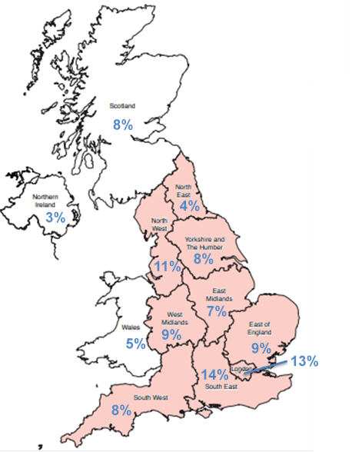

Unweighted base: All MTA (4,098)

The figure below indicates the demographic profile of the MTA sample following weighting by age within gender.

Figure 2: Demographic profile of MTA sample following weighting by age within gender

Unweighted base: All MTA (4,098)

The figure below summarises what the 5% who are not at school are doing currently. Close to three in ten are in either full (13%), part-time (14%) or self (2%) employment, a quarter (25%) are on a government supported training programme or apprenticeship, or something like it, close to a fifth (17%) are unemployed and available for work.

Figure 3: Current activity of those not in education

|  |  |
| --- | --- |
|  |  |
| On a government supported training programme or apprenticeship, or something like it | 25% |
| Employee in part-time job (Under 30 hours per week) | 14% |
| Employee in full-time job (30 hours plus per week) | 13% |
| Self-employed - full or part time | 2% |
| Unemployed and available for work | 17% |
| Permanently sick/disabled | 3% |
| Looking after the home | 2% |
| Doing something else | 18% |
| Prefer not to say | 5% |
| Unweighted Base | (198) |

After weighting, 86% of the MTA are White, 7% are Asian, 4% are Mixed and 3% are Black.

Three in ten (31%) of the MTA in Years 11 and 12 have less than 5 A-C GCSEs, and 59% have five or more.

One in ten (11%) of the MTA hope to achieve fewer than 5 A-C GCSEs, three in ten (29%) 5 or more A-C GCSEs, and one in ten (13%) 2 or more A levels.

Over four in ten (42%) expect to go into higher education.

Figure 4: Highest level of education attainment hoped for (All MTA)

Unweighted base: All MTA (4,098)

## Overview of Gatekeeper sample composition

The figure below indicates the demographic profile of the gatekeeper sample following weighting by age within gender.

Figure 5: Demographic profile of gatekeeper sample following weighting by age within gender

Unweighted base: All gatekeepers (1,998)

## Overview of Junior Soldier sample composition

Nine in ten (89%) of respondents to the Junior Soldier questionnaire are male, and the sample is approximately evenly split in terms of age (46% aged 16, 54% aged 17) and in terms of length of course (46% Short Course, 54% Long Course).

The figure below shows the geographic distribution of the place of birth of Junior Soldiers, with figures for the MTA shown in brackets, and reveals that certain regions are over- or under-represented relative to the overall distribution of the wider MTA:

* **Over-represented**: North East, West Midlands;
* **Under-represented**: East of England, London.

Figure 6: Geographic distribution of the Junior Soldier sample (figures in brackets indicate the geographical distribution of the MTA sample following regional weighting)

Base: 334 Junior Soldiers

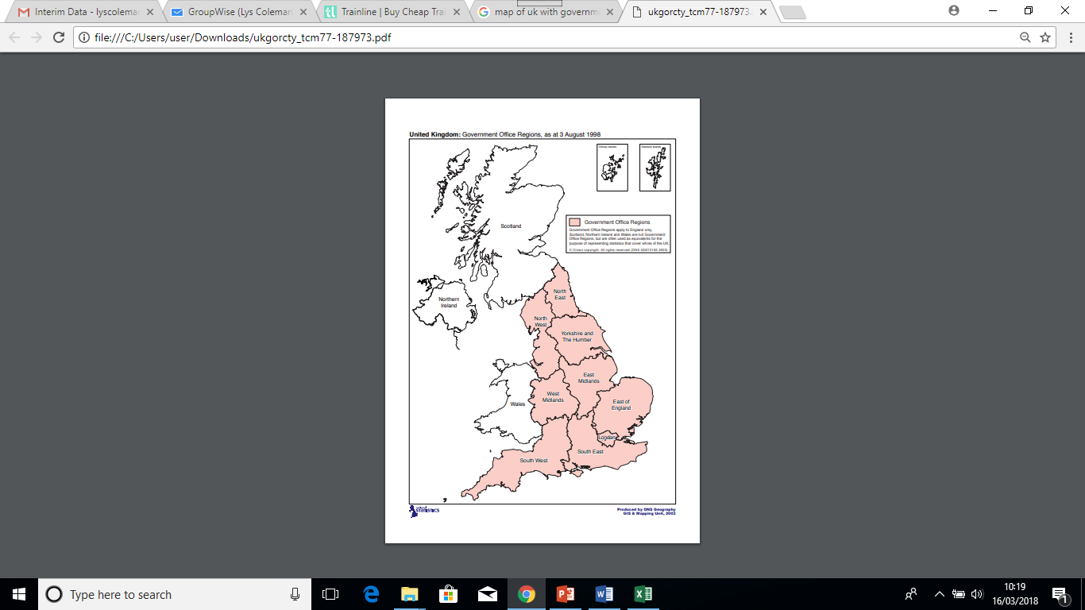

**9% (7%)**

**3% (9%)**

**5% (13%)**

**11% (4%)**

**13% (11%)**

**2% (3%)**

**7% (8%)**

**12% (14%)**

**8% (8%)**

**6% (5%)**

**13% (9%)**

**10% (8%)**

**Outside UK 3%**

Close to half (47%) of Junior Soldier respondents are in Cambrai company, three in ten (30%) in Burma, 14% in Alamein, 8% in Peninsula and 2% in Waterloo.

Figure 7: Training company (All Junior Soldiers)

Base: 311 Junior Soldiers

A third (33%) of Junior Soldier respondents are in the Infantry, one in six (14%) in the REME, and approximately one in ten in the Royal Artillery (12%), the Royal Engineers (11%) and the Royal Signals (9%).

Figure 8: Cap badge (All Junior Soldiers)

Base: 309 Junior Soldiers

Ninety-five percent of Junior Soldiers are from a White background.

A significantly higher proportion of Junior Soldiers have achieved less than 5 A-C GCSEs than Years 11 and 12 MTA (41% compared to 31%).

In terms of educational aspirations, Junior Soldiers are significantly more likely than the wider MTA to expect to achieve 5 or more A-C GCSEs (42% compared to 29%), and significantly less likely to expect to go on to higher education (22% compared to 42%).

Figure 9: Highest level of education attainment hoped for (All MTA and All Junior Soldiers)

Unweighted bases in parentheses  
Arrows indicate statistically significant differences at the 95% level of confidence

# Executive summary

## Introduction

In order to set the results from the MTA and gatekeeper surveys in context, we have initially summarised the key results from the current cohort of Junior Soldiers in relation to their views and experiences of AFCH. This section also considers the reaction of all three audiences (MTA, gatekeepers and Junior Soldiers) to possible changes to the JE offer (section 2.2).

There follows an overview of the segmentation work that was undertaken across the MTA, and a description of the size and nature of the segments identified (section 2.3).

The next section considers the conjoint work that was undertaken to examine, simultaneously, the effect of multiple features of the JE Offer (section 2.4).

The sentiment analysis section outlines the findings with regard to a cut down version of the AFCH promotional video that was shown to a random sample of the MTA and gatekeepers (section 2.5).

The final section (section 2.6) provides an overview of the results to the quantitative survey undertaken with the MTA and gatekeepers, including comparisons with the current Junior Soldier cohort where appropriate. The questions in the quantitative surveys were primarily designed to inform the segmentation exercise and related analyses. However, the results are included to provide additional context, and to summarise key differences across demographic sub-groups of the MTA.

## Junior Soldiers views on AFCH

### Source of awareness of AFCH

Over a quarter of Junior Soldiers report hearing about AFCH via an Army Recruitment Centre and over half say they went to one to find out more, indicating the importance of this channel for engaging the MTA. One in five found out about it via the internet and again over half say they went online to find out more, which also highlights the importance of maximising AFCH’s online presence and ensuring that motivating content is easily accessible. Only 1%/2% mention teachers, which highlights the scale of the difficulty currently in engaging with the MTA via schools.

### Motivations for coming to AFCH

Over half of Junior Soldiers came to AFCH because they have always wanted to join the Army, and close to half because they wanted to serve their country. The military aspects are clearly also appealing, as are the physical/sporting aspects, while in contrast the opportunity to continue their education is a motivator for only one in ten, and one in five attend AFCH in order to avoid continuing in education.

Many of the reasons given for coming to AFCH are very similar among both those on the Short and those on the Long course. However, those on the Long Course are significantly less likely to cite being part of a team, personal development, developing friendships and leadership qualities.

This highlights the importance of ensuring that the military and sporting elements of the JE offer are clearly communicated to potential recruits.

### Time taken to get into AFCH

While a third of Junior Soldiers report it took up to three months from the time of their application to the time of their assessment, two in five report it took longer than six months, including one in ten for whom it took over a year. In contrast, while over two in five report it took up to three months from the time of their assessment to actually going to AFCH, only one in five report it took longer than six months, which suggests that the potential ‘bottle-neck’ is more evident following initial application. There is some evidence that there are greater delays in dealing with applicants to the Short course.

Qualitative feedback from current Junior Soldiers highlighted this as a significant negative in their experiences to date, with many pointing out how much effort they had to make in order to keep the process in motion.

### Extent to which expectations of AFCH have been met

Over two in five Junior Soldiers feel their expectations of AFCH have been met either completely or to a large extent, and a further two in five that they have been met to some extent. In contrast, 16% say their expectations have not been met very much or at all.

There are clear differences between Junior Soldiers on the Short and Long courses, with those on the Short course significantly more likely than their counterparts to feel that their expectations have been met either completely or to a large extent. Close to a quarter of those on the Long course say their expectations have **not** been met very much or at all (compared to one in ten of those on the Short course).

The most commonly cited reason for unmet expectations is that the course is easier than expected in some way (either in relation to PT, discipline or more generally). While a minority found the course more gruelling and stressful than they expected, these results suggest that consideration should be given to the amount/difficulty/speed of progression of the PT offering, and to greater consistency in the approach to discipline.

### Likelihood to continue career in the Army

Seven in ten of Junior Soldiers say they will definitely continue their career in the Army once they leave AFCH, and a further one in five say that they probably will. One in twenty are ambivalent, and a similar proportion probably or definitely will **not** continue once they leave.

Reflecting the extent to which their expectations have been met or otherwise, those on the Short Course are significantly more likely to say that they will definitely continue their career with the Army once they leave AFCH (76% compared to 64%).

While relatively few in number (32), it is interesting to note that **all** female Junior Soldiers say that they will definitely (66%) or probably (34%) continue their career in the Army.

When asked to outline the one thing about AFCH that they would change, food is the most commonly mentioned item, suggesting that a review of the canteen/food policy may be beneficial (within the constraints of the dietary requirements of recruits in training).

The need/desire for more PT is the next most commonly mentioned issue, supporting the suggestion above that consideration should be given to the amount/difficulty/speed of progression of the PT offering.

### Possible changes to the JE offer

The MTA, gatekeepers and Junior Soldiers were asked about the following possible changes to the Junior Entry offer:

* **More STEM to GCSE/A-Level**: Currently the Army offers a limited range of BTECs. If they were to offer more STEM subjects up to GCSE and A Level would this make you/do you think this would make your child more or less likely to consider joining/how likely would you be to take this up?
* **Non-enlistment**: If someone wants to join the Army they have to sign-up and follow certain rules and agree to accept military discipline. If you didn’t have to do this, would this make you/do you think this would make your child/ would this have made you more or less likely to consider joining?
* **Conditional further education**: If you didn’t have to agree to accept military discipline, and you could get further education through the Army on the condition that you join afterwards, would this make you/do you think this would make your child/ would this have made you more or less likely to consider joining?
* **Unconditional further education:** If you didn’t have to agree to accept military discipline, and you could get further education through the Army whether you joined afterwards or not, would this make you/do you think this would make your child more or less likely to consider joining?

In each instance the majority of the MTA are neutral in their responses to the various options, with half or more in each case indicating that they would make them neither more nor less likely to consider joining the Army. Over a third say more STEM would make them more likely to consider joining, and close to three in ten that a non-enlistment option would do so, with boys more likely than girls to do so in both instances. Results are consistent by age.

In relation to the education options, the unconditional offer of further education is unsurprisingly more popular than the conditional offer, and this is also the only option that generates the same level of appeal for boys and girls. Results are consistent by age.

The pattern of response among gatekeepers is very consistent with that for the MTA.

For Junior Soldiers, the offer of additional STEM to GCSE/A-Level is an attractive proposition for close to three quarters, a significantly greater proportion than for the MTA and gatekeepers. This is the only option that generates a strong response, in contrast with the other options where around half of Junior Soldiers say they would have made them neither more nor less likely to join.

This reinforces the findings from the qualitative phase of research, which suggested that the offer of optional additional STEM to a higher level was likely to prove popular for both current Junior Soldiers, and for certain sections of the MTA.

The non-enlistment option appeals to only a quarter of Junior Soldiers, highlighting the risk of alienating a key cohort if this option is pursued. Conditional and unconditional education appeal to close to two fifths of Junior Soldiers, considerably fewer than in relation to additional STEM.

## Segmentation

### Modelling likelihood of being interested in an Army career

In order to understand what are the key ‘fundamental’ drivers of consideration of a career in the Army, a regression model was used by way of a scoping tool to pull out factors that were most predictive of consideration. Models were run for both the MTA and the Parents/Gatekeepers.

The results show that there is a high degree of ‘cross-over’, with predictive variables for both the MTA and Parents/Gatekeepers. For instance, whether they have a friend or another family member serving is critically important and features across models for both the MTA and Gatekeepers. How strongly they rate the importance of family in understanding their own identity, as well as the importance of where they live are also significant predictors of propensity to signal an interest for both the MTA and Gatekeepers. Finally, as you might expect, sporting activity is significantly predictive for both groups, and how they perceive their area to have changed in the last two years, used in this case as a proxy indicator for local pride.

This shows the importance of factors that help to construct a sense of personal identity in the prediction of Army career interest. However, interestingly, they also account for the intergenerational differences in how people construct their sense of self. For instance, it is common knowledge that religiosity is in a generational decline in the UK, with younger people much less likely to report conformity to a religion than older groups, and this trend is indeed reflected in these results. The importance of religion is a significant predictor for Gatekeepers, whereas it is not for the MTA. The importance of national identity is a significant predictor for the MTA, but not for Gatekeepers. Finally, for the MTA, life satisfaction is also found to be predictive of interest.

It is noteworthy to report that both models are based solely on attitudinal and behavioural variables. No demographic indicators were strongly enough predictive of Army career interest to make it into the final model.

This result is both intriguing and problematic. It is intriguing as it suggests that the propensity to be interested in a career is related more to a ‘state-of-mind’ and the ‘social environment’ that people exist within than people’s demographic and socioeconomic background, notwithstanding connections with serving family and friends. It is problematic because it suggests that targeting Gatekeepers and the MTA via key demographic information alone will be no more effective than Above The Line (ATL) communications strategies.

### Segmentation overview

A segmentation exercise identified five MTA segments, and brief descriptions of each are detailed below. As indicated, the extent to which each segment would consider a career in the Army varies considerably across the segments, from 48% of **Can-do Active Citizens (CAC)**, to 24% of **Ambitious and Affluent Clique** (AAC) and **Feckless**, **Poor and Pessimistic** (FPP).

Segment pen portraits

**SLB**

**Strivers Lacking Belonging**

Fairly inactive, not religious, poor sense of personal and national identification, fairly ambitious and pessimistic. From areas of middling prosperity.

**AAC Ambitious & Affluent Clique**

Fairly active with poor sense of national identification, but values friends and family. Not at all religious, but strongly ambitious. Lives in areas of affluence.

**GCP**

**Get-on Community Pride**

Fairly active, not religious, with a fairly strong sense of personal and national identification. Positive about life and local area, but unambitious. Lives in poorer areas.

**FPP** **Feckless, Poor & Pessimistic**

Very inactive, not at all religious with poor sense of personal and national identification. Pessimistic, unambitious and not at all civic-minded. Lives in the poorest areas.

**CAC**

**Can-do Active Citizens**

Very active and civic-minded. Religious with a strong sense of personal and national identification. Positive and ambitious. Live in areas of rising prosperity.

**Have/would consider applying to the Army**

**24%**

**24%**

**31%**

**40%**

**48%**

The first figure below shows how the MTA population breaks down by these five segments and indicates that the segment that shows the strongest propensity towards a career in the Army accounts for a significant proportion – a quarter of the MTA – indicating what a significant potential pool of recruits this segment could be if targeted appropriately.

The two groups with the next highest propensity account for a further two in five of the MTA.

The second figure shows how the proportion of the MTA who would consider a career in the Army breaks down by these segments. At 12% of the wider MTA, the CAC group accounts for over a third of ‘Army considerers’, the SLB for just 9%, and the GCP for a further third.

Prevalence of segments in the MTA population (All MTA)

Prevalence of Army career considerers across MTA segments

It is encouraging to note that the segment which shows the greatest propensity to consider an Army career – **Can-do Active Citizens (CAC) –** account for the largest proportion of the overall MTA (12%).

**Strivers Lacking Belonging** (SLB) are the next most likely to consider a career in the Army, and the fact that they account for only 3% of the population could be seen as a concern. However, our hypothesis is that it exhibits characteristics which would advocate against targeting this segment.

In contrast, while on the face of it **Get-on Community Pride** (GOC) exhibit somewhat lower levels of consideration of the Army, our hypothesis is that it exhibits characteristics which would advocate the targeting of this segment. These hypotheses are explored in later chapters.

### Mapping Key Segments to Local Authorities

Using multilevel regression poststratification modelling, the maps below chart the estimated density of the **Can-do Active Citizens** (left) **Get-on Community Pride** (right)segments England & Wales. Green areas represent top quintiles, and red areas represent bottom quintiles for each.

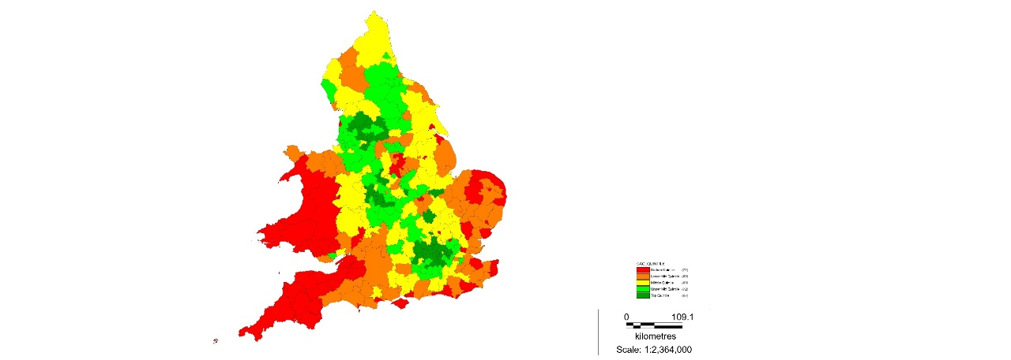 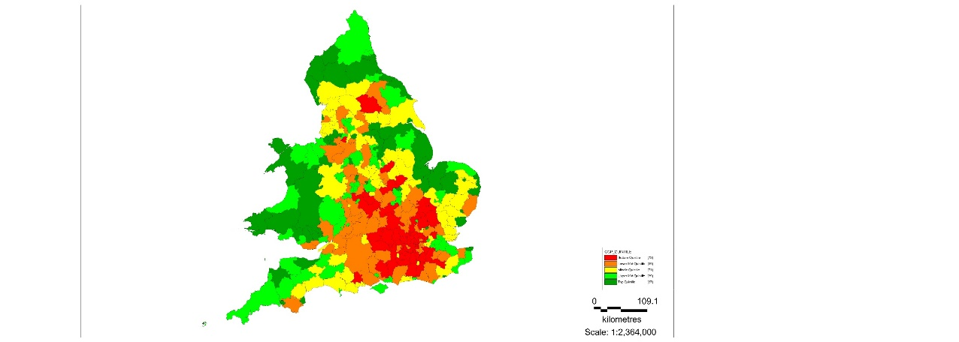

The results of the multilevel regression poststratification modelling above give an alternative estimate of the **Can-do Active Citizens** segment of 22.6%, more than 3% less than the survey estimate. The alternative estimate for the **Get-on Community Pride** segment of 44.4% is more than 8% higher than the survey estimate.

Whilst there are many areas where these groups overlap in high quantities, the difference in the mapped results for the two segments are stark, with top-areas for **Can-do Active Citizens (CAC)** tending to be in commuter-belts and cities, whereas top areas for the **Get-on Community Pride (GCP)** segment tend to centre on post-industrial towns and areas of relatively poor national infrastructure.

### The effect of STEM and FE offers on Army consideration by age

The results of the research suggest that for our two key segments at least (CAC and GCP), there is a small but notable incentive to recruit the MTA younger, and that the introduction of more STEM may help to do so.

It is our view that the introduction of more STEM may attract more of the key segments, but critical to this will be the level at which they would be able to take STEM; especially given that they will move on to their regiment to complete more job-related STEM.

Analysis of the introduction of Further Education options gave mixed results, but key here is that joining the Army with these conditions does not become a more attractive prospect with age for both of our key segments, Get-on Community Pride (GCP) and Can-do Active Citizens.

There may be some merit in trying to attract those classed as CAC as U18s through a separate and significantly enhanced offer, but there is no evidence that waiting for, and developing a bespoke enhanced Further Education offer for post-18 will improve interest significantly.

### Forecasting group size for 2021

Having estimated the maximum size of the interested audience, and the maximum size of those interested in an Army career by CAC and GCP for 2011, we were able to retro-forecasted the results to 2001 estimate based on Census statistics collected in 2001. Given that there are no official forecast figures available in the public domain, we adopted a linear transition approach. We were able forecast 2021 estimates for all these groups based on a linear progression of key populations in England & Wales. Our forecasted estimates for 2021 are as follows:

* Maximum Population Interested = 177,349 / 24.6% (No % change / +7,665);
* Maximum Population Interested within CAC Segment = 79,795 / 11.1% (+0.2% / +4,941);
* Maximum Population Interested within GCP Segment = 97,554 / 13.5% (-.0.2% / +2,724).

Although the results appear to show very little change in the overall proportion of MTA who are interested between 2001 and the forecasted result in 2021, the results at local authority level show much more movement. Readers should be aware that the estimates provided are just that, estimates which may be subject to a degree of error. So, although we have given the estimated figures, they should be interpreted in a more general sense rather than in exactitudes.

### MTA and gatekeepers

A “Conjoint Experiment” was designed to analyse multidimensional preferences of the Junior Entry (JE) offer for the MTA and their gatekeepers. This approach allowed us to examine, simultaneously, the effect of multiple features of the JE Offer.

Key attributes of the offer which were tested include:

* Type of career* (Army Apprenticeship, Business Apprenticeship, Technical Apprenticeship);
* Location (local, UK, overseas);
* Pay (£900, £1,200, £1,600 per month);
* Content of training (20% education/80% on the job training, 50% education/50% on the job training, 80% education, 20% on the job training);
* Duration of training (minimum of 3 months, minimum of 6 months, minimum of 12 months);
* Length of time you have to stay in the job after training (2 years, 4 years, 6 years);
* Job role (choose before you start training, choose during training, choose on completion of training).

‘Type of career’ accounts for 31% of the MTA’s choice motivations and is the main driver of choice. Pay accounts for 26% of respondents’ choice motivations and location for 22%. That means that 79% of young people’s choice motivations are driven by just three very basic attributes, Career Type, pay and location. When you include the expected length of stay in the job, which accounts for 16% of choice motivations, we can explain 95% of the drivers of selecting an offer.

Offer attributes such as training content, duration of training and job role account for a very small proportion of young people’s decisions when thinking about a career, just 5% between them.

In terms of the various levels of attributes, when compared to Business and Technical occupations, a role in the Army is seen as much less attractive, with the negative impacts much larger than for any other attribute level. This points to a wider issue of Army branding and societal perceptions which is outlined in detail in our report on Army Societal Research and highlights the scale of the task to shift these.

The results for Pay show a linear effect – which is intuitive. Clearly it will be necessary to ensure that the Pay scale for Junior Soldiers is competitive when compared with the apprenticeships available to 16-year olds. Qualitative research also revealed that highlighting the pay element as compared to the potential costs of higher education is likely to engage both the MTA and their gatekeepers.

Domestic and ‘local’ locations are strongly preferred to overseas locations, but this does vary by segment as outlined below.

Shorter lengths of stay in the job are more attractive than longer ones, which again is intuitive, and which suggests there may be value in re-considering the minimum length of service post-18.

Other attributes do not show major or significant differences.

The following outlines what drives each of the five MTA segments’ choices, and the choices of their matched gatekeepers:

For **Can-do Active Citizens**, who are most likely to say that they would consider joining the Army (48%), Pay is the most important component of their choice motivations, with the top-band offer of £1,600 per month shown to be more impactful than Career Type. Location is a much smaller effect than average with no statistical difference between being UK-based or local.

For gatekeepers of Can-do Active Citizens, Career Type is the most important driver, with Career Type specifically a role in Business) and Location (specifically local rather than UK or overseas) higher drivers of offer choice than for their children. Pay is valued slightly less than for their children.

For **Strivers Lacking Belonging**, who are the next most likely to say that they would consider joining the Army (40%), Pay is again the most important component of their choice motivations, but only just. They have a slight preference for Technical occupations. Location has only a very small effect and there are no statistical differences between being UK-based or local.

Gatekeepers of Strivers Lacking Belonging show very large differences when compared with their children. Although 40% of children classified as Strivers Lacking Belonging (SLB) say that they are interested in an Army career, their parents show one of the largest opposition to Army roles. Parents of SLB are aligned with their children on the pay component of the offer but tend to value a shorter length of the course more, as well as the ability for their children to select their role during or after completion of the course. Perhaps suggesting that the parents feel their children would need more time, experience and guidance to come to a settled decision. When we compare the differences between parents and children of the SLB segment with those for CAC, the results suggest that the parent-child relationship and expectations are very different, with interests more aligned and supportive for an Army career among CAC, and less aligned and supportive for SLB.

The importance of this dissonance in limiting this segment’s importance for the Army is discussed further in section 2.5 below.

For **Get-on Community Pride**, who are the next most likely to say that they would consider joining the Army (31%), there are clearly different attribute effects, with being Local having the largest impact. There is a slight preference for Technical Career Types, but the Army is shown to have a bit of an image problem for this group. Pay is still linear but much less important compared with other groups. They are less bothered by length of service than others, but six years is still relatively unattractive.

The results between gatekeepers and children of the Get-on Community Pride (GCP) segment show similar levels of parent-child alignment as those classed as CAC. Interestingly, parent choices are driven less by Location than their children, otherwise there does not appear to be any parental barriers in the key drivers of the offer for GCP.

The importance of this consonance in supporting this segment’s importance for the Army is discussed further in section 2.5 below.

**Ambitious & Affluent Clique** are one of the least likely to say that they would consider joining the Army (24%). Career Type is by far the strongest impact with a slight preference for Business occupations. The Army is shown to have a large image problem for this group. Pay is still a very important factor when compared with other groups and length of service is also very important. They appear to have a very different set of choice motivations than other groups.

Results for gatekeepers and children of the **Ambitious & Affluent Clique** (AAC) segment show differential drivers of the Junior Entry offer. Levels of parent-child alignment differ for the key attributes of Career Type and Location, and also Pay. Interestingly, parent choices are driven less by Career Type than their children, suggesting that the Army is less of a barrier.

**Feckless, Poor & Pessimistic** are the other segment least likely to say that they would consider joining the Army (24%). Although Career Type has the strongest impact, the Army is shown to have a strongly negative effect. Less motivated by Pay, being local is very important to those who are members of Feckless, Poor & Pessimistic (FPP). Choice motivations for this segment are less pronounced that other groups.

Finally, results for gatekeepers and children of the Feckless, Poor and Pessimistic (FPP) segment show interesting and slight differential drivers of the Junior Entry offer. As for their children, parents are more likely to select an offer with a technical role, but they are less likely than their children to select a Business Career Type offer. FPP gatekeepers tend to value the pay component of the JE offer slightly more than their children and are significantly less driven by the location of the job offer than their children also.

### Effects of Gender & Ethnicity on Junior Entry Offer Choice

The results of the Conjoint analysis for White British respondents versus BAME respondents show that when we control for other offer attributes, those from the BAME community are almost 3 times as likely to select an offer that includes a Business Career Type when compared to one for the Army.

Location is a less significant driver of choice selection for BAME respondents, with offers that are Local selected on average 1.41 times as much as Overseas offers. This is compared to Local offers being selected 1.8 times as much for White British respondents.

There is little difference between BAME and White British MTA on Pay, with an offer that pays £1,600 per month selected almost 2.1 times as much as an off that pays £900 per month for BAME respondents and almost twice (1.98) as often for White British respondents.

When we segment the results for the MTA by gender, surprisingly there are appears to be very little differential drivers overall for the Junior Entry offer.

However, when we look at the data in more detail, there are slight directional differences within each offer attribute. While male respondents are 2.24 times as likely to select an offer that is for a Technical role, when compared to an Army career, females are 2.16 times as likely. However, female respondents are 2.42 times as likely to choose a Business Career type, compared to just 2.03 for male respondents.

There is also a small, but consistent increased value in the offer being Local for female respondents. Whilst this only accounts for 2.2% additional utility.

### Junior Soldiers

The project also took the opportunity to ask Junior soldiers a similarly structured set of questions in order to ascertain, with the benefit of hindsight, the relative value of each component of the Junior Entry offer. As we were interviewing Junior Soldiers, asking about Career Type was not a relevant variable for analysis so a shortened version of the design was used.

The key attributes for Junior soldiers were Location, Pay, balance of Content of Training, Duration of Training, Length of Stay in the Job and when to decide the Job Role.

Given the differences identified between those on the Long and those on the Short course, the results have been split on this basis.

Those on the Short Course are shown to be driven more by the Pay (54%) component of the offer, and within this component they are three times as likely to select an offer if it offers £1,600 a month than if it offered £900. There is also reasonably strong preference for length of stay to be 4 years or less.

Those on the Long Course are shown to be driven most by the Content of the Training (38%). Within this, it is very striking that the minimum amount of education is the most predictive of choice motivations, and is even more important than the top pay bracket, reflecting the common, but by no means universal, antipathy towards education of this group.

Interestingly, those on the Long Course have a preference for longer periods of service. They tend to be around 1.2 times as likely to select an offer if it stipulates 4 or more years. This suggests that the opportunity to have a long career in the Army is one of the plus points for this group.

## Sentiment analysis

MTA and gatekeepers were shown a cut-down version (76 seconds long) of a marketing video created for the Army about the Junior Entry offer and asked to give live feedback as they watched it.

There are substantial differences in the level of interest depending on MTA segment throughout the video. Firstly, there are movements which are consistent with key ‘moments/messages’ in the video that are also consistent across groups, therefore we can be sure that the MTA have clearly interpreted and responded to these messages as instructed. Second there are also movements that are consistent with key ‘moments/messages’ in the video which are different across MTA segments.

These movements show that our most promising MTAs, **Can-do Active Citizens** and **Get-on Community Pride** respond positively to the video throughout, though to varying degrees. Can-do Active Citizens (CAC) respond strongly positively, and dip only slightly at times, finishing strongly. Get-on Community Pride also respond positively but less-so than for CAC.

Although there is significant variation across the length of the video, results for the **Feckless, Poor & Pessimistic** (FPP) segment show consistently negative ratings, from start to finish.

Results for **Strivers Lacking Belonging** (SLB) and the **Ambitious & Affluent Clique** (AAC) show mixed results, often positive and other times negative, with different patterns of response.

**Sentiment Analysis by MTA segment**

Results for gatekeepers show that there are similarities and differences compared to their children, depending on which MTA segment they belong to. Overall, the parents tend to be more positive than the children about the video, with higher and more consistent sentiment scores on average.

Interestingly, those segments which register the lowest level of interest in an Army career show the most inconsistency in sentiment scores between parent and child. Whilst those from the segments that exhibit the highest likelihood of interest in an Army career have the highest degree of sentiment consistency across the video.

This suggests that different segments exhibit similarities or differences in career preferences more generally, and this, in turn suggests that the segments will have different parent-child relationship structures. It further suggests that parents and gatekeepers, along with other factors, may be a significant influence on the propensity of key segments within the MTA to seriously consider a career in the Army.

If we consider the propensity of the MTA to say that they are interested in an Army career by whether or not both parents and their children gave the same answers on a number of key attitudinal questions, it is apparent that where parents and children are aligned in their attitudes, the children are more likely to be interested in an Army career. Conversely, where they disagree on these issues, they are on average less likely to be interested.

There are also large differences in parent-child alignment across these key attitudinal questions for different MTA segments, with Key segments, such as the **Can-Do Active Citizens** (CAC) and **Get-on Community Pride** (GCP) showing significantly higher levels of attitudinal consistency with their parents.

Almost nineteen in twenty (94%) of the CAC segment gave similar answers to their parents on a majority of the 7 key attitudinal variables we have used above. As did two thirds (65%) of those in the GCP segment. This contrasts sharply with the **Strivers Lacking Belonging** and **Feckless**, **Poor & Pessimistic** segments that show significantly higher levels of disagreement. Just 10% of the SLB segment agree on a majority of the key attitudinal questions with their parents; and for the FPP segment it falls to just 3%.

There is an almost linear relationship between the level of attitudinal consistency between parents and their children and the likelihood of a child being interested in an Army career.

Although these data support strongly the notion that parents/gatekeepers are a key influence for MTA segments, it is perhaps not enough for the MTA to simply agree with their parents/gatekeepers. For this theory to be verified further, we must find evidence that the directionality of the attitudinal consistency matters also. This means that children and parents who exhibit attitudinal mindsets which are aligned in ways that are favourable towards a career in the Army, should be more likely to be interested. Whereas those who are aligned in ways which are negatively associated with an Army career, should be less likely to be interested. On examination, this does in fact prove to be the case.

Propensity to consider Army career by level and positive/negative direction of parent-child agreement

## Overview of quantitative survey results

### Sources of careers advice

Parents are a key source when the MTA are seeking advice about careers, along with careers advisers and the internet.

### Activity levels

Three quarters of the MTA report having attended/belonged to a club or activity, most commonly a sports club, Scouts/Cubs, Girlguiding, a youth club or the Duke of Edinburgh Awards. While participation rates are similar among Junior Soldiers, there are clear differences in the focus of activity, which are much less likely to be youth clubs, Girlguiding or Scouts/Cubs, and much more likely to be Army Cadet Force (33% of Junior Soldiers have been in ACF).

Three in five of the MTA report doing physical or sporting activity either every day or most days, and this rises to three quarters of Junior Soldiers.

### Religion

Three in five of the MTA and two thirds of their gatekeepers report having a religion, and a third of both groups (20% off all MTA and a quarter of gatekeepers) say that they are practising. Junior Soldiers are significantly less likely to report having a religion (two in five) and only one in ten of this group say that they are currently practising (equating to less than one in twenty of all Junior Soldiers).

### Importance of aspects to sense off self

Family and friends are regarded as very important to the MTA’s sense of self. While this is true for both White and BME MTA, it is particularly the case for the White MTA. In contrast, national identity, where they live, ethnicity and religion are significantly more important for BME than White MTA.

All aspects are rated as significantly less important by MTA who report having no religion than those who have a faith, while Muslims attach a significantly greater level of importance to national identity, where they live, and particularly their ethnicity and religion than any other group. Those who have or would consider applying to the army are significantly more likely to feel all aspects are more important to their sense of self than those who have/would not, with the exception of their family.

Gatekeepers are significantly more likely than the MTA to regard family, national identity and religion, and less likely to find friends very important to their sense of self.

Junior Soldier respondents are significantly more likely than the wider MTA to feel that their family, their national identity, and where they live are very important to their sense of self, and significantly less likely than the wider MTA to feel that their ethnic background and religion are very important to their sense of self.

### MTA consideration of applying to the Army/likelihood of gatekeeper to allow

A third of the MTA have or would consider applying to the Army, with boys significantly more likely than girls to do so. While the likelihood of considering applying reduces with age, it is consistent across both White and BME MTA. Consideration is higher in London, East Midlands, Northern Ireland, Yorkshire and Humber, Scotland and the South West.

Two thirds of gatekeepers would definitely or probably allow their child to join the Army. In contrast to the MTA, where consideration of applying to the Army decreases with age, Gatekeepers’ likelihood of allowing their child to join the Army increases with age.

### Advocacy

The Net Promoter Score (NPS) is calculated by subtracting those classed as detractors (i.e. scoring 0 to 6 in terms of likelihood to recommend a career in the Army) from those classed as promoters (i.e. scoring 1 to 2 in terms of likelihood to recommend a career in the Army).

MTA return a NPS of -72 and gatekeepers a NPS of -69, and this demonstrates the size of the challenge to normalise the possibility of a career in the Army. In contrast Junior Soldiers return an NPS of +7, with those on the Short course more positive than those on the Long course (+16 compared to 0). While this is clearly, and unsurprisingly, more positive than the MTA and gatekeepers, we might expect this to be higher amongst this cohort, particularly given their own commitment to continuing a career in the Army (70% say they will definitely continue and a further 21% that they probably will).

# Overview of results

## Junior Soldiers views on AFCH

### Source of awareness of AFCH

Over a quarter (27%) of Junior Soldiers report hearing about AFCH via an Army Recruitment Centre and over half (56%) say they went to one to find out more, indicating the importance of this channel for engaging the MTA.

One in five (18%) found out about it via the internet and again over half (52%) say they went online to find out more, which also highlights the importance of maximising AFCH’s online presence and ensuring that motivating content is easily accessible.

Only 1%/2% mentioned teachers, which highlights the scale of the difficulty currently in engaging with the MTA via schools.

Figure 10: Sources of awareness of AFC Harrogate (All Junior Soldiers)

Base: All Junior Soldiers (289)  
Q: How did you hear about AFC Harrogate?  
Q: Once you had heard about it, where did you go to find out more?

Those on the Short course are significantly more likely than those on the Long course to have found out about AFCH via their parents (14% compared to 7%) or a careers fair (10% compared to 3%), while the opposite is true in relation to the internet (10% compared to 24%).

### Motivations for coming to AFCH

Over half (56%) of Junior Soldiers went to AFCH because they have always wanted to join the Army, and close to half (47%) because they wanted to serve their country.

The military aspects are clearly appealing (42%), as are the physical/sporting aspects (35%), while in contrast the opportunity to continue their education is a motivator for only one in ten (10%), and one in five (18%) attend AFCH in order to avoid continuing in education.

Figure 11: Motivations for coming to AFCH (All Junior Soldiers)

Base: All Junior Soldiers (289)  
Q: Which, if any, of the following made you decide to come to AFC Harrogate?

Many of the reasons given for coming to AFCH are very similar among both those on the Short and those on the Long course. However, the figure below highlights that those on the Long Course are significantly less likely to cite being part of a team (20% compared to 36%), personal development (22% compared to 33%), developing friendships (16% compared to 30%) and leadership qualities (19% compared to 29%).

Figure 12: Motivations for coming to AFCH (Junior Soldiers by course length)

Bases in parentheses  
Q: Which, if any, of the following made you decide to come to AFC Harrogate?

While caution should be shown due to the small base size for female Junior Soldiers (32 in total), they are significantly more likely than their male counterparts to say they wanted to come to AFCH to develop their leadership qualities (50% compared to 20%), to be part of a team (44% compared to 25%) and to develop close friendships (44% compared to 20%).

### Time taken to get into AFCH

While a third (33%) of Junior Soldiers report it took up to three months from the time of their application to the time of their assessment, two in five (39%) report it took longer than six months, including 11% for whom it took over a year.

In contrast, while over two in five (43%) report it took up to three months from the time of their assessment to actually going to AFCH, only one in five (20%) report it took longer than six months, which suggests that the potential ‘bottle-neck’ is more evident following initial application.

Figure 13: Time taken to get into AFCH (All Junior Soldiers)

Base: All Junior Soldiers (289)  
Q: Approximately how long did it take from the time of your application to the time of your assessment day?  
Q: And approximately how long did it take from the time of your assessment to actually coming to AFC Harrogate?

There is some evidence that there are greater delays in dealing with applicants to the Short course. Half (50%) of this group report it taking over six months from the time of application to assessment, including one in five (19%) who waited over a year. This compares with three in ten (30%) of Long course applicants (including only 5% who waited over a year).

While there are differences between the two groups in relation to the time taken between assessment and going to AFCH, these are significantly less marked (24% of Short course applicants waited over six months, compared to 17% of Long course applicants).

### Extent to which expectations of AFCH have been met

Over two in five (42%) Junior Soldiers feel their expectations OF AFCH have been met either completely or to a large extent, and a further two in five (40%) that they have been met to some extent. In contrast, 16% say their expectations have not been met very much or at all.

Figure 14: Extent to which expectations of AFCH have been met (All Junior Soldiers)

Base: All Junior Soldiers (287)  
Q: To what extent have your expectations of AFC Harrogate been met?

There are clear differences between Junior Soldiers on the Short and Long courses, with those on the Short course significantly more likely than their counterparts to feel that their expectations have been met either completely or to a large extent (50% compared to 34%). Close to a quarter (23%) of those on the Long course say their expectations have **not** been met very much or at all (compared to 9% of those on the Short course).

Figure 15: Extent to which expectations of AFCH have been met (Junior Soldiers by length of course)

Bases in parentheses  
Q: To what extent have your expectations of AFC Harrogate been met?

Figure 16 below summarises the reasons Junior Soldiers provide for their response to this question. While a significant proportion provide a positive response (17%), or simply say it has matched their expectations (17%), there are some areas where expectations have not been entirely met.

The most common reason for Junior Soldiers to feel that their expectations have not been met is the lack/ease of PT[4].

*‘Not as much sport and physical stuff as I expected. Wanted and prepared for more exercise.’*

*‘I expected there to be more PT in order to physically prepare us for the next phase of training.’*

*‘I thought the physical training would be a lot more, I also thought that would have been a lot more military training such as skills.’*

*‘Because I expect the fitness etc to be harder I like a challenge.’*

In addition, some on the Short Course feel they should be able to do sports.

*‘I thought on the short course I would be able to do boxing and other fighting sports; however, it was not explained on the short course you wouldn't be able to play sports.’*

This is echoed in a more general sense by those who feel it is easier than they expected, and those who expected a higher level of discipline.

*‘It's not what I expected, it's a bit too soft, we should be treated like soldiers in regiment so we can prepare for regiment.’*

*‘It lacks the challenge I thought it would bring both physically and mentally.’*

*‘It’s nothing like the real army according to my mates who have already been through Harrogate, and it’s just like school again, I can’t wait to leave this place and get to my unit.’*

*‘It's a lot easier than it's made out to be and the standard of the people here is quite low.’*

*‘I expected it to be a lot stricter but the disciplinary system is kind of in a little bubble because of society and what they would think.’*

*‘I feel that it is too lenient at times and people get away with more than they should and discipline should be forced more.’*

*‘Because they don't crack down enough on people, either get rid of the ones that don't care or crack down on them hard from the start.’*

While fewer in number, there is, however, a minority of Junior Soldiers who find the experience more gruelling and stressful than they were expecting.

*‘It is just too much stress and is very depressing to be here and all I want to do is leave but I'm stuck here for 6 weeks.’*

*‘I didn't realise that it would be this hard and physically and mentally demanding.’*

*‘It was a lot harder than I expected mentally more than physically.’*

Some also feel the educational aspects are more of a focus than expected.

*‘It's in some aspect how I visualised it however in others not so much for example I didn't visualise this much education when I thought of AFC Harrogate.’*

*‘I enjoy the physical aspect and soldiering. Wasn't expecting so much education and lack of freedom.’*

*‘Not enough physical development and too much education.’*

For a small number there is a sense that the information they had seen/heard about AFCH prior to joining was somewhat misleading.

*‘Not what I was told about before I joined, not as much PT as expected. everything was just not advertised as is actually is.’.*

*‘Squaddies at 16 showed it being really fun and outgoing but so far we have just ironed a lot and not done much PT.’*

*‘When I arrived here it was not what I expected. After watching the TV programme and videos on the internet I expected a lot to be different.’*

Figure 16: Reasons for expectation rating (All Junior Soldiers)

|  |  |
| --- | --- |
|  | % |
| I knew what to expect/it was what I expected | 17% |
| Positive comment | 17% |
| Less PT than expected/wanted | 8% |
| Good/high level of discipline/challenge | 7% |
| Easier than expected/wanted | 6% |
| Less discipline than expected/wanted | 5% |
| More stressful/demanding than expected | 5% |
| Longer/more boring/less enjoyable | 4% |
| I just didn’t expect this (vague/general) | 4% |
| Misled by video/TV/ARC | 4% |
| Less freedom than expected | 3% |
| More education than expected/wanted | 3% |
| I didn’t know what to expect | 2% |
| Poor preparation for military life | 2% |
| Treated like children | 2% |
| Good preparation for military life | 2% |
| Sample base | (317) |

There are some differences depending on which company Junior Soldiers are in:

* Those in companies other than Burma and Cambrai are more likely to mention an expectation of more discipline (13%);
* Those in Burma company are more likely to mention that it is easier than they expected (10%), that there is more education (7%), that it is a poor preparation for military life (5%), and that they are treated like children (4%);
* Those in Cambrai company are much more likely than those in other companies to say it is as they expected (28%, compared to 13% of those in Burma company and 3% of those in other companies).

### Likelihood to continue career in the Army

Seven in ten (70%) of Junior Soldiers say they will definitely continue their career in the Army once they leave AFCH, and a further one in five (21%) say that they probably will. One in twenty (5%) are ambivalent, and a similar proportion (4%) probably or definitely will **not** continue once they leave.

Reflecting the extent to which their expectations have been met or otherwise, those on the Short Course are significantly more likely to say that they will definitely continue their career with the Army once they leave AFCH (76% compared to 64%).

While relatively few in number (32), it is interesting to note that **all** female Junior Soldiers say that they will definitely (66%) or probably (34%) continue their career in the Army.

Figure 17: Likelihood to continue career in the Army (All Junior Soldiers)

Base: All Junior Soldiers (334)  
Q: How likely are you to continue your career with the Army once you leave AFC Harrogate?

### One thing would change about AFCH

When asked to outline the one thing about AFCH that they would change, the key aspects that come through are food, more freedom, more PT (reflecting the issue outlined in the section above), better staff behaviour and better organisation. The figure below illustrates the full breadth of responses.

Figure 18: One thing would change about AFCH (All Junior Soldiers)

|  |  |
| --- | --- |
|  | % |
| Food | 15% |
| Less discipline/more freedom | 9% |
| More PT | 7% |
| Better staff/staff behaviour (incl. support, treatment) | 6% |
| Better organisation (incl. time management, communication) | 6% |
| No sponsored weekends/free weekends | 5% |
| Phone | 5% |
| More sports/activities/facilities | 5% |
| Shorter course | 5% |
| Rules during the first 6 weeks | 5% |
| Less/different education | 4% |
| More discipline | 3% |
| No sports and skills | 3% |
| More sleep | 3% |
| Accommodation | 2% |
| Blanket punishments | 2% |
| More time for admin | 2% |
| Smoking | 2% |
| Leave | 1% |
| Better scoff house | 1% |
| Positive comment | 4% |
| Other | 9% |
| No, None, Nothing | 5% |
| Don’t know | 2% |

The following provide verbatim examples in some of the main categories above.

**Food**

*‘More food throughout the day.’*

*‘Actually, cooked food and more healthy options.’*

*‘Better scoff – like it’s good for first 2 weeks then terrible.’*

**More PT**

*‘More and harder PT.’*

*‘More PT, I feel it is good but it needs to be more regular and to maybe have certain periods focussing on improving actual strength e.g. deadlifts.’*

**Less discipline/more freedom**

*‘More opportunities to get out in the first six weeks.’*

*‘The JS to be treated more like adults and get a bit more freedom,’*

**More phone time**

*‘In the first 6 weeks JS are allowed their phone more frequently.’*

**Shorter course**

*‘Shorter training as it is a long time to spend away from home.’*

*‘On the long course I feel like it could be condensed in to a shorter course, 8 months or so. I understand that the infantry under training need more time on exercises and military training as such but the course does drag on. The days feel slow as not a lot goes on in them, if even just a few more lessons were put in to the day then the course would be shorter, JS would be happier as they do not have to live under phase 1 conditions for so long. JS want to get to their regiments.’*

*‘The length of the long course, there is too much spare time in the working day and too much education time.’*

**Weekends**

*‘I wouldn't change much apart from sponsored weekends as I live across water I hate having to participate in sponsored weekends because I can't go home.’*

*‘Working weekends. On the weekends it is our time to chill and relax after a stressful week.’*

**Less/different education**

*‘Less education, I feel for the time personally I put into it the qualification is not worth it and I would want to study something that would be more interesting to me or help me in the feature e.g. a higher-level qualification of maths or history.’*

*‘More education and educational qualifications.’*

**Sports and skills**

*‘Sports and skills twice a week from 18:30-20:30 takes up lots of free time that could be better spent relaxing, doing admin and doing fitness.’*

*‘No sports and skills, this is because of less time for admin etc.’*

**More discipline**

*‘Stricter with the discipline, be a lot stricter with who they let into the army, harder selection process.’*

*‘Some individuals within a platoon are jack and lazy. I personally think life should be somewhat more strict to weed out the weak and those who shouldn't be here.’*

*‘Treating us like soldiers in regiment and not being so soft on us.’*

One particularly interesting (and perhaps surprising) comment indicates that Junior Soldiers are currently not able to undertake activities to support recruitment, something the qualitative phase clearly identified as a positive way of engaging with the wider MTA.

*‘I wish JS would be allowed to do recruitment in their local areas I've been invited to several areas of my county to talk about the college yet wasn't allowed to go and do recruitment.’*

There are some differences depending on which company Junior Soldiers are in:

* Blanket punishments are mentioned only by those in Burma company (6% of this cohort). Those in Burma company are also more likely than those in other companies to mention a shorter course (11%), and less education (9%);
* Those in the Infantry are more likely than those of other cap badges to mention a desire for more PT (12% compared to 5%);
* Those in Cambrai company are more likely to mention their phones (10%), the rules in the first 6 weeks (10%) and a desire for more sport (8%).

### Possible changes to the JE offer

The following section summarises the responses to the following questions among the MTA, gatekeepers and Junior Soldiers:

* **More STEM to GCSE/A-Level**: Currently the Army offers a limited range of BTECs. If they were to offer more STEM* subjects up to GCSE and A Level would this make you/do you think this would make your child more or less likely to consider joining/how likely would you be to take this up?
* **Non-enlistment**: If someone wants to join the Army they have to sign-up and follow certain rules and agree to accept military discipline. If you didn’t have to do this, would this make you/do you think this would make your child/ would this have made you more or less likely to consider joining?
* **Conditional further education**: If you didn’t have to agree to accept military discipline, and you could get further education through the Army on the condition that you join afterwards, would this make you/do you think this would make your child/ would this have made you more or less likely to consider joining?
* **Unconditional further education:** If you didn’t have to agree to accept military discipline, and you could get further education through the Army whether you joined afterwards or not, would this make you/do you think this would make your child more or less likely to consider joining?

In each instance the majority of the MTA are neutral in their responses to the various options, with half or more in each case indicating that they would make them neither more nor less likely to consider joining the Army.

Over a third (36%) say more STEM would make them more likely to consider joining, and close to three in ten (28%) that a non-enlistment option would do so, with boys more likely than girls to do so in both instances. Results are consistent by age.

In relation to the education options, the unconditional offer of further education is unsurprisingly more popular than the conditional offer (42% compared to 32%), and this is also the only option that generates the same level of appeal for boys and girls. Results are consistent by age.

Figure 19: Impact of changes on likelihood to consider joining the Army (All MTA)

Unweighted base: All MTA (4,098)

Boys: 42%

Girls: 41%

Boys: **34%**

Girls: 30%

Boys: **30%**

Girls: 25%

Boys: **41%**

Girls: 32%

The pattern of response among gatekeepers is very consistent with that for the MTA, with the exception that Gatekeepers of boys are more likely than those of girls to think that unconditional further education would make their child consider joining the Army.

Figure 20: Impact of changes on child’s likelihood to consider joining the Army (All Gatekeepers)

Unweighted base: All Gatekeepers (1,998)

Boys: 47%

Girls: 40%

Boys: **36%**

Girls: 29%

Boys: **35%**

Girls: 28%

Boys: **41%**

Girls: 33%

For Junior Soldiers, the offer of additional STEM to GCSE/A-Level is an attractive proposition for close to three quarters (73%), significantly greater proportion than for the MTA and gatekeepers. This is the only option that generates a strong response, in contrast with the other options where around half of Junior Soldiers say they would have made them neither more nor less likely to join.

Reflecting this, the non-enlistment option appeals to only a quarter (25%) of Junior Soldiers, highlighting the risk of alienating a key cohort if this option is pursued.

Conditional and unconditional education appeal to close to two fifths (38% and 35% respectively) of Junior Soldiers.

Figure 21: Impact of changes on likelihood to consider joining the Army (All Junior Soldiers)

Unweighted base: All Junior Soldiers (286)

MTA: 42%

GK: 44%

JS: **35%**

MTA: 32%

GK: 33%

JS: 38%

MTA: 28%

GK: 32%

JS: **25%**

MTA: 36%

GK: 37%

JS: **73%**

While the option of more STEM is significantly more appealing to those on the Short course than those on the Long course, a large proportion of the latter cohort say that they would be very or fairly likely to take this up (68%, compared to 79% of those on the Short course).

The response to the other options is consistent across both groups.

## Segmentation

### Modelling likelihood of being interested in an Army career

In order to understand what the key ‘fundamental’ drivers of young people’s consideration of a career in the Army, a multivariate regression model was used by way of a scoping tool to pull out those factors that were most predictive of consideration. Separate models were run for both the MTA and Parents/Gatekeepers. The results show that a number of important variables have predictive power for both the MTA and Parents/Gatekeepers. The results also show a lot of ‘cross-over’, with similar variables being predictive of army interest for the MTA and Parents/Gatekeepers.

For instance, a factor found to be critically important and features across models for both the MTA and Gatekeepers is whether the respondent has a friend or a family member that is currently serving. Other variables that are important include how respondents understand their own identity. For instance, the importance of family, as well as the importance of where they live in understanding who they are, were also found to be significant predictors of the propensity to be interested in an Army career.

Finally, as you might expect, sporting activity is also significantly predictive for both groups, as well as how they perceive their area to have changed in the last two years. This last variable is used as a proxy indicator for local pride.

Figure 22: Significant predictors of interest in an Army career

|  |  |  |  |  |
| --- | --- | --- | --- | --- |
| MTA/Child | |  | Parent/Gatekeeper | |
| Variable | **Question** |  | **Variable** | **Question** |
| AreaChange | *On the whole, do you think that over the past two years the area you live in has got better or worse or would you say things haven't changed much?* |  | **AreaChange** | *On the whole, do you think that over the past two years the area you live in has got better or worse or would you say things haven't changed much?* |
| NationalIdentityImportance | *How important is your national identity to you?* |  | **ReligionImportance** | *How important is your religion to you?* |
| WhereYouLive | *How important is where you live to your sense of who you are?* |  | **WhereYouLive** | *How important is where you live to your sense of who you are?* |
| FamilyImportance | *How important is your family to your sense of who you are?* |  | **FamilyImportance** | *How important is your family to your sense of who you are?* |
| LifeSatisfaction | *All things considered, how satisfied are you with your life as a whole?* |  | **SportingActivity** | *How often do you do any physical or sporting activity?* |
| SportingActivity | *How often do you do any physical or sporting activity?* |  | **FriendsFamilyServing** | *Do you have any close friends or family currently serving in the Armed Forces?* |
| FriendsFamilyServing | *Do you have any close friends or family currently serving in the Armed Forces?* |  |  |  |
|  | |  |  | |
| Although there is an average correct classification of 71.4%, the model correctly classifies for just 47.7% of those who would consider. | |  | Although there is an average correct classification of 72.8%, the model correctly classifies for just 32.1% of those who would consider. | |
| Note: A multivariate binary logistic regression was used to identify key predictive variables for propensity of interest in joining the Army. Variables shown are the result of parsimonious models from run stepwise regressions | | | | |

The results presented above show, quite clearly, the importance of factors that help people construct a sense of personal identity in the probability of being interested in an Army career. However, it is interesting that these variables also account for the intergenerational differences in how people construct their sense of self. For instance, it is common knowledge that religiosity is in a generational decline in the UK, with younger people much less likely to report conformity to a religion than older groups (please see the British Social Attitudes Survey findings [here](http://www.bsa.natcen.ac.uk/latest-report/british-social-attitudes-28/religion.aspx)). This trend is also reflected in these results. The importance of religion is a significant predictor of Army career interest for Gatekeepers, whereas it is not for the MTA. The importance of national identity is a significant predictor for the MTA, but not for Gatekeepers. Finally, for the MTA, life satisfaction is also found to be predictive of interest.

It is certainly noteworthy to report that both models hold relatively poor overall predictive power. Although the model’s predictive power is not critically important, especially given that the question wasn’t originally designed for modelling purposes, the differential trends are worth noting.

Further work will be needed to have a deeper understanding of the observable factors explain Army career interest however, it is worth reminding readers that both models are based solely on attitudinal and behavioural variables. No demographic indicators were found to be strongly enough predictive of Army career interest to make it into the final model.

This result is both intriguing and problematic.

It is intriguing as it suggests that the propensity to be interested in a career is related more to a ‘state-of-mind’ and respondents’ ‘social environment’ than their demographic and socioeconomic background; notwithstanding any connections with serving family members and friends.

However, it is also problematic because it suggests that targeting the MTA and Parents/Gatekeepers via key demographic and socioeconomic information alone will be no more effective than Above The Line (ATL) communications strategies.

Consequently, it would be helpful to segment the MTA into subgroups of similar attitudes and behaviours, that are more helpful for the Army to understand and identify.

### Segmentation method

A key aspect of our analysis includes segmentation, with the aim of identifying key subgroups of respondents with similar attitudes and levels of activity, with a view to understanding which respondents are more attracted to the JE offer than others. Learning from the analysis described above, we were able to build on our understanding of the key drivers of Army interest to construct a bespoke segmentation of the MTA. This will help the Army better understand how to differentiate between audiences of interest and audiences that are unlikely to ever be interested in an Army career.

Respondents that are organised into the same segment are said to be similar to each other for a set of given characteristics; and respondents that are organised into different segments are said to be dissimilar for the same characteristics.

We have done this by fitting a latent class model, which is a technique that is used to identify groups that are unlikely to be directly observable within a population. Because someone’s’ preference for joining the Army is not an easily classifiable outcome, it cannot usually be measured directly. Latent class analysis usually reflects some reality in the real world, in this instance, something about respondent’s personality and behaviours. Latent groups are measured using a number of observed variables. The observed responses are said to be driven by the underlying latent variables.

Latent class analysis is different from cluster analysis as it does not always provide a valid solution. But latent class models are generally preferred over cluster models because the groups found are derived using a model-based approach. Groups are derived in a way that explains the variation within the data and the goodness of fit can be examined and people’s probability of membership can also be calculated. Latent class analysis assumes that it is the ‘hidden’ structure of the data that drives the responses to the observed questions – see Figure 23 below. Whereas cluster analysis groups data based on a distance measure and simply groups respondents together who have given similar responses – see Figure 24 below. The main benefit of cluster analysis is that a solution is always found.

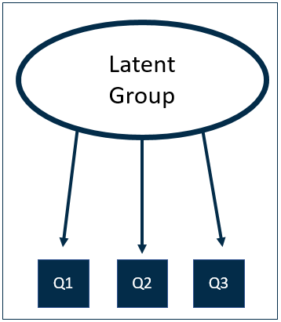

Figure 23 - Latent Class Diagram

Figure 24 - Cluster Analysis Diagram

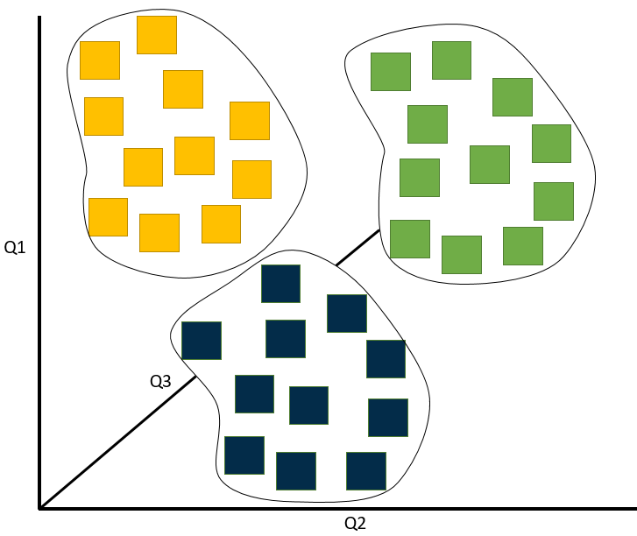

For this project, two stable and optimal solutions were found. A 5-class solution and a 4-class solution. In the interest of brevity, we have presented the 5-class solution below because it shows greater variability across the key variable of interest, interest in an Army career.

### Five segments

Key descriptions of each of the five segments are detailed below. Readers should note that the descriptions are only that; and are designed as a ‘short-hand’ to help readers understand the key attitudinal and behavioural differences between groups.

Figure 25: Pen portraits

**FPP** **Feckless, Poor & Pessimistic**

Very inactive, not at all religious with poor sense of personal and national identification. Pessimistic, unambitious and not at all civic-minded. Lives in the poorest areas.

**AAC Ambitious & Affluent Clique**

Fairly active with poor sense of national identification, but values friends and family. Not at all religious, but strongly ambitious. Lives in areas of affluence.

**GCP**

**Get-on Community Pride**

Fairly active, not religious, with a fairly strong sense of personal and national identification. Positive about life and local area, but unambitious. Lives in poorer areas.

**SLB**

**Strivers Lacking Belonging**

Fairly inactive, not religious, poor sense of personal and national identification, fairly ambitious and pessimistic. From areas of middling prosperity.

**CAC**

**Can-do Active Citizens**

Very active and civic-minded. Religious with a strong sense of personal and national identification. Positive and ambitious. Live in areas of rising prosperity.

**Have/would consider applying to the Army**

**24%**

**24%**

**31%**

**40%**

**48%**

The figure below shows how the MTA population breaks down by these five segments and shows that the segment that shows the strongest propensity towards a career in the Army accounts for a quarter of the MTA.

The two groups with the next highest propensity account for a further two in five of the MTA. The two segments that show the weakest propensity towards the Army account for three in ten (30%) of the MTA population.

Figure 26: Prevalence of segments in the MTA population (All MTA)

Interestingly, if you examine the propensity to be interested in joining the Army by segment (see below), we can see that the two largest segments by interest are slightly different. “**Can-do Active Citizens**” make up the largest group of interested (12% of the population), closely followed by “**Get-on Community Pride**” (11% of the population).

Because “**Strivers Lacking Belonging**” make up such a small proportion of the population, the total proportion of this segment who are interested in an Army career accounts for just 3% of the MTA. Likewise, those interested from the “**Ambitious Affluent Clique**” segment accounts for just 6% of the national population, and those classed as “**Feckless, Poor & Pessimistic**” and are interested account for just 1%.

Figure 27: Prevalence of Army career considerers across MTA segments

Interestingly, those who completed the Junior Soldier questionnaire were asked a similar set of behavioural and attitudinal questions that were used to classify both the MTA and Gatekeepers in the five MTA segments described above.

This has given us the ability to, understand, as best we can, whether the existing Junior Soldier population is reflective of the broader MTA, or particular groups.

All but two questions used in the segmentation were asked to Junior Soldiers in exactly the same way. And for those questions that were part of the segmentation process but were not asked as part of the Junior Soldiers questionnaire (just two), we have either taken a similar question response and recoded it to reflect the MTA version, or we have randomly distributed the sample to eliminate the effect of the variable.

Interestingly, there is a very clear skew in the composition of the Junior Soldier classification towards one of our key segments; **Get-on Community Pride** (GCP).

This is fairly strong evidence that suggests the existing Junior Soldier offer is already attracting disproportionately more recruits from this key segment.

Figure 28: Prevalence of segments in the Junior Soldier population

^*please note that sample sizes for the Junior Soldiers results are just 152 & 134 for long course & short course respectively*

As well as exhibiting higher levels of consideration of a career in the Army, the “**Can-do Active Citizens**”, who make up the largest group of interested MTA (12% of the population), are also the strongest advocates of a career in the Army, with a Net Promoter Score of -47.

Figure 29: Net Promoter Score by MTA segment

NPS

Unweighted bases in parentheses   
Q: On a scale of 0 to 10, where 0 is not at all likely and 10 is extremely likely, how likely is it that you would recommend a career in the Army to a family member or friend/your child?

-47

-85

-78

-89

-82

Promoters

Detractors

### Segment profiles

The figures overleaf illustrate the demographic and attitudinal profiles of the five segments identified.

Figures 30 and 31 show the variables that have been used to define the segments, and how each segment scores against these in absolute terms (expressed as a percentage).

Figures 32 to 34 show a range of other variables in indexed form, to illustrate the additional factors that characterise each segment.

To summarise:

**Can-do active citizens (CAC)**

This group have high educational aspirations and are very active. They regard their local area as improving, they feel that their ethnicity, religion, national identity, family and friends are important to their sense of self and are very satisfied with their life as a whole.

Slightly more likely to be male, aged 14 to 15 and living in ACORN defined areas of Rising Prosperity (please see below for more detailed description of ACORN definitions). This group is more religious than other groups and has very high levels of engagement with membership organisations.

**Strivers lacking belonging (SLB)**

This group has high educational aspirations and is moderately active. They regard their local area as getting worse, they do not feel that ethnicity, religion, national identity, family or friends are important to their sense of self and are dissatisfied with their life as a whole.

Slightly more likely to be aged 16 to 17; and living in ACORN areas of Rising Prosperity and Affluent Achievers. This group is fairly religious but non-Christian, with high levels of engagement with membership organisations.

**Get-on community pride (GOP)**

This group has low educational aspirations and is fairly active. Regard local area as getting worse, feel family and friends are important to their sense of self, and are fairly satisfied with their life as a whole.

Living in ACORN areas of Financially Stretched and Urban Adversity. Not very religious and with low levels of engagement with membership organisations.

**Ambitious affluent clique (AAC)**

High educational aspirations, and moderately active. Regard local area as stable, feel family and friends are important to their sense of self, and are fairly satisfied with their life as a whole.

Slightly more likely to be female, living in ACORN areas of Affluent Achievers. This group is not religious and with low levels of engagement with membership organisations.

**Feckless, poor, pessimistic (FPP)**

Low educational aspirations, and inactive. Regard local area as stable, do not feel ethnicity, religion, national identity, family or friends are important to their sense of self, and are dissatisfied with their life as a whole.

Slightly more likely to be male, aged 17, living in ACORN areas of Financially Stretched and Urban Adversity. This group is not at all religious and has very low levels of engagement with membership organisations.

### Acorn Categories

**Affluent Achievers**

These are some of the most financially successful people in the UK. They live in wealthy, high status rural, emi-rural and suburban areas of the country. Middle aged or older people, the ‘baby-boomer’ generation, predominate with many empty nesters and wealthy retired. Some neighbourhoods contain large numbers of well-off families with school age children, particularly the more suburban locations. These people live in large houses, which are usually detached with four or more bedrooms. Some will own homes worth many millions. Other homes are significantly more expensive than the average for their locality. Around one in eight of these families will own a second property. A high proportion of these people are very well educated and employed in managerial and professional occupations. Many own their own business. Incomes are generally well above average. Many can afford to spend freely and frequently and have also built up savings and investments. Wealth has also been, or is being, built up through their expensive houses. Most of these people are owner occupiers, with half owning their home outright and the remainder often having significant equity in their homes. Usually confident with new technology and managing their finances, these people are established at the top of the social ladder. They are healthy, wealthy and confident consumers.

**Rising Prosperity**

These are generally younger, well educated, and mostly prosperous people living in our major towns and cities. Most are singles or couples, some yet to start a family, others with younger children. Often these are highly educated younger professionals moving up the career ladder. Most live in converted or modern flats, with a significant proportion of these being recently built executive city flats. Some will live in terraced town houses. While some are buying their home, occasionally through some form of shared equity scheme, others will be renting. While many have good incomes not all might yet have had time to convert these into substantial savings or investments. They are likely to be financially confident, managing their money and choosing the provider of their financial, or other, services. They are the internet generation, ‘early adopters’ most likely to use smart phones and frequently use the internet and new technology. These people have a cosmopolitan outlook and enjoy their urban lifestyle. They like to eat out in restaurants, go to the theatre and cinema and make the most of the culture and nightlife of the big city.

**Comfortable Communities**

This category contains much of middle-of-the-road Britain, whether in the suburbs, smaller towns or the countryside. All life stages are represented in this category. Many areas have mostly stable families and empty nesters, especially in suburban or semi-rural locations. There are also comfortably off pensioners, living in retirement areas around the coast or in the countryside and sometimes younger couples just starting out on their lives together. Generally, people own their own home. Most houses are semi-detached or detached, overall of average value for the region. Incomes overall are average, some will earn more, the younger people a bit less than average. Those better established might have built up a degree of savings or investments. Employment is in a mix of professional and managerial, clerical and skilled occupations. Educational qualifications tend to be in line with the national average. Most people are comfortably off. They may not be very wealthy, but they have few major financial worries.

**Financially Stretched**

This category contains a mix of traditional areas of Britain. Housing is often terraced or semi-detached, a mix of lower value owner occupied housing and homes rented from the council or housing associations, including social housing developments specifically for the elderly. This category also includes student term-time areas. There tends to be fewer traditional married couples than usual and more single parents, single, separated and divorced people than average. Incomes tend to be well below average. Although some have reasonably well-paid jobs more people are in lower paid administrative, clerical, semi-skilled and manual jobs. Apprenticeships and O-levels are more likely educational qualifications. Unemployment is above average as are the proportions of people claiming other benefits. People are less likely to engage with financial services. Fewer people are likely to have a credit card, investments, a pension scheme, or much savings. Some are likely to have been refused credit. Some will be having difficulties with debt. These people are less likely than average to use new technology or to shop online or research using the internet, although will use the internet socially. Overall, while many people in this category are just getting by with modest lifestyles a significant minority are experiencing some degree of financial pressure.

**Urban Adversity**

This category contains the most deprived areas of large and small towns and cities across the UK. Household incomes are low, nearly always below the national average. The level of people having difficulties with debt or having been refused credit approaches double the national average. The numbers claiming Jobseeker’s Allowance and other benefits is well above the national average. Levels of qualifications are low and those in work are likely to be employed in semi-skilled or unskilled occupations. The housing is a mix of low rise estates, with terraced and semi-detached houses, and purpose-built flats, including high rise blocks. Properties tend to be small and there may be overcrowding. Over half of the housing is rented from the local council or a housing association. There is some private renting. The relatively small proportion of the housing is owner occupied is generally of low value. Where values are influenced by higher urban property prices these are still lower value relative to the location. There are a large number of single adult households, including many single pensioners, lone parents, separated and divorced people. There are higher levels of health problems in some areas. These are the people who are finding life the hardest and experiencing the most difficult social and financial conditions.

### Segment profiles

Figure 30: Educational and activity profiles of MTA segments (segmentation variables %)

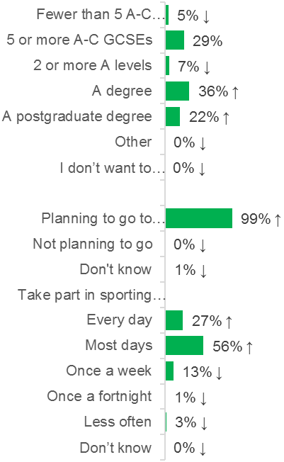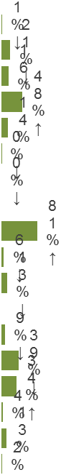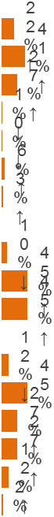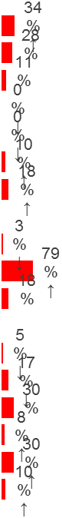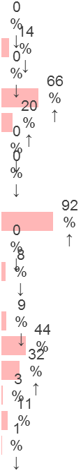

**Can-do active citizens (CAC)**

**Strivers lacking belonging (SLB)**

**Get-on community pride (GCP)**

**Ambitious affluent clique (AAC)**

**Feckless, poor, pessimistic (FPP)**

Figure 31: ‘Engagement’ profiles of segments (segmentation variables %)

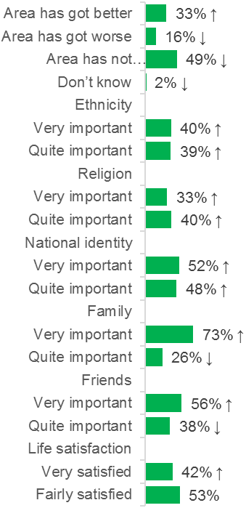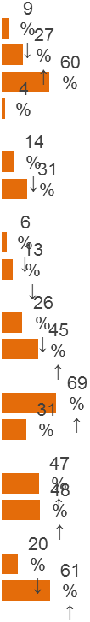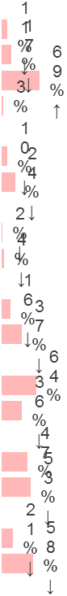

**Can-do active citizens (CAC)**

**Strivers lacking belonging (SLB)**

**Get-on community pride (GCP)**

**Ambitious affluent clique (AAC)**

**Feckless, poor, pessimistic (FPP)**

Figure 32: Demographic profiles of MTA segments (indexed figures)

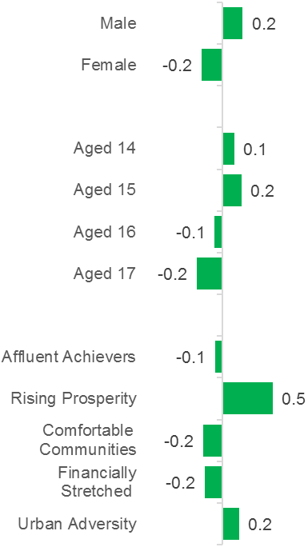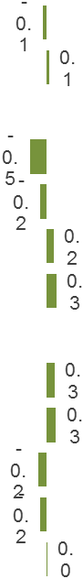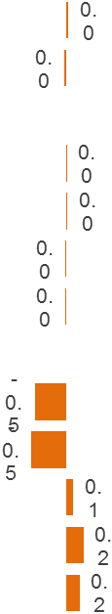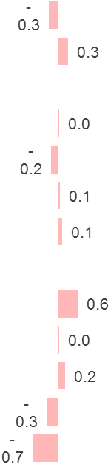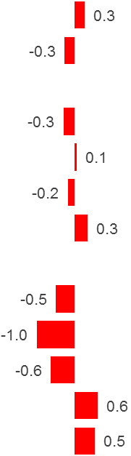

**Can-do active citizens (CAC)**

**Strivers lacking belonging (SLB)**

**Get-on community pride (GCP)**

**Ambitious affluent clique (AAC)**

**Feckless, poor, pessimistic (FPP)**

Figure 33: Religious profiles of MTA segments (indexed figures)

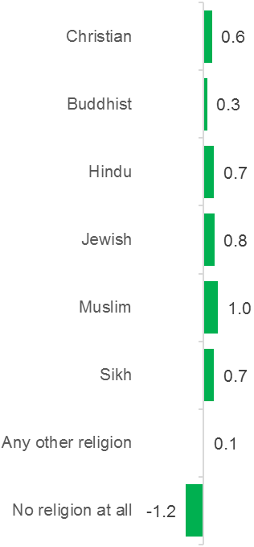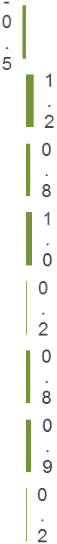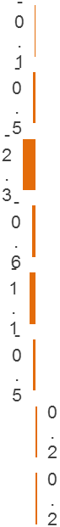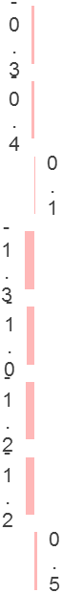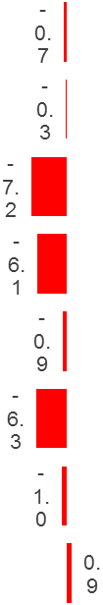

**Can-do active citizens (CAC)**

**Strivers lacking belonging (SLB)**

**Get-on community pride (GCP)**

**Ambitious affluent clique (AAC)**

**Feckless, poor, pessimistic (FPP)**

Figure 34: Membership profile of MTA segments (indexed figures)

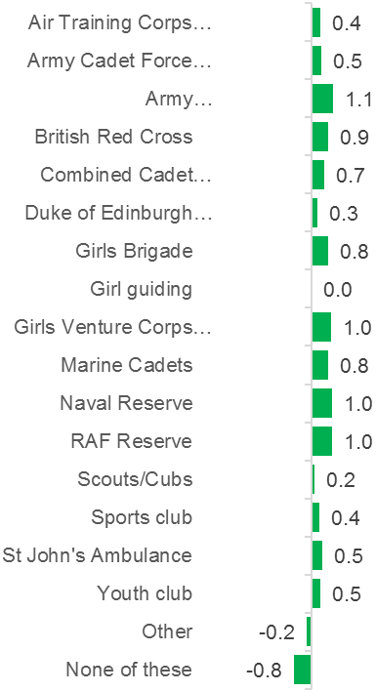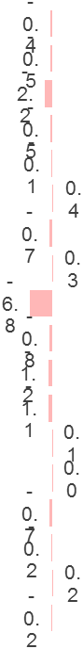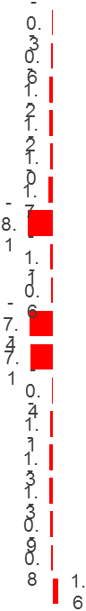

**Can-do active citizens (CAC)**

**Strivers lacking belonging (SLB)**

**Get-on community pride (GCP)**

**Ambitious affluent clique (AAC)**

**Feckless, poor, pessimistic (FPP)**

### Possible changes to the JE offer by MTA segment

The figure below shows how the five segments respond to the possible changes to the JE offer, and in each case, it is the Can-do Active citizens who respond most positively, particularly in relation to the educational options; and it is the Feckless.

Combined with the positive response of the current Junior Soldier cohort to the introduction of additional STEM, this provides further evidence that builds on the qualitative phase of research that the offer of **optional** STEM would be motivating to both current Junior Soldiers and key segments of the MTA.

Figure 35: More likely to consider joining the Army (All MTA by segment)

Arrows indicate statistically significant differences at the 95% level of confidence

Interestingly, when we examine the data for each segment by those who say they are interested and those not interested, there is a much larger discrepancy in the proportion that say STEM and Further Ed would make them more likely to consider an Army career.

Figure 36: More likely to consider joining Army by segment by Interested/Not Interested

Arrows indicate statistically significant differences at the 95% level of confidence

Figure 36 (above) shows that, as we might expect, across all segments, those who already say that they are interested in an Army career are more responsive to the introduction of STEM and Further Education. Three quarters (75%) of Can-do Active Citizens (CAC) who are interested in an Army career say that they would be more interested if there were more STEM, as do around three-fifths of GCP (57%) and AAC (63%) respondents who already say that they would consider joining the Army. Of all those who do not say that they are interested, the Can-do Active Citizen (CAC) segment is the most likely to be responsive to the introduction of STEM and Further Education, and Feckless, Poor & Pessimistic (FPP) are the least likely.

### The effect of STEM & FE offers on Army Consideration by age

For most segments, apart from Get-on Community Pride (GCP), there does appear to be a slight decline in the likelihood of being interested in an Army career by age group. Figure 37 (below) shows results for Army career consideration by age group. The biggest drop is seen among the Strivers Lacking Belonging (SLB) segment, which sees an 11% drop between 14-15-year olds and 16-17-year olds, followed by Feckless, Poor and Pessimistic (FPP).

Figure 37: Would consider/have considered joining Army by Segment by Age group

Arrows indicate statistically significant differences at the 95% level of confidence

When we analyse the data discussed in recent chapters, for whether respondents would be more or less likely to consider joining the Army based on whether the offer included more STEM subjects up to GCSE and A Levels; we also see slight decreases in the share who say that they would be more interested by age group. Figure 38 (below) shows that for Can-do Active Citizen’s (CAC), there is around a 6-percentage point drop between 14-15-year olds and 16-17-year olds being more likely to consider joining the Army if there were more STEM offered. So, although the offer is considered an attractive prospect for a majority in this segment, it has diminishing value with age. There is a 5-point drop for the Get-on Community Pride (GCP) segment, and a 2-point increase for Ambitious & Affluent Clique (AAC). The results for unconditional Further Education (see figure 39 below) show a slightly different picture.

Figure 38: More likely to consider joining Army if they were to offer more STEM subjects up to GCSE and A Levels by segment by Age Group

Arrows indicate statistically significant differences at the 95% level of confidence

For Can-do Active Citizen’s (CAC), there is around a 3-point drop in the proportion of the MTA that would be more likely to consider joining the Army if Further Education were offered unconditionally, between the ages of 14-15 and 16-17. There is a 4-point drop for Get-on Community Pride (GCP). For Strivers Lacking Belonging (SLB) and Ambitious & Affluent Clique (AAC) there is actually an increase of 9 and 2 percentage points respectively.

Figure 39: More likely to consider joining Army if you didn’t have to agree to accept military discipline, and could get further education through the Army whether you joined afterwards or not by segment by Age Group

Arrows indicate statistically significant differences at the 95% level of confidence

Overall the results suggest that for our two key segments at least (CAC and GCP), there is a small but notable incentive to recruit the MTA earlier, and that the introduction of more STEM may help to do so.

Considering that the introduction of STEM would be welcomed by those on the short course (and to some extent, those on the long course), the data above appear to corroborate earlier findings finds.

It is our view that the introduction of more STEM may attract more of the key segments, but critical to this will be the level at which they would be able to take STEM; especially given that they will move on to their regiment to complete more job-related STEM.

Consequently, for this reason and others discussed in more detail below, its ability to attract key segments will be a positive, but ultimately a limited one.

Analysis of the introduction of Further Education options gave mixed results, but key here is that joining the Army with these conditions does not become a more attractive prospect with age for both of our key segments, Get-on Community Pride (GCP) and Can-do Active Citizens.

Therefore, the notion that it may be worth the Army waiting to pursue them until they are 18+; having completed A level/degree, is not supported by the results. There may be some merit in trying to attract those classed as CAC as U18s through a separate and significantly enhanced offer, but there is no evidence that waiting for, and a developing an enhanced Further Education offer for post-18 will improve interest.

### Segment Mapping

Using multilevel regression poststratification modelling, the map below charts estimated density of the **Can-do Active Citizens** segment across England & Wales. yellow and green areas represent higher than average areas, and red areas lower than average.

Figure 40: Can-do Active Citizens (CAC) Quintiles by Local Authority

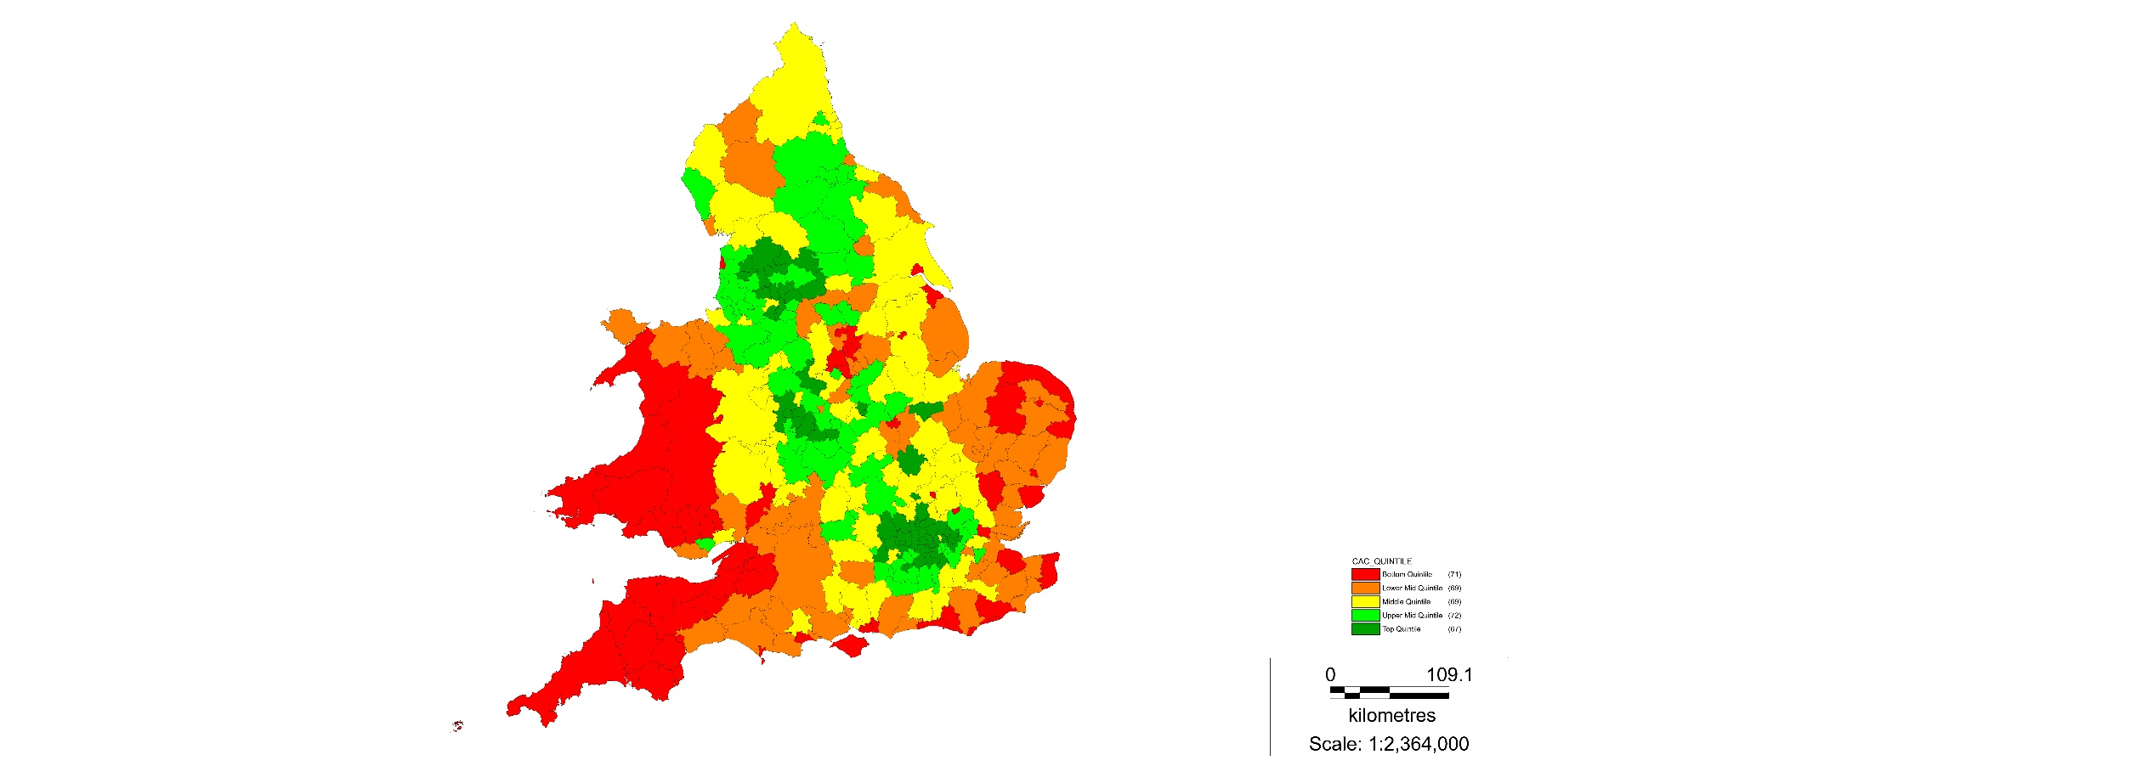

|  |  |  |
| --- | --- | --- |
| **Can-Do Active Citizens** | | |
| Top 20 Local Authorities |  | Bottom 20 Local Authorities |
| **Newham** | 1 | **Blaenau Gwent** |
| **Redbridge** | 2 | **Isles of Scilly** |
| **Harrow** | 3 | **Norwich** |
| **Tower Hamlets** | 4 | **Hastings** |
| **Slough** | 5 | **Caerphilly** |
| **Brent** | 6 | **Rhondda / Cynon Taf** |
| **Ealing** | 7 | **Brighton and Hove** |
| **Blackburn with Darwen** | 8 | **Merthyr Tydfil** |
| **Luton** | 9 | **Torfaen** |
| **Hounslow** | 10 | **Kingston upon Hull** |
| **Waltham Forest** | 11 | **Cornwall** |
| **Bradford** | 12 | **Ashfield** |
| **Westminster** | 13 | **Great Yarmouth** |
| **Birmingham** | 14 | **Torridge** |
| **Barnet** | 15 | **Plymouth** |
| **Enfield** | 16 | **Bridgend** |
| **Hillingdon** | 17 | **Lincoln** |
| **Leicester** | 18 | **Isle of Wight** |
| **Oldham** | 19 | **Waveney** |
| **Merton** | 20 | **Neath Port Talbot** |

The results of the multilevel regression poststratification modelling above give an alternative estimate of the **Can-do Active Citizens** segment of 22.6%, more than 3 percentage points less than the survey estimate. The map below charts the estimated density of the **Get-on Community Pride** segment across England & Wales. Again, green areas represent top quintile local authorities, and red areas represent bottom quintile LAs.

Figure 41: Get-on Community Pride (GCP) Quintiles by Local Authority

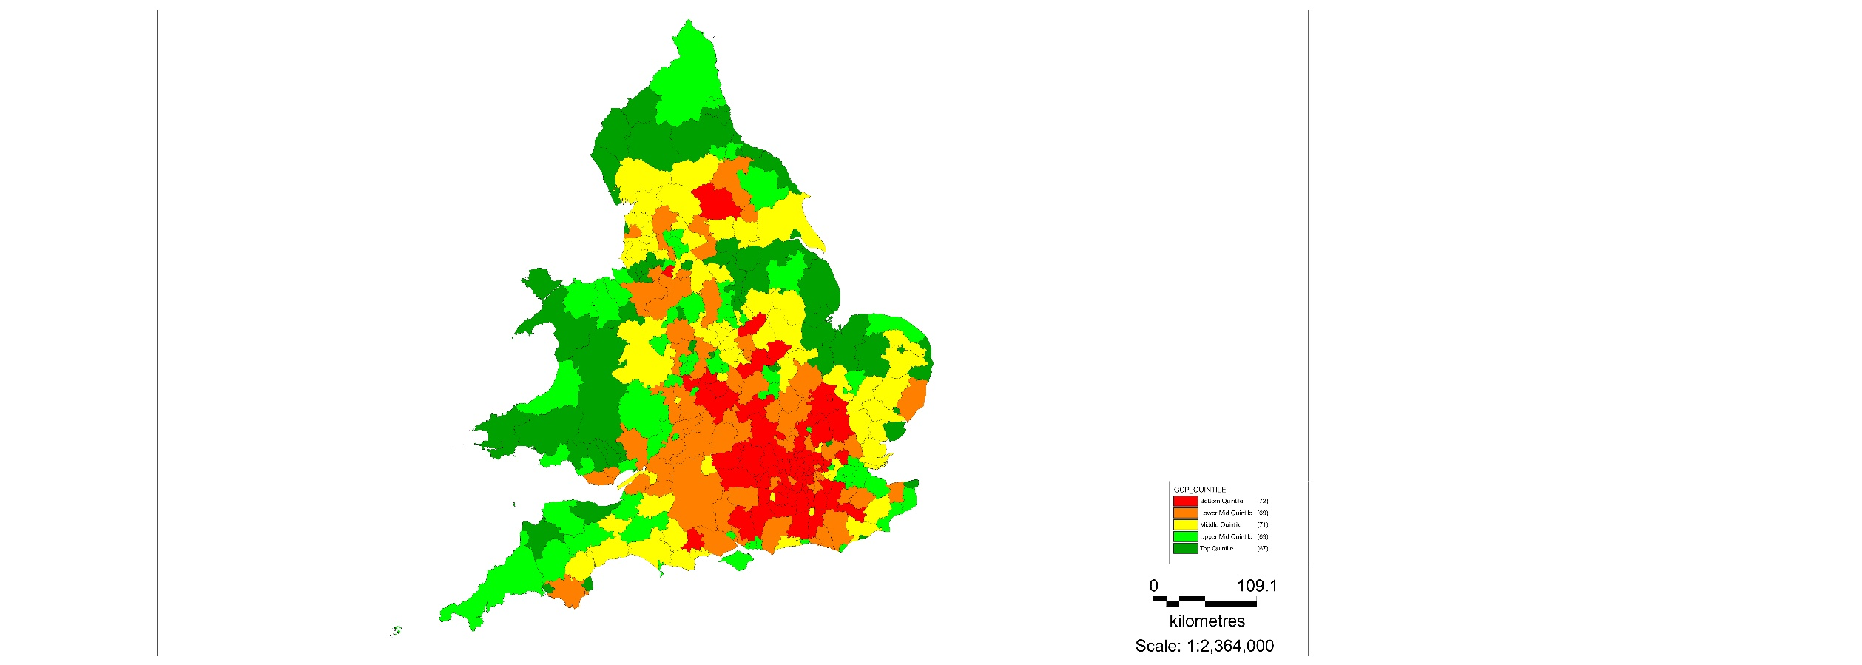

|  |  |  |
| --- | --- | --- |
| **Get-On Community Pride** | | |
| Top 20 Local Authorities |  | Bottom 20 Local Authorities |
| **Blaenau Gwent** | 1 | **City of London** |
| **Kingston upon Hull** | 2 | **Harrow** |
| **Boston** | 3 | **Westminster** |
| **Merthyr Tydfil** | 4 | **Richmond upon Thames** |
| **Knowsley** | 5 | **Barnet** |
| **Neath Port Talbot** | 6 | **Redbridge** |
| **Blackpool** | 7 | **Wokingham** |
| **Great Yarmouth** | 8 | **St Albans** |
| **Hartlepool** | 9 | **Elmbridge** |
| **South Tyneside** | 10 | **Kensington and Chelsea** |
| **Torfaen** | 11 | **South Bucks** |
| **Ashfield** | 12 | **Wandsworth** |
| **North East Lincolnshire** | 13 | **Chiltern** |
| **Corby** | 14 | **Tower Hamlets** |
| **Bolsover** | 15 | **Hart** |
| **Redcar and Cleveland** | 16 | **Windsor and Maidenhead** |
| **Stoke-on-Trent** | 17 | **Kingston upon Thames** |
| **Caerphilly** | 18 | **Epsom and Ewell** |
| **Torridge** | 19 | **Woking** |
| **Sunderland** | 20 | **Ealing** |

The results of the multilevel regression poststratification (MRP) modelling above give an alternative estimate of the **Get-on Community Pride** segment of 44.4%, more than 8 percentage points higher than the survey estimate.

The difference in the results for the two segments are stark, with top-areas for **Can-do Active Citizens (CAC)** tending to be in larger cities, and top areas for **Get-on Community Pride (GCP)** tending to centre on post-industrial towns.

### Re-estimating the size of key groups and forecasting their size for 2021

Overall, using the MRP modelling to re-estimate the total proportion of those who are interested, or have been interested in an Army career, gives an overall figure of just over one quarter of the MTA (27.8%). This figure is around 6% lower than the original survey estimate. Using this updated information can allow us to estimate the current annual population.

* Total Population of the MTA (14-17-year olds) = 2,757,490;
* Total Population of the MTA (14-17-year olds) within a single year in-take = 689,372.

Figure 42: Estimates of those interested in an Army career

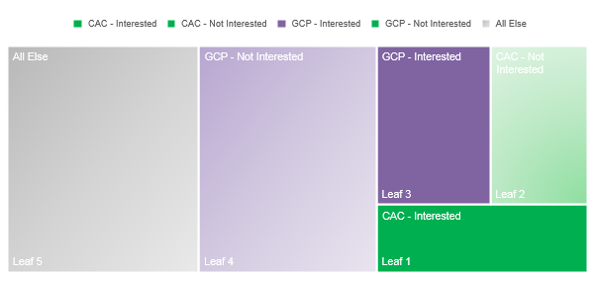

Having calculated the total annual population of the MTA per annum, we can now estimate the maximum populations who would consider an Army career within the two key segments; Can-do Active Citizens (CAC) and Get-on Community Pride (GCP).

* Maximum Population Interested within Key Segments (Purple and Green coloured areas) = 169,674 (24.6%);
* Maximum Population Interested within CAC (Green coloured Areas) = 74,843 (10.9%);
* Maximum Population Interested within GCP (Purple coloured Areas) = 94,830 (13.7%).

Readers should be aware that the estimates provided are just that, estimates which may be subject to a degree of error. So, although we have given the estimated figures, they should be interpreted in a more general sense rather than in exactitudes.

Having estimated maximum size of the interested audience, and the maximum size of those interested by CAC and GCP for 2011, we retro-forecasted the results to 2001 estimate and presumed linear population growth estimates between 2011 and 2021 at the same rate as for 2001 to 2011.

* Forecasted Maximum Population Interested within Key Segments for 2021 = 177,349 (24.6%);
* Forecasted Maximum Population Interested within CAC Segment = 79,795 (11.1%);
* Forecasted Maximum Population Interested within GCP = 97,554 (13.5%).

Although there appears to have been very little change in the overall proportion of MTA who are interested between 2001 and the forecasted result in 2021, the results at local authority level show much more movement.

Figure 43: Local Authority change in interest in Army career 2001 to 2021

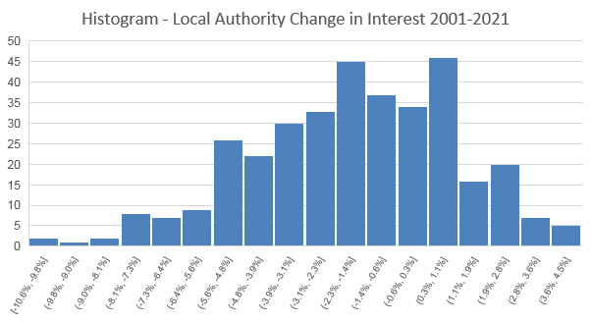

This is because the population has been growing unevenly across England and Wales. This means that while we expect to see the share of the overall population remain the same nationally, the actual number of those who are interested will grow.

As the histogram above shows, there is of course very large variation across local areas. Some local authorities will have seen in excess of a ten percent fall in populations that are interested in an Army career, whilst others will have seen almost a five percent increase.

Between 2011 and 2021 an additional 7,665 interested annual MTA will have been added. The CAC segment will grow by almost five thousand people, but just a fraction of a percent of the total population. The CGP segment will grow by just over two and a half thousand people, but decline by a fraction of a percent of the total population.

Figure 44: Maximum interested within segments

Figure 45: Maximum interested within CAC

Figure 46: Maximum interested within GCP

The results presented above present a story that may at first feel counterintuitive but is in fact perfectly plausible.

There may well always be a sizable share of the national population who could be interested in an Army career. The evidence suggests the total size of interested population is not small. Instead the results show that the audience is more than sufficient in size to fulfil recruitment objectives, and interestingly the maximum size of the audience may be growing, in absolute terms, and not falling.

What may have changed substantially, may not be the size of the audience, but instead the opportunity cost of an Army career, the alternatives, and how the Army engages with its audience.

With this in mind, we now move onto assess how the MTA value key components of the Junior Entry offer.

## Conjoint analysis

### Method

Our research design included a “Conjoint Experiment” (*part of the discrete choice modelling family of survey techniques*) and was designed to analyse multidimensional preferences of the Junior Entry (JE) offer for the MTA. This approach allowed us to examine, simultaneously, the effect of multiple features of the JE Offer.

Key attributes of the offer which were tested include:

* Type of career* (Army Apprenticeship, Business Apprenticeship, Technical Apprenticeship);
* Location (local, UK, overseas);
* Pay (£900, £1,200, £1,600 per month);
* Content of training (20% education/80% on the job training, 50% education/50% on the job training, 80% education, 20% on the job training);
* Duration of training (minimum of 3 months, minimum of 6 months, minimum of 12 months);
* Length of time you have to stay in the job after training (2 years, 4 years, 6 years);
* Job role (choose before you start training, choose during training, choose on completion of training).

*\*Please note: for Junior soldiers this attribute was not included*

The respondent was asked to evaluate different offers presented to them. The offers were presented as packages aimed at the MTA, with items for each attribute randomly selected and displayed.

In the figures displayed below you can see how these were introduced and the presented to respondents.

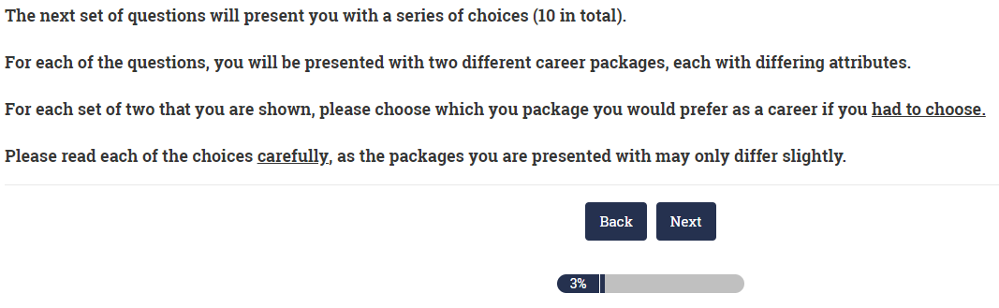

Respondents were asked to choose between 2 offers, which were comprised of a random combination of attribute levels.

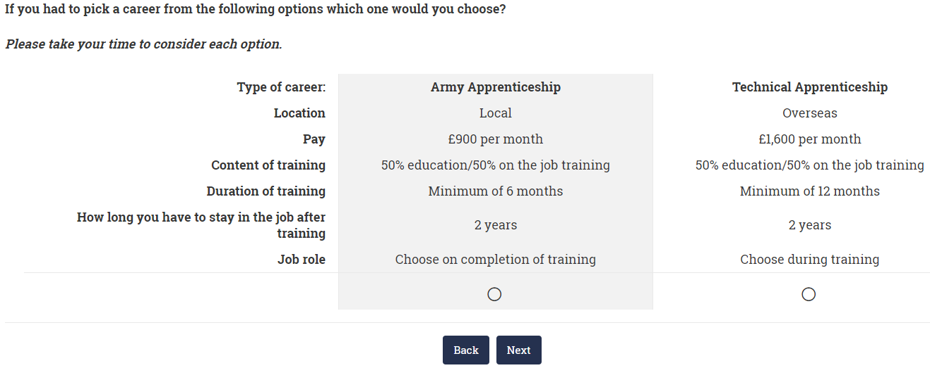

### Conjoint outputs

The data are analysed using a ‘conditional logistic regression’ approach, and the results can be analysed for different sub-groups. The results of the Conjoint Analysis show give us two pieces of information.

First of all, the ‘utility’ of each attribute. This is the amount of variation that is explained by that particular attribute. The driving factors for respondents when selecting which option, that they prefer.

Figure 49 below shows the ‘Utility’ results for each attribute for all MTA respondents. The data suggest that ‘Type of career’ accounts for 31% of respondents’ choice motivations and is the main driver of choice. Pay accounts for 26% of respondents’ choice motivations and location for 22%. That means that 79% of young people’s choices motivations are driven by just three very basic attributes, Career Type, pay and location.

When you include the expected length of stay in the job, which accounts for 16% of choice motivations, we can explain 95% of the drivers of selecting an offer.

Offer attributes such as training content, duration of training and job role account for a very small proportion of young people’s decisions when thinking about a career, just 5% between them.

Figure 47: Conjoint Output – All Respondents

The second piece of information to consider from this type of analysis is the impact of each level within the attributes. We have produced standardised estimates for how attractive each level of an attribute is for respondents. This means that we can compare the effect not only of each attribute, but also whether there are any diminishing returns to levels, or how the impact of levels compares with others from different attributes.

The figures given in the chart below (Figure 50) are generally transformed indicators and do not directly relate to the likelihood of selecting an offer. To do so, you must transform the results by taking the exponential of these figures. This means that overall, a career that offers a technical role (0.78) would be 2.18 times as likely to be selected on average.

Figure 50 below shows results for the impact of each level with all attributes for all respondents. The first thing to notice is that when compared to Business and Technical occupations, a role in the army is seen as much less attractive. As there is relatively little difference between Business and Technical roles, this suggests that the Army will be the key distinction, and likely have a significant negative effect. These impacts are larger than for any other attribute level.

The results for Pay show a linear effect – which is intuitive. The higher the pay the stringer the effect.

Also, UK-based and ‘local’ locations are strongly preferred to overseas locations with a slight preference for Local over UK.

As you might expect, shorter commitments to the army (length of stay in the job) are more attractive than longer ones, which again is intuitive. Other attributes do not show major or significant differences.

Figure 48: Conjoint Output – All Respondents

### Conjoint analysis of the Junior Entry Offer by MTA segment

When we analyse the results by segments we can see substantial changes in the proportional utility of each attribute for the different segments. For instance, those whose choice motivation is driven most by Pay, is Strivers Lacking Belonging, and those with the highest choice motivation for Location is Get-on Community Pride.

Figure 49: Conjoint Output – by Segment

The results above show large variations in the utility of each attribute when respondents are selecting an offer.

For instance, although Get-on Community Pride shows the largest utility for Location of the offer (28%), Ambitious & Affluent Clique shows the smallest with just 13% of their choice motivations explained by this attribute.

Although Strivers Lacking Belonging are driven most by the Pay attribute of an offer, with 33% of their choice motivation explained by it, for Feckless, Poor & Pessimistic just 17% of their decisions are explained by the pay offer.

For Ambitious & Affluent Clique, type of Career dominates preferences, with 39% of their choice motivation explained by this attribute alone.

Examining the level-effects for the segments reveals more detail about each component of an offer for each group.

Starting with **Can-do Active Citizens** (below) who are most likely to say that they would consider joining the Army (48%), the results show that Pay is the most important component of their choice motivations, with the top-band offer of £1,600 per month shown to be more impactful than Career Type. Location is a much smaller effect than average with no statistical difference between being UK-based or local.

Figure 50: Conjoint Output – CAC “Can-do Active Citizens” - *Very active and civic-minded. Religious with a strong sense of personal and national identification. Positive and ambitious. Lives in areas of rising prosperity*

**Strivers Lacking Belonging** (below) are the next most likely to say that they would consider joining the Army (40%). Again, Pay is the most important component of their choice motivations, but only just.

Strivers Lacking Belonging have a slight preference for Technical occupations. Location has only a very small effect and there are no statistical differences between being UK-based or local.

Figure 51: Conjoint Output – SLB “Strivers Lacking Belonging” - *Fairly inactive, not religious, poor sense of personal and national identification, fairly ambitious and pessimistic. From areas of middling prosperity*

**Get-on Community Pride** (below) are the next most likely to say that they would consider joining the Army (31%). This time we can see clearly different attribute effects, with being Local having the largest impact. There is a slight preference for Technical Career Types, but the Army is shown to have a bit of an image problem for this group. Pay is still linear but much less important compared with other groups. Get-on Community Pride are less bothered by length of service than others, but six years is still relatively unattractive.

Figure 52: Conjoint Output – GCP “Get-on Community Pride” - *Fairly active, not religious, with a fairly strong sense of personal and national identification. Positive about life and local area, but unambitious. Lives in poorer areas.*

**Ambitious & Affluent Clique** (below) are one of the least likely to say that they would consider joining the Army (24%). Career Type is by far the strongest impact with a slight preference for Business occupations. The Army is shown to have a large image problem for this group. Pay is still a very important factor when compared with other groups and length of service is also very important. Ambitious & Affluent Clique appear to have a very different set of choice motivations than other groups.

Figure 53: Conjoint Output – AAC “Ambitious & Affluent Clique” - *Fairly active with poor sense of national identification, but values friends and family. Not at all religious, but strongly ambitious. Lives in areas of affluence.*

**Feckless, Poor & Pessimistic** (below) are the other segment least likely to say that they would consider joining the Army (24%). Although Career Type has the strongest impact, the Army is shown to have a strongly negative effect. Less motivated by Pay, being local is very important to those who are members of Feckless, Poor & Pessimistic (FPP). Choice motivations for FPP are less pronounced that other groups.

Figure 54: Conjoint Output – FPP “Feckless, Poor & Pessimistic” - *Very inactive, not at all religious with poor sense of personal and national identification. Pessimistic, unambitious and not at all civic-minded. Lives in the poorest areas.*

### Conjoint analysis of the Junior Entry Offer comparing parents with their children by segment

Given that Parents and Gatekeepers were asked exactly the same type of questions for the conjoint analysis as the MTA, this gives us a unique opportunity to assess how parental and child motivations compare. Interestingly, when we match the data for Parents and Gatekeepers back to their respective MTA child, we can see how the different drivers of choice vary by the different segments. For instance, most parents (though not all), place greater emphasis than their children on the role being domestic/local. Also, most parents tend to value the Pay component very slightly less and the type of Career slightly more than their children.

Looking at the results for **Can-do Active Citizens** (below), we can see that the results show that Career Type is the most important driver, with Career Type and Location of the offer higher drivers of offer choice than for their children. Parents of Can-do Active Citizens will be 2.2 times more likely to select an offer that is for a role in Business when compared with an offer for the Army, and 1.9 times as likely to select an offer that is Local than one that is Overseas. Pay is valued slightly less than for their children, with parents 1.6 times as likely to choose an offer with the top-band of £1,600 per month rather than £900 per month.

Figure 55: Conjoint Output – CAC “Can-do Active Citizens” - *Very active and civic-minded. Religious with a strong sense of personal and national identification. Positive and ambitious. Lives in areas of rising prosperity*

Looking at the results for **Strivers Lacking Belonging** (below), we can see that there are very large differences in the results when compared with their children. Although 40% of children classified as Strivers Lacking Belonging (SLB) say that they are interested in an Army career, their parents show one of the largest opposition to Army roles. Parents of SLB are more than 2.8 times as likely to select offers that are for a Business Career Type than an Army role, and 2.3 times as likely to select offers that are advertised as Local rather than ones Overseas.

Parents of SLB are aligned with their children on the pay component of the offer but tend to value a shorter length of the course more, as well as the ability for their children to select their role during or after completion of the course. Perhaps suggesting that the parents feel their children would need more time, experience and guidance to come to a settled decision.

When we compare the differences between parents and children of the SLB segment with those for CAC, the results suggest that the parent-child relationship and expectations are very different, with interests more aligned and supportive for an Army career among CAC, and less aligned and supportive for SLB.

Figure 56: Conjoint Output – SLB “Strivers Lacking Belonging” - *Fairly inactive, not religious, poor sense of personal and national identification, fairly ambitious and pessimistic. From areas of middling prosperity*

The results between parents and children of the **Get-on Community Pride** (GCP) segment show similar levels of parent-child alignment as those classed as CAC. Interestingly, parent choices are driven less by Location than their children, otherwise there does not appear to be any parental barriers in the key drivers of the offer for GCP.

Figure 57: Conjoint Output – GCP “Get-on Community Pride” - *Fairly active, not religious, with a fairly strong sense of personal and national identification. Positive about life and local area, but unambitious. Lives in poorer areas*

Results for parents and children of the **Ambitious & Affluent Clique** (AAC) segment show differential drivers of the Junior Entry offer.

Levels of parent-child alignment differ for the key attributes of Career Type and Location, and also Pay. Interestingly, parent choices are driven less by Career Type than their children, suggesting that the Army is less of a barrier.

Where AAC children are three and a half times as likely to select an offer that has a role in Business, their parents are almost two and a quarter times as likely. Parents place greater emphasis on Location, and far less emphasis in Pay.

Figure 58: Conjoint Output – AAC “Ambitious & Affluent Clique” - *Fairly active with poor sense of national identification, but values friends and family. Not at all religious, but strongly ambitious. Lives in areas of affluence*

Finally, results for parents and children of the **Feckless, Poor and Pessimistic** (FPP) segment show interesting and slight differential drivers of the Junior Entry offer.

As for their children, parents are more likely to select an offer with a technical role, but they are less likely than their children to select a Business Career Type offer.

FPP parents tend to value the pay component of the JE offer slightly more than their children and are significantly less driven by the location of the job offer than their children also. FPP Children are almost two and a half times as likely to pick an offer that is local rather than overseas, compared with just over one and a half times as likely for their parents.

Figure 59: Conjoint Output – FPP “Feckless, Poor & Pessimistic” - *Very inactive, not at all religious with poor sense of personal and national identification. Pessimistic, unambitious and not at all civic-minded. Lives in the poorest areas*

### Conjoint analysis by Ethnicity

When we segment the results for the MTA by broad ethic group, we see fairly large differential drivers of the Junior Entry offer. Figure 64 (below) shows the utility of attributes for the Junior Entry offer split by Black, Asian & Minority Ethnic (BAME) respondents and those classed as White British.

What is immediately apparent is the substantial difference in utility of the Career and Location attributes between the two.

For BAME MTA respondents, Career Type accounts for 39% of choice motivations and Location just 12%.

For White British MTA Career Type accounts for 10% less of the choice motivations (29%), and Location for much around 23%.

Figure 60: Conjoint Output – Utility of Attributes by Ethnicity

Figure 61: Conjoint Output – BAME Respondents*.*

The results in figure 65 (above) show that when we control for other offer attributes, those MTA that are classed as from the BAME community are almost 3 times (2.98) as likely to select an offer that includes a Business Career Type when compared to one for the Army. They are 2.68 times as likely to choose a technical Career Type than an Army role.

Location is a less significant driver of choice selection for BAME respondents, with offers that are Local selected on average 1.41 times as much as Overseas offers. This is compared to Local offers being selected 1.8 times as much for White British respondents.

There is little difference between BAME and White British MTA on Pay, with an offer that pays £1,600 per month selected almost 2.1 times as much as an off that pays £900 per month for BAME respondents and almost twice (1.98) as often for White British respondents.

Figure 62: Conjoint Output – White Respondents*.*

Finally, for White British MTA respondents, while Business and Technical Career Types were selected on average 2.12 and 2.13 times as much respectively, as described above, this is substantially less likely than for BAME respondents (2.98 & 2.68 respectively).

### Conjoint analysis by Gender

When we segment the results for the MTA by gender, surprisingly there are appears to be very little differential drivers overall for the Junior Entry offer.

Overall, it appears that Male and Female MTA are driven by the attributes of the Junior Entry offer to similar degrees.

Figure 67 (below) shows these results. There are only very slight differences in the utility of each attribute to drive the selection of offers.

However, when we look at the data in more detail, what becomes apparent is the slight directional differences within each offer attribute.

Figure 63: Conjoint Output – Utility of Attributes by Gender

Figure 64: Conjoint Output – Male

While male respondents are 2.24 times as likely to select an offer that is for a Technical role, when compared to an Army Career Type, female are 2.16 times as likely. However, female respondents are 2.42 times as likely to choose a Business Career type, compared with 2.03 for male respondents.

There is also a small, but consistent increased value in the offer being Local for female respondents. Whilst this only accounts for 2.2% additional utility, the difference in odds of selection is noteworthy. For girls being local is selected 1.88 times as often as Overseas offers, and for boys the difference is just 1.63 for the same level.

Figure 65: Conjoint Output – Female

Finally, there is slightly greater value placed on shorter Length of Service for girls than boys. 2 year offers are selected 1.6 times as often as 6 year offers, and for boys the odds are just 1.42 when compared to 6 year length of stays.

### Conjoint analysis of the Junior Entry Offer for Junior Soldiers by Course Length

The project also took the opportunity to ask Junior soldiers a similarly structured set of questions in order to ascertain, with the benefit of hindsight, the relative value of each component of the Junior Entry offer. As we were interviewing Junior Soldiers, asking about Career Type was not a relevant variable for analysis so a shortened version of the design was used.

The key attributes for Junior soldiers were Location, Pay, balance of Content of Training, Duration of Training, Length of Stay in the Job and when to decide the Job Role.

These results give us an opportunity to assess how the differences in the relative value of the JE offer by the length of course also, so the results have been split by those on the Short Course, and those on the Long Course.

Figure 66: Conjoint Output – Utility of Attributes by Junior Soldier Length of Course

The key attributes for Junior soldiers were Location, Pay, balance of Content of Training, Duration of Training, Length of Stay in the Job and when to decide the Job Role, and as the results show, there is significant variation in the utility of each attribute.

Those on the Short Course are shown to be driven more by the Pay (54%) component of the offer, and those on the Long Course are shown to be driven most by the Content of the Training (38%).

The attribute level results, displayed below, show that pay is a strong predictor of choice for those on the Short Course. Those on the Sort Course are three times as likely to select an offer if it offers £1,600 a month than if it offered £900. There is also reasonably strong preference for length of stay to be 4 years of less.

Figure 67: Conjoint Output Utility of Attribute Levels – Junior Soldiers Short Course

For those on the Long Course the results are very different. The results shown in the chart below, suggest that the balance of Training Content is much more important, with the minimum amount of education the most predictive of choice motivations. This part of the JE offer is even more important than the top pay bracket. Interestingly, those on the Long Course have a slight preference for longer periods of service. They tend to be around 1.2 times as likely to select an offer if it stipulates 4 or more years.

Figure 68: Conjoint Output – Junior Soldiers Long Course

## Sentiment analysis

### Results for the MTA

The results for the sentiment analysis shows how the MTA responded to a cut-down version (76 seconds long) of a marketing video created for the Army about the Junior Entry offer. A random 50% of the survey respondents were shown the video and asked to give live feedback as they watched it, and also post-video. For the scores, respondents were asked whether they thought that parts of the video were more or less interesting (see figure 62 below). These results are then weighted and aggregated.

Figure 69: Sentiment Analysis – Results by MTA Segments

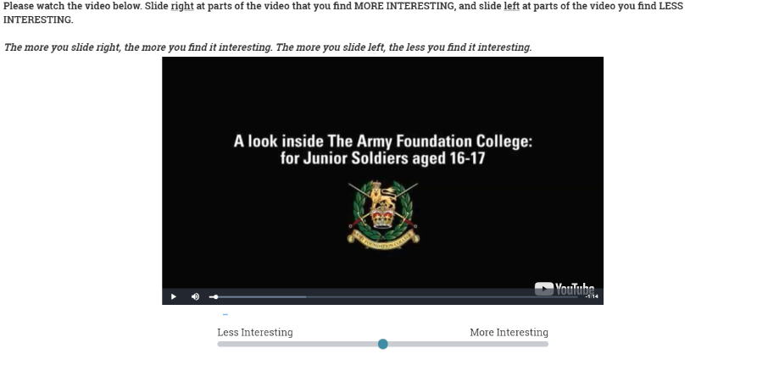

The results displayed in Figure 66 (below) show that there are substantial differences in the level of interest depending on MTA segment throughout the video. From the data in Figure 66, there are two initial findings to report.

Firstly, there are movements which are consistent with key ‘moments/messages’ in the video that are also consistent across groups, therefore we can be sure that the MTA have clearly interpreted and responded to these messages as instructed.

Second there are also movements that are consistent with key ‘moments/messages’ in the video which are different across MTA segments.

These movements show that our most promising MTAs, **Can-do Active Citizens** and **Get-on Community Pride** respond positively to the video throughout, though to varying degrees. Can-do Active Citizens (CAC) respond strongly positively, and dip only slightly at times, finishing strongly. Get-on Community Pride also respond positively but less-so than for CAC.

Figure 70: Sentiment Analysis – Results by MTA Segments

Although there is significant variation across the length of the video, results for the **Feckless, Poor & Pessimistic** (FPP) segment show consistently negative ratings, from start to finish.

Results for **Strivers Lacking Belonging** (SLB) and the **Ambitious & Affluent Clique** (AAC) show mixed results, often positive and other times negative, with different patterns of response.

For all five MTA segments it’s fair to say that the introductory part of the video, the first 12 seconds, are simply reflective of their general view of the Army, with the CAC and GCP segments in the positive, and the AAC, SLB and FPP segments in the negative.

The next tranche of video is 13 seconds long and illustrates some of the social and activity facilities that are available for recruits.

As is illustrated in Figure 67 (below), when the narrator describes the facilities being “really good”, including a swimming pool, gym and welfare, describing how there are computer rooms, pool tables and a cinema, and displaying imagery that shows young people socialising and using the facilities, average sentiment for all segments rises substantially. This peaks at 25 seconds into the video, when the top four segments, CAC, GCP, SLB and AAC all show significantly positive sentiment scores. Although the FPP segment records their highest score throughout the video, it’s not quite positive, just below the zero-line.

Figure 71: Sentiment Analysis – Results by MTA Segments (12-25 Seconds)

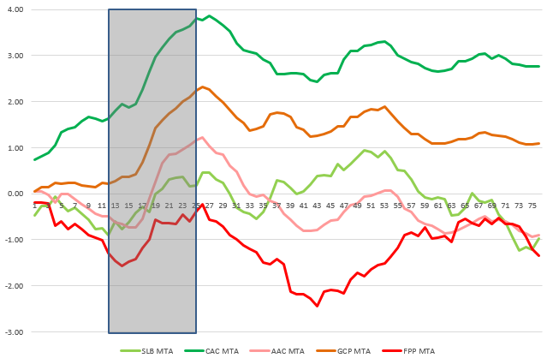



The next tranche of video is 8 seconds long and focuses on fitness. It pictures young recruits in full gear on long and muddy runs with a young man narrating that “*you don’t really need to be that fit to get in; you need to be fit to say in; 5 mile runs; navigation; map-reading; compass-work*”. It’s clear to see from the results (see figure 68, below) that all five segments show a gradual decline in sentiment scores, and largely to the same degree.

Figure 72: Sentiment Analysis – Results by MTA Segments (25-33 Seconds)

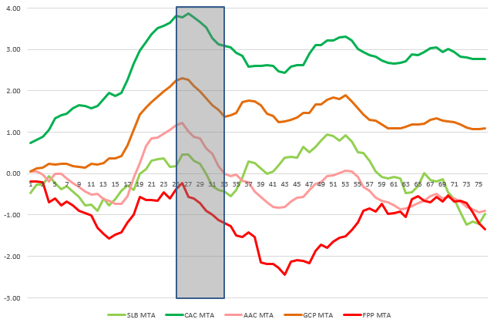

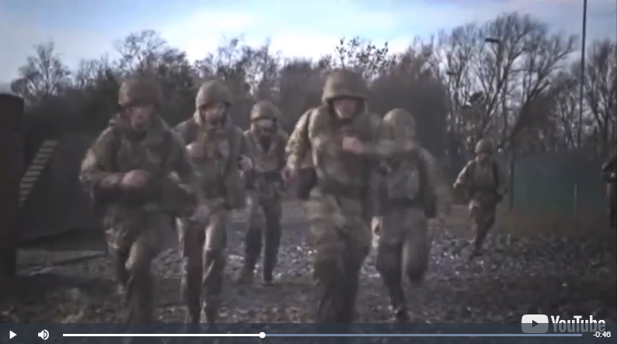

Only the GCP and CAC segments remain quite strongly positive after this portion of the video has been shown; and the AAC and SLB segments show middling results, with FPP back into strongly negative scores. Even for the next tranche of video this trend for FPP and AAC continues to move even more strongly negative.

The next tranche of video is quite short, just 5 seconds long, and features a series of short video clips picturing recruits loading and firing weaponry under range conditions. This part of the video is narrated by a recruit who describes the activity as “*weapons handling*”.

Figure 73: Sentiment Analysis – Results by MTA Segments (33-38 Seconds)

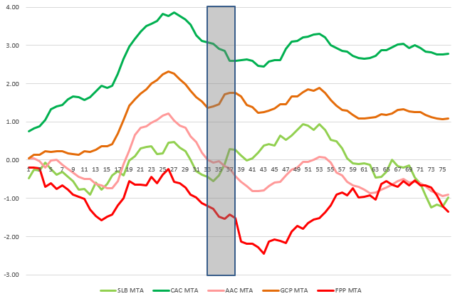

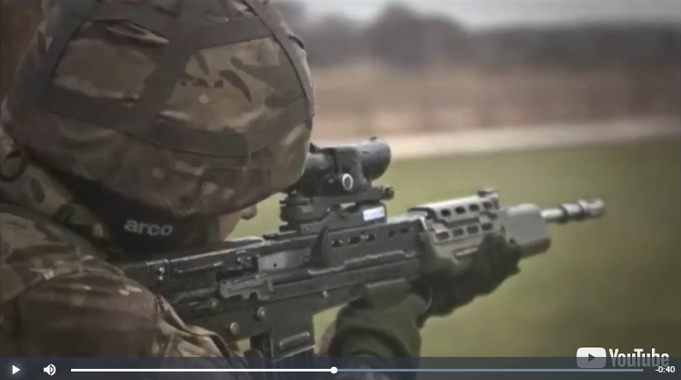

Interestingly, during this portion of the video there was no real reaction displayed by the CAC segment, who ‘level-off’ a little and continue on a very slight decline which was initiated by the previous tranche of video on hard work and exercise. For the FPP and AAC segments also, there appears to be no significant reaction, with a slight ‘levelling-off’ for a brief moment, but otherwise a continued and gradual decline. However, for the SLB and GCP there are strong and significant increases in the sentiment towards the video at this point.

These results suggest that strong and differential attraction to a key component of the Army offer for these segments, who are clearly interested in and respond positively to the images of firing weaponry. GCP is a key target segment for the Army, and it is interesting that they respond differently at this point of the video to CAC, who are also a key target segment.

Figure 74: Sentiment Analysis – Results by MTA Segments (44-52 Seconds)

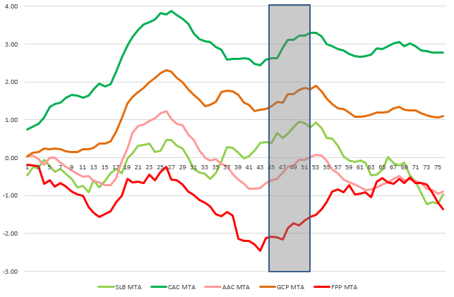



The next tranche of video is 8 seconds long. It focuses on, and is narrated by, a young female recruit who describes some of the friendships she has made during her time on the course. The imagery is social, showing recruits having fun and interacting well with one another. The narrator describes powerfully, and in some detail, the depth of the relationships that she has made, stating “*I’ve made like, the strongest friends I’ve ever had, like considering I’ve only known these girls for like 5 months, I trust them more than the people I’ve known my entire life*”. Figure 70 (above) shows how strongly key parts of the MTA react to this part of the video with all segments increasing in positive sentiment, particularly segments FPP, CAC and AAC. For the SLB segment this tranche represents the peak level of positive sentiment.

Finally, Figure 71 (below) shows the closing 9 seconds of the video, which features imagery with recruits marching across open spaces in formation.

Figure 75: Sentiment Analysis – Results by MTA Segments (65-74 Seconds)

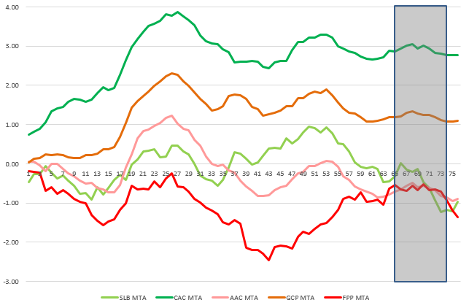

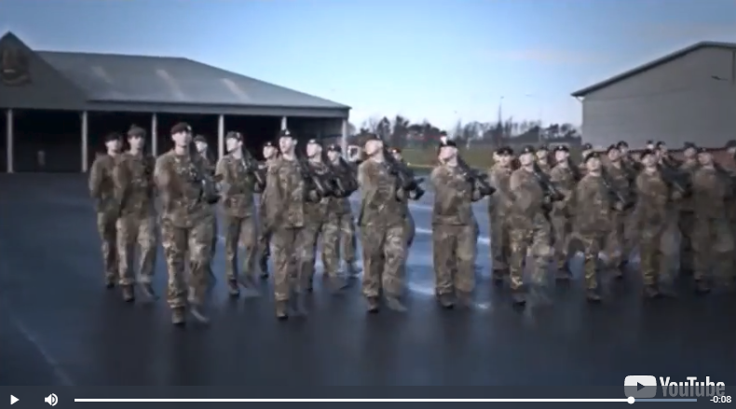

The narrator describes the responsibilities and personal transformation that recruits make into adulthood stating “*you have to, kind of, grow-up; especially at our age, I couldn’t think of a single thing better to do if this is what you’re interested in*”.

Once again there are clear differential effects of the videos core message on the sentiment scores for different segments of the MTA. The SLB, AAC and FPP segments all finish quite poorly, with steep declines in sentiment, likely put-off from the visuals of recruits marching and notions of additional responsibility. Conversely, the CAC and GCP segments appear unfazed by the scenes of marching recruits, even increasing positive sentiment at the point where personal growth and independence is described.

The promotional video was also shown to a selection of parents which allowed us to analyse the results of parents ‘linked’ with their children. Figure 72 (below) shows the results.

Figure 76: Sentiment Analysis – Results by Parents/Gatekeepers by MTA Segments

The results show that there are similarities and differences in the results for parents and their children, depending on which MTA segment they belong to.

Overall, the parents tend to be more positive than the children about the video, with higher and more consistent sentiment scores on average.

However, the results also suggest that there is a remarkable level of consistency between the average sentiment scores of parents and children across the video, depending on which segments are analysed. Interestingly, those segments which register the lowest level of interest in an Army career show the most inconsistency in sentiment scores between parent and child. Whilst those from the segments that exhibit the highest likelihood of interest in an Army career have the highest degree of sentiment consistency across the video.

Figure 77: Sentiment Analysis – Results by MTA Segments, parents and children combined

These results can be interpreted in two ways.

First, it suggests that different segments exhibit similarities or differences in career preferences more generally, and this, in turn suggests that the segments will have different parent-child relationship structures.

Second, it implies that parents and gatekeepers, along with other factors, may be a significant influence on the propensity of key segments within the MTA to seriously consider a career in the Army.

We explore the role of parents and gatekeepers further in the next chapter.

## The Influence of Parents & Gatekeepers

### Parent-child attitudinal consistency leads to greater interest in Army career

The data displayed in Figure 74 (below) shows the propensity of the MTA to say that they are interested in an Army career, by whether or not both parents and their children gave the same answers on a number of key attitudinal questions.

The results suggest that where parents and children are aligned in their attitudes, the children are more likely to be interested in an Army career. Conversely, where they disagree on these issues, they are on average less likely to be interested.

Figure 78: Propensity to consider an Army career by parent-child agreement on different attitudinal variables

The results in Figure 75 (below) show that there are also large differences in parent-child alignment across these key attitudinal questions for different MTA segments.

Figure 79: Parent-child agreement on 4 or more attitudinal questions of parent-child agreement

Key segments, such as the **Can-Do Active Citizens** (CAC) and **Get-on Community Pride** (GCP) showing significantly higher levels of attitudinal consistency with their parents.

Almost nineteen in twenty (94%) of the CAC segment gave similar answers to their parents on a majority of the 7 key attitudinal variables we have used above. As did two thirds (65%) of those in the GCP segment.

This contrasts sharply with the **Strivers Lacking Belonging and Feckless**, **Poor & Pessimistic** segments that show significantly higher levels of disagreement. Just 10% of the SLB segment agree on a majority of the key attitudinal questions with their parents; and for the FPP segment it falls to just 3%.

Figure 80: Propensity to consider Army career by level of parent-child agreement number of attitudinal questions

Interestingly, there is an almost linear relationship between the level of attitudinal consistency between parents and their children and the likelihood of a child being interested in an Army career.

Examining the chart above (Figure 76) shows that only one quarter of those who agree with their parents on two or fewer key attitudinal questions, say that they are interested in an Army career.

Whereas a majority (51%) of those who gave the same attitudinal answers as parents on all seven questions, say that they are interested in an Army career.

Although these data support strongly the notion that parents/gatekeepers are a key influence for MTA segments, it is perhaps not enough for the MTA to simply agree with their parents/gatekeepers.

For this theory to be verified further, we must find evidence that the directionality of the attitudinal consistency matters also.

This means that children and parents who exhibit attitudinal mindsets which are aligned in ways that are favourable towards a career in the Army, should be more likely to be interested. Whereas those who are aligned in ways which are negatively associated with an Army career, should be less likely to be interested.

The results presented in Figure 77 (below) support this view. The data shows that those who have similar attitudinal responses to their parents on a majority of questions; and these attitudes are favourable towards an Army career; are most likely to say that they are interested.

Figure 81: Propensity to consider Army career by level and positive/negative direction of parent-child agreement

The results also show that those who have similar attitudinal responses to their parents on a majority of questions; and these attitudes are not favourable towards an Army career; are least likely to say that they are interested.

## Overview of quantitative survey results

### Introduction

This section provides an overview of the results to the quantitative survey undertaken with the MTA and gatekeepers, including comparisons with the current Junior Soldier cohort where appropriate. The questions in the quantitative surveys were primarily designed to inform the segmentation exercise and related analyses. However, the results are included to provide additional context, and to summarise key differences across demographic sub-groups of the MTA.

### Sources of careers advice

Parents are a key source when MTA are seeking advice about careers, (74%) as are careers advisers at school or college (66%) and the internet (64%).

Figure 82: Sources of careers advice (All MTA)

Unweighted base: All MTA (4,098)  
Q: If you wanted to find out about the different types of career you might follow, where would you go to for advice and guidance?

Parents are the most important source of careers advice across all age groups, and for both boys and girls, but they, and teachers, become less important as age increases, counteracted by an increased focus on the internet and friends.

Figure 83: Sources of careers advice (All MTA by gender and age)

|  |  |  |  |  |  |  |  |
| --- | --- | --- | --- | --- | --- | --- | --- |
| Column % | Total | Aged 14 | Aged 15 | Aged 16 | Aged 17 | Male | Female |
| Parents | 74% | **79% ↑** | 75% | 72% | **70% ↓** | 73% | 75% |
| Careers adviser at school/college | 66% | 67% | 66% | 67% | 65% | 66% | 67% |
| Internet | 64% | **58% ↓** | 64% | 65% | **70% ↑** | **62% ↓** | **67% ↑** |
| Teacher | 56% | **63% ↑** | 58% | **53% ↓** | **51% ↓** | 55% | 58% |
| Friends | 33% | **29% ↓** | 31% | 35% | **37% ↑** | **31% ↓** | **36% ↑** |
| Other family members | 25% | 26% | 26% | 26% | 24% | 24% | 26% |
| Unweighted base | (4,098) | (923) | (1,157) | (953) | (1,065) | (2,046) | (2,052) |
| Q: If you wanted to find out about the different types of career you might follow, where would you go to for advice and guidance?  Arrows indicate statistically significant differences at the 95% level of confidence | | | | | | | |

Junior Soldiers are significantly less likely than the wider MTA to cite their parents as the people they would go to for advice and guidance about the different types of career they might follow (35% compared to 74%), and also less likely to cite careers advisers (31% compared to 66%), teachers (9% compared to 56%) and friends (14% compared to 33%).

Figure 84: Sources of careers advice (All MTA and All Junior Soldiers)

Unweighted bases in parentheses  
Q: (Before joining AFCH) If you wanted to find out about the different types of career you might follow, where would you go to for advice and guidance?

### Activity

**Participation in clubs**

Three quarters (74%) of the MTA have ever attended/taken part in a club or activity, most commonly a sports club (35%), Scouts/Cubs (29% of boys) or Girlguiding (28% of girls), a youth club (25%), or the Duke of Edinburgh Awards (22%). Relatively few have participated in any armed forces-related groups.

Participation rates are similar among Junior Soldiers, three quarters (75%) of whom report having ever attended/taken part in a club or activity. However, there are clear differences in the focus of their activities, which are much less likely to be youth clubs (13% compared to 25% of the MTA), Girlguiding (9% of girls compared to 28%) or Cubs/Scouts (11%[5] of boys compared to 29%), and much more likely to be the Army Cadet Force (33% compared to 4%).

Figure 85: Activities ever taken part in (All MTA and All Junior Soldiers)

Unweighted bases in parentheses  
Q: Which, if any, of the following have you ever taken part in?

Among the MTA, overall participation reduces with age, from 77% of those aged 14, to 70% of those aged 17.

MTA participation also varies significantly by geography, as shown in the figure below, being highest in Northern Ireland (83%) and Scotland (81%), and lowest in the North of England (70%).

Figure 86: Ever taken part in any club/activity (All MTA by region)

|  |  |  |
| --- | --- | --- |
| Row % | % | Unweighted base |
| Northern Ireland | 83% | (91) |
| Scotland | **81%↑** | (324) |
| Summary: South | 75% | (1,311) |
| Summary: Midlands | 73% | (1,120) |
| Wales | 71% | (144) |
| Summary: North | **70%↓** | (1,108) |
| Q: Which, if any, of the following have you ever taken part in?  Arrows indicate statistically significant differences at the 95% level of confidence | | |

Notable differences in MTA participation in particular organisations by region include:

* 41% of the MTA in Scotland have been a member of a sports club (cf. 34% total sample), 27% have participated in Scouts/Cubs (cf.16% total sample); and 29% have participated in the Duke of Edinburgh Awards (cf. 25% total sample);
* 61% in Northern Ireland have been a member of a youth club (cf. 24% total sample), 10% have been involved with St John’s Ambulance (cf. 4% total sample) and 8% have participated in the Girls Brigade (cf. 3% total sample).

**Physical activity**

Three in five (61%) of all MTA report doing physical or sporting activity either every day or most days, although this falls to 52% of girls, 51% of those aged 17, and 44% of those who have never taken part in any clubs/membership organisations.

Junior Soldiers report more frequent activity prior to attending AFCH, with three quarters (76%) saying they did so every day or most days.

Figure 87: Frequency of physical or sporting activity (All MTA and All Junior Soldiers)

Unweighted bases in parentheses  
Q: (Before you came to AFC Harrogate) How often do you do any physical or sporting activity?

**MTA: Every day/most days**:

* Boys 69%
* Girls 52%
* Aged 14 66%
* Aged 15 65%
* Aged 16 59%
* Aged 17 51%

### Religion

While Gatekeepers are more likely than the MTA to report having a religion (63% compared to 58%), they are no more likely to consider themselves as actively practising (36% compared to 35% of the MTA who have a religion).

A significantly smaller proportion of Junior Soldiers report having a religion (39%), predominantly Christian (34%), and only one in ten (9%) of this group report that they are actively practising.

Figure 88: Religion (All MTA compared to all gatekeepers)

Unweighted bases in parentheses: All MTA and all gatekeepers  
What is your religion even if you are not currently practising?  
Arrows indicate statistically significant differences at the 95% level of confidence

**Actively practising:**

* MTA: 35%
* Gatekeepers: 36%

### Importance of aspects to sense of self

When asked how important various aspects of their lives/circumstances are to their sense of self, family and friends are clearly regarded as most important by the MTA (93% and 88% quite/very important respectively).

Figure 89: Importance of aspects to sense of self (All MTA)

Unweighted base: All MTA (4,098)  
Q: How important is/are xxx to your sense of who you are?

While family and friends are very important to both White and BME MTAs’ sense of self, this is particularly the case for White MTA.

In contrast, while less important than family and friends, national identity, where they live, ethnicity and religion are all significantly more important for BME than White MTA.

Figure 90: Importance of aspects to sense of self (Very important – All MTA by ethnicity)

Unweighted bases in parentheses   
Q: How important is/are xxx to your sense of who you are?  
Arrows indicate statistically significant differences at the 95% level of confidence

All aspects are rated as significantly less important by MTA who report having no religion than those who have a faith, while Muslims attach a significantly greater level of importance to national identity, where they live, and particularly their ethnicity and religion than any other group.

Figure 91: Importance of aspects to sense of self (Very important – All MTA by religion)

Unweighted bases in parentheses   
Q: How important is/are xxx to your sense of who you are?  
Arrows indicate statistically significant differences at the 95% level of confidence

Those who have or would consider applying to the army are significantly more likely to feel all aspects are more important to their sense of self than those who have/would not, with the exception of their family.

Figure 92: Importance of aspects to sense of self (Very important – All MTA by consideration of applying to the Army)

Unweighted bases in parentheses   
Q: How important is/are xxx to your sense of who you are?  
Arrows indicate statistically significant differences at the 95% level of confidence

Gatekeepers are significantly more likely than the MTA to regard family, national identity and religion, and less likely to find friends very important to their sense of self.

Figure 93: Importance of aspects to sense of self (Very important – All MTA compared to all gatekeepers)

Unweighted bases in parentheses   
Q: How important is/are xxx to your sense of who you are?  
Arrows indicate statistically significant differences at the 95% level of confidence

Junior Soldier respondents are significantly more likely than the wider MTA to feel that their family (73% compared to 63%), their national identity (34% compared to 28%), and where they live (37% compared to 22%) are very important to their sense of self, and significantly less likely than the wider MTA to feel that their ethnic background (7% compared to 19%) and religion (3% compared to 12%) are very important to their sense of self.

Figure 94: Importance of aspects to sense of self (Very important – All MTA compared to All Junior Soldiers)

Unweighted bases in parentheses   
Q: How important is/are xxx to your sense of who you are?  
Arrows indicate statistically significant differences at the 95% level of confidence

### Consideration of applying to the Army

Over one in ten (13%) of the MTA have close friends or family currently serving in the Armed Forces (rising to 17% of 16-year olds), and this proportion is matched for Gatekeepers (14%).

A third (34%) of the MTA have or would consider applying to the Army, with boys significantly more likely than girls to do so (39% compared to 29%). While the likelihood of considering applying reduces with age, from 37% of 14-year olds to 30% of 17-year olds, it is consistent across both White and BAME MTA (34% and 32% respectively).

Those not currently in education are significantly less likely than those who are to consider applying (24%).

Figure 95: Consideration of applying to the Army (All MTA)

Unweighted base: All MTA (4,098)  
Q: Have you or would you consider applying to the Army?   
Arrows indicate statistically significant differences at the 95% level of confidence

Boys: 39%

Girls: 29%

**Age:**

14: 37%

15: 35%

16: 33%

17: 30%

Not at school: 24%

There are also variations by academic expectations, with those expecting a post-graduate degree or 5 or more A-C GCSEs significantly more likely than others to consider applying. Similarly, those planning on university are more likely than those who are not to consider applying (37% compared to 32%).

Figure 96: Have/would consider applying to the Army (All MTA by academic expectations)

Unweighted bases in parentheses   
Q: Have you or would you consider applying to the Army?   
Arrows indicate statistically significant differences at the 95% level of confidence

The figure below indicates the proportion of the MTA who have or would consider applying to the Army in each nation/region and shows that consideration is higher in London (41%), East Midlands (39%), Northern Ireland, Yorkshire and Humber (both 37%), Scotland (36%) and the South West (36%).

Figure 97: Have/would consider applying to Army (All MTA by region)

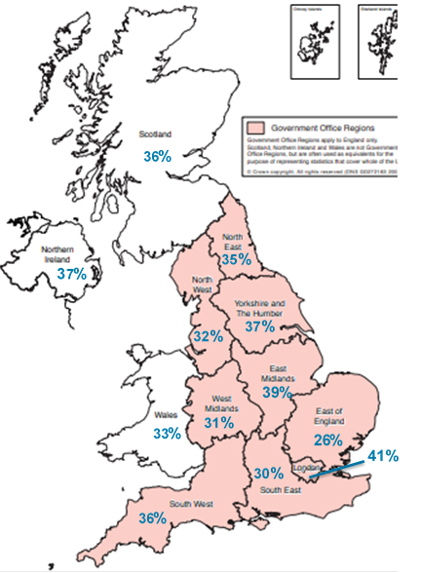  
Unweighted base: All MTA (4,098)  
Q: Have you or would you consider applying to the Army?   
Arrows indicate statistically significant differences at the 95% level of confidence

Two thirds (66%) of gatekeepers would definitely or probably allow their child to join the Army.

In contrast to the MTA, where consideration of applying to the Army decreases with age, Gatekeepers’ likelihood of allowing their child to join the Army increases with age, with 69% of those with 17 year olds who would definitely or probably allow their child to join.

Figure 98: Likelihood of allowing child to join Army (All gatekeepers)

Unweighted base: All MTA (4,098)  
Q: Have you or would you consider applying to the Army?   
Arrows indicate statistically significant differences at the 95% level of confidence

**Child**:

Boys: 67%

Girls: 64%

**Child age:**

14: 64%

15: 62%

16: 66%

17: 69%

The figure below shows the Net Promoter Scores for the MTA and gatekeepers, which is calculated by subtracting those classed as detractors (i.e. scoring 0 to 6 in terms of likelihood to recommend a career in the Army) from those classed as promoters (i.e. scoring 9 to 10 in terms of likelihood to recommend a career in the Army).

These negative scores of -72 and -69 respectively demonstrate the size of the challenge to normalise the possibility of a career in the Army.

In contrast Junior Soldiers return an NPS of +7, with those on the Short course more positive than those on the Long course (+16 compared to 0). While this is clearly, and unsurprisingly, more positive than the MTA and gatekeepers, we might expect this to be higher amongst this cohort, particularly given their own commitment to continuing a career in the Army (70% say they will definitely continue and a further 21% that they probably will).

Figure 99: Net Promoter Score (All MTA, All Gatekeepers and All Junior Soldiers)

Unweighted bases in parentheses   
Q: On a scale of 0 to 10, where 0 is not at all likely and 10 is extremely likely, how likely is it that you would recommend a career in the Army to a family member or friend/your child?

Promoters

Detractors

+7

-69

-72

NPS

Appendix: Statement of Terms

Set out below are BMG Research’s standard terms and conditions. These shall be considered to be in place unless:

a) Our client sets out their own Terms and Conditions at proposal stage, and our submission of a proposal is considered to be acceptance of these or,

b) We sign a contract prepared by the client which sets out the Terms and Conditions under which work will be undertaken.

**Compliance with International Standards**

BMG complies with the International Standard for Quality Management Systems requirements (ISO 9001:2008) and the International Standard for Market, opinion and social research service requirements (ISO 20252:2012) and The International Standard for Information Security Management (ISO 27001:2013).

**Freedom of Information**

BMG is willing to support the client in responding to all Freedom of Information requests. However, we regard all information about individuals as personally sensitive and should not be disclosed. We also regard our methodology and all other aspects of this tender that are used to evaluate its merit as commercially sensitive. This is a competitive tender and is judged against a set of criteria to evaluate the way we have interpreted the specification and the approach we have put forward to meeting the objectives. If this was placed into the public domain and therefore open to our competitors it could put us at a material disadvantage in any future tendering process. Therefore, such commercially sensitive information should not be disclosed, without permission, for a period of at least one year after the award of the tender.

**Ethical practice**

BMG promotes ethical practice in research: We conduct our work responsibly and in light of the legal and moral codes of society.

We have a responsibility to maintain high scientific standards in the methods employed in the collection and dissemination of data, in the impartial assessment and dissemination of findings and in the maintenance of standards commensurate with professional integrity.

We recognise we have a duty of care to all those undertaking and participating in research and strive to protect subjects from undue harm arising as a consequence of their participation in research. This requires that subjects’ participation should be as fully informed as possible and no group should be disadvantaged by routinely being excluded from consideration. All adequate steps shall be taken by both agency and client to ensure that the identity of each respondent participating in the research is protected.

Your acceptance of this proposal will be taken as agreement to abide by good practice in social research ethics.

**Termination of contract**

If commissioned based on the content of this proposal, the agency considers this to be your acceptance of our stated terms and conditions. Once commissioned, the agency reserves the right to levy a termination charge should the contract be cancelled by the client. All prices quoted are valid for ninety days from the date of this document. Included in the price quoted is a technical report detailing the methodology as delivered. This documentation would be made available to the client on request unless already detailed as part of the specified outputs.

With more than 25 years’ experience, BMG Research has established a strong reputation for delivering high quality research and consultancy.

BMG serves both the public and the private sector, providing market and customer insight which is vital in the development of plans, the support of campaigns and the evaluation of performance.

Innovation and development is very much at the heart of our business, and considerable attention is paid to the utilisation of the most up to date technologies and information systems to ensure that market and customer intelligence is widely shared.



Company Reg: 2841970 VAT No: 580660632

1. Maximum confidence interval of ±1.5% at the 95% confidence level.
2. Maximum confidence interval of ±2.2% at the 95% confidence level.
3. Maximum confidence interval of ±5.5% at the 95% confidence level.
4. Please note that the responses to this question will be fully coded up in the final report, and percentages attributed to each element.
5. Interestingly, 15% of female Junior Soldiers report being a member of Cubs/Scouts.