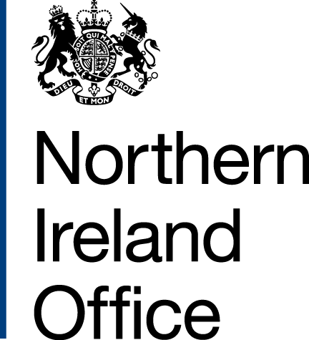 | Lord Duncan of Springbank Parliamentary Under-Secretary of State for Northern Ireland  1 Horse Guards Road  London  SW1 2HQ  T 020 7210 0206
Stormont House
Belfast
BT4 3SH
E min.duncan@nio.gov.uk
www.gov.uk/nio
@niopressoffice

Deposited Papers Clerk
House of Lords Library

Deposited Papers Clerk
House of Commons Library

01 November 2019

Dear Deposited Papers Clerks,

During the course of Second Reading of the Northern Ireland Budget Bill, I committed to responding to the points that Lord Lexden and others raised in relation to the renewable heat incentive scheme in Northern Ireland and placing a copy of my response in the House library. I would therefore be grateful if the attached correspondence could be placed in both libraries of the House.

Yours sincerely,
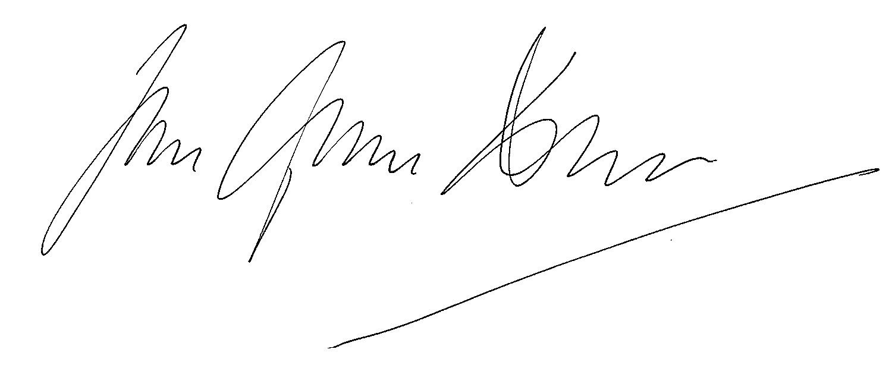

LORD DUNCAN OF SPRINGBANK
PARLIAMENTARY UNDER-SECRETARY OF STATE FOR NORTHERN IRELAND

