Helen Whately MP
Parliamentary Under Secretary of State for Arts, Heritage and Tourism
4th Floor
100 Parliament Street
London SW1A 2BQ

www.gov.uk/dcms
enquiries@culture.gov.uk

INT2019/10249/DC
25 September 2019

House of Commons Library
House of Commons
London
SW1A 0AA
Dear House of Commons Library
Further to the answers to the Parliamentary Questions (PQs) from the Rt Hon Priti Patel MP (PQ 262360 and PQ 261505), regarding society lotteries reform, I attach responses to the consultation from Camelot, together with some other key stakeholders, and redacted copies of two campaign letters, as follows:

- Camelot (submission dated 7 September 2018)
- The Lottery Forum (submission dated September 2018)
- The Lotteries Council (submission dated August 2018)
- People's Postcode Lottery (submission dated August 2018)
- The Health Lottery (undated submission, received 7 September 2018)
- Local Government Association (submission dated September 2018)
- Example campaign letter 1 (redacted) (email dated 13 July 2018)
- Example campaign letter 2 (redacted) (letter dated 12 August 2018)

I would be grateful if you could please arrange for these to be deposited in the House of Commons Library.

Yours sincerely,
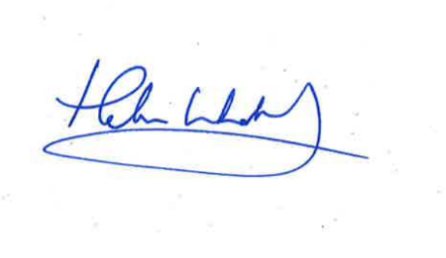
Helen Whately MP
Parliamentary Under Secretary of State for Arts, Heritage and Tourism

