Rt Hon Jeremy Wright QC MP
Secretary of State for Digital, Culture, Media and Sport
4th Floor
100 Parliament Street
London SW1A 2BQ

www.gov.uk/dcms
enquiries@culture.gov.uk

TO2019/03552/DC
10 April 2019

The Clerk
House of Commons
London
SW1A 0AA
Dear Clerk
The Times/The Sunday Times: proposed undertakings submitted by News UK to vary the 1981 conditions

I am writing to make you aware of a submission by News UK to DCMS requesting that the Secretary of State accept proposed undertakings in place of undertakings that were put in place by the then Secretary of State for Trade (the Rt Hon. John Biffin) in 1981.

The proposed new undertakings seek to vary the sections of the 1981 conditions which require that ultimate control over the resources, including journalists, available to each newspaper are kept separately with the editor of each newspaper. The main variation proposed by News UK is to set out explicitly in paragraph 5 of the proposed undertakings that “The newspapers may share services and resources, including journalists, to such extent as the editors agree.”

News UK have submitted that the changes would permit a greater sharing of resources and services, including journalists, between The Times and The Sunday Times and that such sharing is a necessary step to mitigate the financial challenges that the two titles will face in the future.

I am placing in the library of the House today a copy of the application we received from News UK along with details on how to comment on the application.

I hope this information is useful.

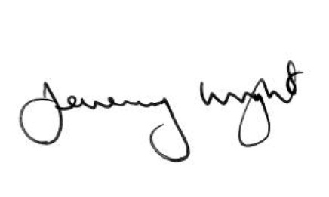

Rt Hon Jeremy Wright QC MP
Secretary of State for Digital, Culture, Media and Sport

