Lord Forsyth of Drumlean
Chair, Economic Affairs Committee
House of Lords
London, SW1A 0PW
15 March 2019

Dear Michael,
The Secretary of State wrote to you in January 2019 explaining that the department was publishing advice for the schools, further education and higher education sectors. I would like to draw your Committee’s attention to information that the department will publish today to help local authority children’s services to prepare. These notices signpost Directors of Children’s Services to relevant information already published as part of the public information campaign, setting it in the context of how it may affect children’s services.

The guidance will be published on gov.uk as part of the wider public information campaign, on gov.uk/euexit.

I attach a copy of the notice, which I will place in the libraries of both Houses along with a copy of this letter.

Yours sincerely,

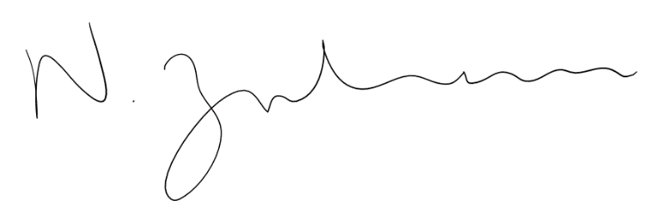

Nadhim Zahawi MP
Parliamentary Under-Secretary of State for Children and Families

