Rt Hon Jeremy Wright QC MP
Secretary of State for Digital, Culture, Media and Sport
4th Floor
100 Parliament Street
London SW1A 2BQ

www.gov.uk/dcms
enquiries@culture.gov.uk

TO2019/03313/DC
4 April 2019

The Clerk
House of Commons
London
SW1A 0AA

Dear Clerk,

I am writing to make you aware of guidance my department will publish today on GOV.UK.

We are updating the Guidance titled: ‘.eu top level domain name registrations in the event of a ‘no deal’ EU exit’. The updates reflect changes made by Eurid, the Registry for .eu, to their EU exit notice of 22 March 2019. EURid has put on hold plans regarding domain names registered to individuals and undertakings located in the UK and Gibraltar following the European Council’s decision to extend the Article 50 period. Changes have been made throughout the guidance to reflect this.

A new section (0.6) regarding UK holders of Member States’ country code top level domains has been added. Further updates have been made relating to the new Regulation concerning .eu top level domain that came into force on 29 March 2019 (section 0.5).

I will place a copy of the document and this letter in the Libraries of both Houses.

I hope this information is useful.

Yours ever,

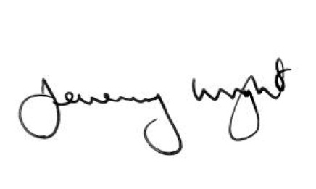

Rt Hon Jeremy Wright QC MP
Secretary of State for Digital, Culture, Media and Sport

