Michael Ellis MP
Minister for Arts, Heritage and Tourism
4th Floor
100 Parliament Street
London SW1A 2BQ

www.gov.uk/dcms
enquiries@culture.gov.uk

1 February 2019

House of Commons Library
Palace of Westminster
Westminster
London SW1A 0AA

depositedpapers@parliament.uk

Please find attached a copy of a consultation document; “Revising the definition of treasure in the Treasure Act 1996 and revising the related codes of practice”.

The consultation will be launched on 1 February and a copy of the document will be deposited in the Libraries of the House of Commons and Lords on this date.

Please also find attached a copy of the consultation document; “Strengthening the Process for Retaining National Treasures”

This consultation was launched on 15 December and a copy of this document will be deposited in the Libraries of the House of Commons and Lords on 1 February.

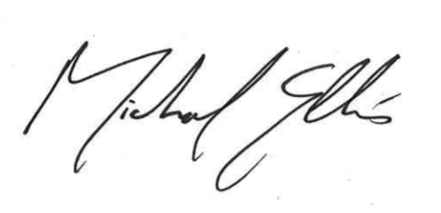

Michael Ellis MP
Minister for Arts, Heritage and Tourism

