Lord Boswell of Aynho
Chairman, European Union Committee
House of Lords
London
SW1A 0PW

22 November 2018

Dear Lord Boswell,

In advance of the meeting of the European Council on Sunday 25 November, the UK and EU have today published a draft Political Declaration setting out the framework for the future relationship between the EU and the UK, which has been agreed at negotiators’ level and agreed in principle at political level, subject to endorsement by the 27 leaders of the EU Member States. This follows the shorter Outline Political Declaration published last week.
This builds on the progress that has already been made and signals the ambition of both sides to embark on a new, deep and special partnership after the UK leaves the EU.
I am placing a copy of the draft Political Declaration and this letter in the Library of the House.

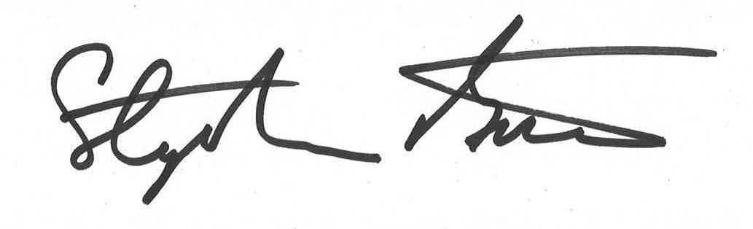

RT HON STEPHEN BARCLAY MP
SECRETARY OF STATE FOR EXITING THE EUROPEAN UNION

