Penny Young
Librarian
House of Commons
London SW1A 0AA

2 July 2018

INFECTED BLOOD INQUIRY

I am writing to request that you place in the libraries of both Houses of Parliament copies of the Infected Blood Inquiry documents, so they can be made available to members of both Houses.

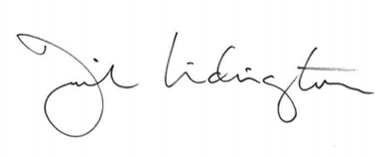

Rt Hon David Lidington CBE MP

