Dr Andrew Murrison MP
Chair of the Northern Ireland Affairs Committe
House of Commons
London
SW1A 0AA

28 June 2018

Dear Andrew,

British and Irish Intergovernmental Conference

I am writing to inform you that the UK Government will be holding a meeting of the British-Irish InterGovernmental Conference on the 25 July.

As I am sure you are aware and as set out in strand three of the Belfast Agreement, the purpose of the conference is to be a consultative forum. Its aim is to ‘bring together the British and Irish Governments to promote bilateral co-operation on all matters of mutual interest within the competence of both Governments’.

The conference will be progressed in full accordance with the well-established three stranded approach, and, as the Belfast Agreement states explicitly, ‘there will be no derogation from the sovereignty of either Government’.

The conference is ‘concerned with non-devolved Northern Ireland matters’, therefore the focus of the meeting will be on East-West issues. It will take place in London and be chaired by myself, with the Secretary of State for Northern Ireland in attendance.

I have deposited a copy of this letter in the library of both Houses.

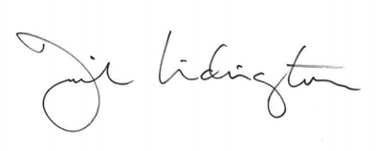

Rt Hon David Lidington CBE MP

