18 May 2018

The Deposited Paper Clerks
The Library
House of Lords
SW1H 0PW

Dear Deposited Paper Clerks,

FREE SCHOOL MEALS UNDER UNIVERSAL CREDIT TECHNICAL NOTE

I would be grateful if the attached technical note regarding estimating the number of free school meal pupils under Universal Credit could be deposited in the House Libraries.

Yours sincerely,
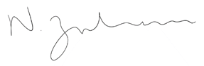

Nadhim Zahawi MP
Parliamentary Under-Secretary of State for Children and Families

