Dear Ms Young,

I would be grateful if the attached letter could be placed in the Library of the House.

Yours Sincerely,
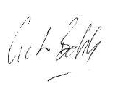

GUTO BEBB MP

