Lord Adonis
House of Lords
London
SW1A 0PW

1 September 2017

Dear Lord Adonis,

WRITTEN PARLIAMENTARY QUESTION HL747

Please find attached a response to parliamentary question HL747 from the Department for Exiting the European Union. This information supplements the earlier answer provided by Lord Price, Minister of State for International Trade.

A copy of this answer is also being placed in the Library of the House.

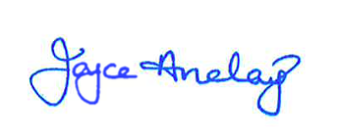

RT HON BARONESS ANELAY OF ST JOHNS DBE
MINISTER OF STATE FOR EXITING THE EUROPEAN UNION

HL747

Lord Adonis (Labour)

Her Majesty's Government how much (1) has been paid since July 2016, and (2) is budgeted to be paid in 2017–18, to recruitment agents or companies for the recruitment of staff to (a) the Department of International Trade, and (b) the Department for Exiting the European Union.

Answered by: Lord Price
The Department for International Trade (DIT) has paid £1.15m to organisations for services relating to the recruitment of staff since July 2016. Recruitment costs are managed locally by the functional areas of DIT; there is no central budget for recruitment.
My noble friend a copy of the figures relating to the Department for Exiting the European Union will be placed in the library of the House once they are made available.

The Department for Exiting the European Union response in reference to HL747:

The Department for Exiting the European Union was established in July 2016, since that time the Department has grown to over 450 staff. No expenditure has been incurred via external companies or recruitment agencies in relation to the recruitment of staff.

The Department has used the services of Civil Service Resourcing for the recruitment of staff through campaigns and to date, the invoiced expenditure recorded on the departmental financial system totals £58k for these services.

