Kelvin Hopkins MP
House of Commons
Parliament Square
London
SW1A 0AA

16 March 2017
Dear Kelvin,

I am writing to you following the Westminster Hall debate on Wednesday 8 March on financial support for apprentices. Thank you for calling the debate. This issue is of great importance to this government.
During the debate I stated that by 2020 apprenticeship spending will have increased to £2.5 billion, almost double what it was in 2015. I wish to make clear that I should have said that by 2020 apprenticeship spending will have increased to £2.5 billion, almost double what it was in 2010.
I have written to the Editor of Hansard and I am placing a copy of this letter in the libraries of both Houses of Parliament.
Yours sincerely,
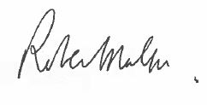
Robert Halfon

