Rt Hon Alun Cairns MP
Secretary of State for Wales
 | Gwydyr House  London, SW1A 2NP | Tŷ Gwydyr  Llundain, SW1A 2NP
 | 1 Caspian Point  Cardiff Bay, CF10 4DQ | 1 Pwynt Caspian  Bae Caerdydd, CF10 4DQ
 | www.walesoffice.gov.uk
The Librarian
House of Commons Library
London
SW1A 0AA

 | 20 September 2016

Dear Sir/Madam,

WALES BILL – MEMORANDUM CONCERNING THE DELEGATED POWERS IN THE BILL FOR THE DELEGATED POWERS AND REGULATORY REFORM COMMITTEE

As Secretary of State for Wales I wish to deposit the attached copy of the Wales Bill Delegated Powers Memorandum in the library of the House.

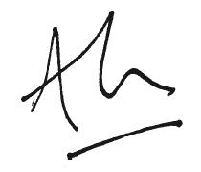

Rt Hon Alun Cairns MP

Secretary of State for Wales

