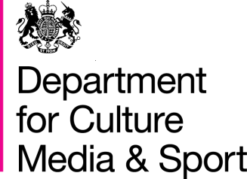
BBC Charter Review 2016
Information Sheet
Public and Parliamentary Scrutiny

On 15 September 2016 the government published a draft Royal Charter and Framework Agreement. This is one in a series of information sheets, explaining some of the key policies contained in the drafts in more detail.

Background
The proposals for Charter Review set out by the Government in a Green Paper in July 2015 were subject to one of the largest government consultations ever. The government received more than 300 written responses from industry and media experts, and 192,000 consultation responses from the public. This resulted in a White Paper published in May 2016.
The government has now published the draft Charter and Framework Agreement, which will be scrutinised further by Parliament. These documents reflect the policies that were set out in the White Paper and the legal drafting has been undertaken in consultation with both the BBC and Ofcom.

Parliamentary scrutiny
Debates in the Devolved Administrations- The government has committed - as part of the Memoranda of Understanding, and the Smith Commission agreement - to debates in each of the devolved legislatures for the first time. These can take place over the coming weeks and and the government will listen carefully to the issues raised in these debates.

Debates in Westminster - Subject to other business in the House, the Westminster Parliament will then be able to consider the draft documents, including outcomes from the debates in the devolved assemblies. These debates will take place in October.

Privy Council - Following the debates in Westminster, the government will consider the points raised and update the draft documents as required. The draft Charter will then be submitted to the Privy Council in November, in order for the new Charter to be granted before the end of the year, when the current Charter expires.

