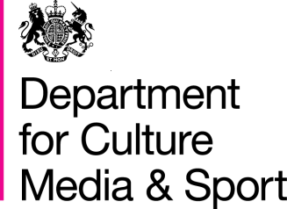

BBC Charter Review 2016
Information Sheet - Distinctiveness

On 15 September 2016 the government published a draft Royal Charter and Framework Agreement. This is one in a series of information sheets, explaining some of the key policies contained in the drafts in more detail.

Background
The Royal Charter and licence fee funding put the BBC in a unique position, able to do things that other media providers cannot. Over the course of the last Charter the BBC Trust has called for the BBC to be more distinctive, particularly on its most mainstream services. The BBC itself has recognised that it should seek to be more distinctive.

The government’s policy
The government’s objective is to create the structures within which the BBC can unleash its creativity and talent to provide audiences with world class distinctive content. To do this the new Royal Charter and Framework Agreement includes distinctiveness in the BBC’s mission, purposes and regulatory framework.

The provisions in the Charter and Agreement
Royal Charter Article 5: The BBC’s Mission. This Charter expands the BBC’s mission to include distinctiveness as well as other elements fundamental to its objective: ‘to act in the public interest, serving all audiences through the provision of impartial, high-quality and distinctive output and services which inform, educate and entertain.’

Royal Charter Article 6(4): The BBC’s Public Purpose. This Charter revises the existing purposes, reflecting work undertaken by the BBC Trust and views from the public consultation including reference to distinctive content. The BBC’s fourth purpose begins: ‘To show the most creative, highest quality and distinctive output and services.’

Framework Agreement Schedule 2: For effective regulation there needs to be a clear understanding of its objectives. This schedule sets out the aims for the new regulatory framework and some areas in particular that Ofcom will need to consider in setting the first regulatory conditions that were identified through the Charter Review process.

BBC Trust, Service Review of BBC Television, July 2014, p.32: http://downloads.bbc. co.uk/bbctrust/assets/files/ pdf/regulatory_framework/ service_licences/service_reviews/ television_services/television_ services.pdf BBC Trust, Service Review Radio 1, 1Xtra, Radio 2, Radio 3, 6 Music and Asian Network, March 2015, p.7: http:// downloads.bbc.co.uk/bbctrust/ assets/files/pdf/our_work/music_ radio/music_radio.pdf
Lord Hall Speech at the Science Museum on the future vision of the BBC, 7 September 2015: http://www.bbc.co.uk/mediacentre/ speeches/2015/tony-halldistinctive-bbc

