John Benger
Librarian
House of Commons
London
SW1A 0AA

21 July 2015

Dear John,

I would be grateful if the attached document, ‘Letter from Charity Commission to the Independent Schools Council regarding the Charities (Protection and Social Investment) Bill’ could be deposited as a paper in the Library so that it is available to Members in both Houses.
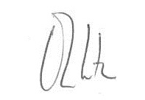

OLIVER LETWIN

