John Benger
Librarian
House of Commons
London
SW1A 0AA

3 July 2015

Dear John,

I would be grateful if the attached document, ‘HANDLING CORRESPONDENCE FROM MEMBERS OF PARLIAMENT, MEMBERS OF THE HOUSE OF LORDS, MEPs AND MEMBERS OF DEVOLVED ADMINISTRATIONS - GUIDANCE FOR DEPARTMENTS’ could be deposited as a paper in the Library so that it is available to Members in both Houses.
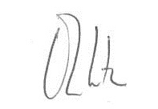

OLIVER LETWIN

